LIZZO KICKS OFF THE NEW YEAR WITH “JUICE”

RISING STAR UNVEILS EAGERLY AWAITED NEW SINGLE ALONG WITH COMPANION VIDEO

LIZZO TO ROCK COACHELLA, SUNDAY APRIL 14th & 21st

“JUICE” AVAILABLE NOW AT ALL DSPS AND STREAMING SERVICES

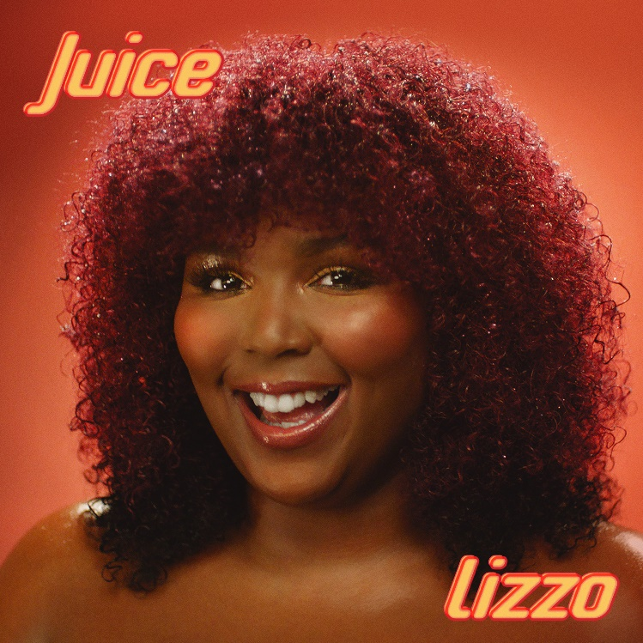

Nice Life Recording Company/Atlantic recording artist Lizzo has announced the release of her eagerly anticipated new single. “Juice” is available now via all digital music retailers and streaming services; the track is joined by a new companion visual, which premiered this morning on YouTube Live as well as on MTV Live and MTVU every hour on the hour beginning at 9am this morning. “Juice” will also be playing on the Viacom Times Square billboard screens at 12pm and 5pm EST today. The music video for “Juice” is streaming now at Lizzo’s official YouTube channel HERE.

Lizzo will celebrate “Juice” with eagerly awaited sets at the upcoming Coachella Valley Music & Arts Festival (April 12th – April 21st). For updates, please visit www.lizzomusic.com/tour.

“Juice” marks the latest in a recent string of singles that includes “Boys,” “Fitness,” and “Truth Hurts,” all available now for individual streaming and download. All three are joined by companion visuals, streaming now at Lizzo’s official YouTube channel HERE.

2018 was yet another extraordinary year for Lizzo, highlighted by a stellar live performance at Lollapalooza – named #1 on Time Out’s “The Five Best Things We Saw At Lollapalooza on Friday” – as well as a remarkable show at New York City’s MoMa PS1 Warm Up 2018 and multiple high profile appearances during New York Fashion Week. The year also saw a stunning range of media attention, spanning cover appearances on Galore and Teen Vogue’s “Pass The Mic Music Issue” to feature interviews including Rolling Stone, the New York Times, V, Glamour, and Allure, which named Lizzo among its “Beauty Disruptors: 12 People Changing the Beauty Industry for the Better.” Lizzo was also featured on several “Best Of” lists for her hit track “Boys,” including Time’s “10 Best Songs of 2018,” Pitchfork’s “100 Best Songs of 2018,” and Paste’s “50 Best Songs of 2018” and more. “Fitness” was also included in Paper Magazine’s “Top 100 Songs of 2018.”

“COCONUT OIL,” Lizzo’s hugely acclaimed Nice Life Recording Company/Atlantic Records debut EP, was released in October 2016 to unanimous critical acclaim and popular success. “COCONUT OIL” is highlighted by the hit single, “Good As Hell,” also featured on 2016’s “BARBERSHOP: THE NEXT CUT (ORIGINAL MOTION PICTURE SOUNDTRACK).” Rolling Stone singled out the track in its “Best Pop Albums of 2016 So Far,” explaining that, “Despite these albums, pop still remains a genre for singles. Lizzo's boisterous ‘Good As Hell,’ produced by omnipresent 2016 producer Ricky ‘Wallpaper" Reed,’ is a straight-no-chaser shot of self-confidence with a call-and-response chorus.”

CONNECT WITH LIZZO
LIZZOMUSIC.COM
FACEBOOK
TWITTER
INSTAGRAM
YOUTUBE

# # #

Press Contact:
Ashley Kalmanowitz
Ashley.Kalmanowitz@atlanticrecords.com
212.707.2051

