FOR IMMEDIATE RELEASE
SEPTEMBER 23, 2019

LIZZO’S “TRUTH HURTS” TOPS THE BILLBOARD HOT 100 FOR A FOURTH CONSECUTIVE WEEK

“TRUTH HURTS” MARKS THE LONGEST RUNNING #1 HIT BY A SOLO FEMALE RAP ARTIST IN HOT 100 HISTORY

“TRUTH HURTS” REACHES #1 SPOT ON TOP 40 RADIO CHARTS WITH THE MOST SPINS FOR AN ARTIST IN ONE WEEK

DEBUT ALBUM CUZ I LOVE YOU CURRENTLY IN THE TOP 10
ON BILLBOARD TOP 200 CHART FOR 16 CONSECUTIVE WEEKS

“TRUTH HURTS” CERTIFIED 2X PLATINUM

SOLD OUT FALL NORTH AMERICAN TOUR “CUZ I LOVE YOU TOO TOUR” DATES CONTINUE THROUGH OCTOBER

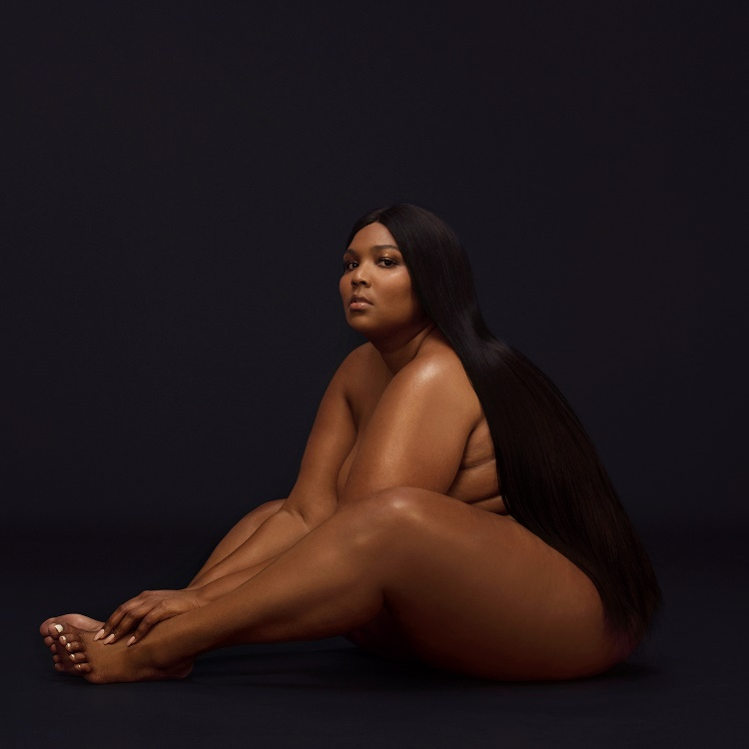

Lizzo’s hit track, “Truth Hurts,” has officially maintained its chart-topping status for a fourth consecutive week. “Truth Hurts” sits atop the Billboard Hot 100 again this week, making Lizzo’s smash hit the longest running #1 hit by a solo female rap artist in Hot 100 history. Additionally, “Truth Hurts” has reached the #1 spot on the Top 40 radio charts this week with the most spins for an artist in one week.

“Truth Hurts” is certified 2x platinum and is also featured on the deluxe edition of her Nice Life Recording Company/Atlantic Records debut album CUZ I LOVE YOU. The album, which debuted at #6 on the Billboard Top 200 chart has spent a solid 16 consecutive weeks in the Top 10 on the Billboard Top 200 chart and is currently at its peak position at #4.

Lizzo has performed the chart topping hit on a number of high profile TV appearances as of late; most recently including the 2019 VMAs, where she also performed “Good As Hell,” The Today Show Summer Concert Series alongside “Good As Hell,” “Juice” and “Soulmate” and during her powerhouse set at NPR’s Tiny Desk. Lizzo also brought down the house with “Truth Hurts” at the 2019 BET Awards.

Last month, Lizzo released the “Truth Hurts (Da Baby Remix)” and the two performed the track together for the first time at Made In America festival. In addition, Lizzo also recently released her highly anticipated video for “Tempo” featuring Missy Elliott, which has since amassed over 14 million views.

This past week, Lizzo hit the road again on her sold out “Cuz I Love You Too Tour,” the second leg of her worldwide “Cuz I Love You Tour.” Dates continue now through October 28th, wrapping in San Francisco at the Bill Graham Civic Auditorium. For complete details and ticket information, please visit www.lizzomusic.com/tour

Lizzo released her Nice Life Recording Company/Atlantic Records debut album, CUZ I LOVE YOU to much critical acclaim on April 19th and the album debuted at #6 on the Billboard Top 200 Albums chart, marking her first Billboard 200 entry. CUZ I LOVE YOU is also the #1 Pop album, #1 Digital album, #1 new release debut album and #2 on the Billboard Top Albums chart.

Lizzo marked the arrival of CUZ I LOVE YOU with a number of high profile TV appearances, including the nationally syndicated Ellen DeGeneres Show, NBC’s The Tonight Show Starring Jimmy Fallon and TODAY, and ABC’s Jimmy Kimmel Live! and HBO’s 2 Dope Queens, as well as visits to Comedy Centrals The Daily Show with Trevor Noah and Bravo’s Watch What Happens Live with Andy Cohen as well as E! News’ Busy Tonight.

In addition, Lizzo has been featured in a remarkable range of worldwide media outlets and national publications, spanning The New York Times, GQ, Billboard, TIME, Entertainment Weekly and Playboy to the covers of Billboard, ELLE, V Magazine, New York Magazine's Spring Fashion Issue, Allure, Essence and more. Additionally, Lizzo attended this year’s annual Met Gala with Marc Jacobs.

CONNECT WITH LIZZO
LIZZOMUSIC.COM
FACEBOOK
TWITTER
INSTAGRAM
YOUTUBE

CUZ I LOVE YOU TOO
U.S. FALL TOUR 2019
www.lizzomusic.com

SEPTEMBER
22 – New York, NY – Radio City Music Hall SOLD OUT
24 – New York, NY – Radio City Music Hall SOLD OUT
25 – Washington, DC – The Anthem SOLD OUT
26 – Washington, D.C. – The Anthem SOLD OUT
28 – Chicago, IL – Aragon Ballroom SOLD OUT
29 – Chicago, IL – Aragon Ballroom SOLD OUT
30 – Nashville, TN – Ryman Auditorium SOLD OUT

OCTOBER
2 – Louisville, KY – Palace Theatre SOLD OUT
4 – Houston, TX – Revention Music Center – SOLD OUT
5 – Dallas, TX – South Side Ballroom – SOLD OUT
8 -Saint Louis, MO – The Pageant SOLD OUT
9 – Minneapolis, MN – The Armory SOLD OUT
10 – Madison, WI – The Sylvee SOLD OUT
11 – Minneapolis, MN – The Armory SOLD OUT
15 – Denver, CO – Fillmore Auditorium SOLD OUT
16 – Denver, CO – Fillmore Auditorium SOLD OUT
18 – Los Angeles, CA – Hollywood Palladium SOLD OUT
20 – Los Angeles, CA – Hollywood Palladium SOLD OUT
21 – Los Angeles, CA – Hollywood Palladium SOLD OUT
23 – Phoenix, AZ – The Van Buren SOLD OUT
24 – San Diego, CA – Cal Coast Credit Union Open Air Theatre SOLD OUT
25 – Las Vegas, NV – The Chelsea at the Cosmopolitan of Las Vegas SOLD OUT
27 – San Francisco, CA – Bill Graham Civic Auditorium SOLD OUT
28 – San Francisco, CA – Bill Graham Civic Auditorium SECOND DATE ADDED

Contact Information:
Ashley Kalmanowitz
Ashley.Kalmanowitz@atlanticrecords.com
212.707.2025

Tour/Online
Jessica Nall
Jessica.Nall@atlanticrecords.com
(818)-238-6835

