**MASON RAMSEY RELEASES *TWANG* EP**

**5-SONG COLLECTION OF NEW MUSIC** **INCLUDES INSTANT FAN-FAVORITE TITLE TRACK “TWANG” & “PUDDLE OF LOVE” CO-WRITTEN BY RAMSEY**

**HIGHLIGHTED AS STAND OUT FEATURE ON BLOCKBUSTER REMIX OF LIL NAS X’S RECORD-BREAKING SINGLE “OLD TOWN ROAD”**

[**STREAM/LISTEN HERE**](https://masonramsey.lnk.to/TwangEP)

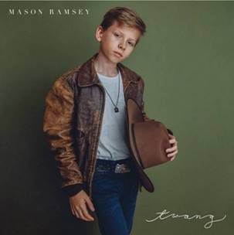

**NEW YORK, NY** (July 26, 2019) — 12-year-old rising Country superstar, **MASON RAMSEY** releases his highly anticipated ***TWANG* EP** out todayvia Big Loud Records/Atlantic Records,his first batch of music in over a year since his debut ***FAMOUS* EP**. The 5 tracks – which feature the instant fan-favorite title track – also mark the first time Ramsey is credited as a co-writer, an impressive feat for a 12-year-old. The companion visual to ”Twang,” which was released last month, currently has nearly 6 million views on [YouTube](https://masonramsey.lnk.to/twangvideo).

These releases come fresh off the heels of Ramsey’s **stand out feature** on **Lil Nas X’s record-breaking “Old Town Road” (with Billy Ray Cyrus and Young Thug),”** which exceeded over 20M+ streams globally in the first week alone and catapulted Ramsey **to Twitter’s #1 Worldwide Trending Topic**. The blockbuster song’s remix was accompanied by two viral visuals including an [**emoji-filled lyric video**](https://youtu.be/loSuMqwQA38) and an [**Area 51-inspired visual**](https://youtu.be/aA7xDP9sQzk), which have a combined total of over **25M+ views** on YouTube.

***TWANG* EP Track List:**

1. Twang  *(Brian Kelley, Jordan Schmidt, Hunter Phelps, Ernest K. Smith)*

2. Puddle of Love  *(Mason Ramsey, Tyler Hubbard, Corey Crowder)*

3. How Could I Not  *(Corey Crowder, Ernest K. Smith, Brian Kelley, James McNair)*

4. On My Way  *(Emily Shackelton, Alex Kline, Tenille Townes)*

5. Before I Knew It  *(Tyler Hubbard, Jon Pardi, Corey Crowder)*

***

**ABOUT MASON RAMSEY:**

As the youngest major label Country artist signed in the genre in nearly two decades, Mason Ramsey continues his fast-track to stardom after being discovered singing in an aisle at his local Walmart. Praised by ***THE NEW YORK TIMES*** as delivering "a stylistically diverse country and roots music EP,” the **BIG LOUD RECORDS** and **ATLANTIC RECORDS** artist’s debut ***FAMOUS EP*** spawned a hit single of the same name which scored a **#4 spot on *Billboard*’s Hot Country Songs Chart**. In addition to making his debut at the famed Grand Ole Opry, the Golconda, IL-bred phenom has also performed at several high-profile festivals including **CMA FEST**, **iHEARTCOUNTRY FESTIVAL**, **STAGECOACH**, and **COACHELLA**, and was also nominated for the *Social Star Award* at the 2019 iHeartRadio Awards. Ramsey has also made major television appearances on ***THE TODAY SHOW***,  ***GOOD MORNING AMERICA***and ***ELLEN***. Named among ***Billboard*’s “21 Under 21” class of 2018**, Ramsey has supported multi-platinum duo Florida Georgia Line during their FLORIDA GEORGIA LINE LIVE FROM LAS VEGAS residency and labelmate Chris Lane. After completing his first sold-out headline tour this past spring, Ramsey will hit the road for the fall leg of his headlining HOW’S UR GIRL & HOW’S UR FAMILY PT. 2 TOUR.

**NEW PRESS IMAGE – PHOTO CREDIT: NICK SWIFT**

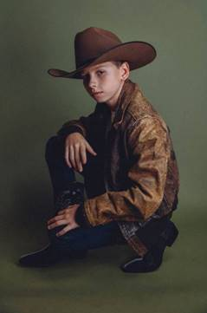

* * *

**MEDIA CONTACTS:**

Jason Davis, Atlantic Records (National) - [Jason.Davis@atlanticrecords.com](mailto:Jason.Davis@atlanticrecords.com)

Andrew George, Atlantic Records (Tour/Online) - [andrew.george@atlanticrecords.com](mailto:andrew.george@atlanticrecords.com)

Jensen Sussman, Sweet Talk Publicity - [jensen@sweettalkpr.com](mailto:jensen@sweettalkpr.com)

Julianne Cassidy, Sweet Talk Publicity - [jcassidy@sweettalkpr.com](mailto:jcassidy@sweettalkpr.com)

# # #