**MASON RAMSEY UNVEILS FALL LEG OF HEADLINE**

**HOW’S UR GIRL & HOW’S UR FAMILY PT.2 LAUNCHING OCTOBER 3**

**PRESALE TICKETS AVAILABLE APRIL 30;**

**GENERAL ONSALE BEGINS MAY 3**

**EPIC TOUR SCHEDULE ALSO INCLUDES ARRAY OF NORTH AMERICAN FESTIVALS~~,~~** **INCLUDING NASHVILLE’S CMA FEST 2019 JUNE 6-9**

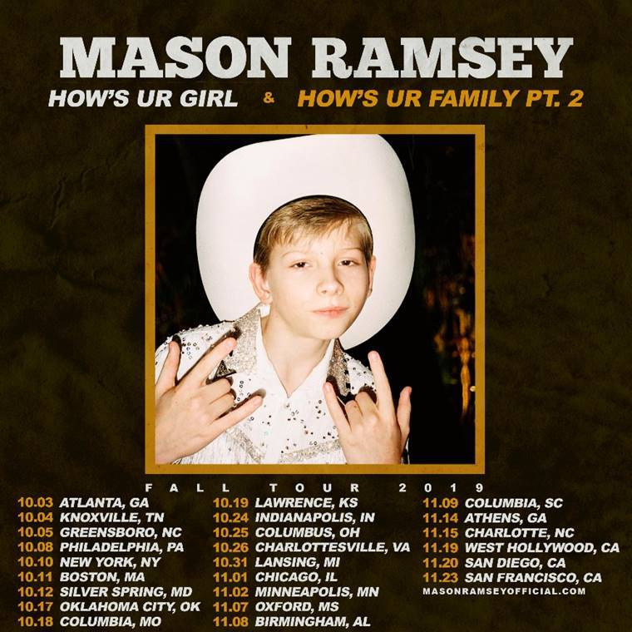

**NEW YORK, NY** (April 29, 2019) —12-year-old rising Country superstar **MASON RAMSEY** has unveiled dates for the fall leg of his headlining HOW’S UR GIRL & HOW’S UR FAMILY PT.2.Just capping the first sold-out run this past Saturday (3/27), his buzzworthy trek recently splashed across headlines after the larger-than-life entertainer crowd-surfed during an at-capacity show in Nashville, TN, while riding an inflatable horse float. Watch *Good Morning America*’s mention [here](http://mms.tveyes.com/MediaCenterPlayer.aspx?u=aHR0cDovL21lZGlhY2VudGVyLnR2ZXllcy5jb20vZG93bmxvYWRnYXRld2F5LmFzcHg%2FVXNlcklEPTUzNjk3NCZNRElEPTExNDc2MzkzJk1EU2VlZD0zNTE3JlR5cGU9TWVkaWE%3D).

The new dates get underway on October 3 at Variety Playhouse in Atlanta, GA, and continue through late November. Ramsey’s fan community and Spotify presales begin April 30 at 10 a.m. (local time) with all local presales beginning May 1 at 10a.m. (local time). General public onsale starts May 3 at 10 a.m. (local time). For complete details, please visit [masonramseyofficial.com/tour](https://masonramseyofficial.com/tour).

Hailed as radiating “stage presence and confidence of performers two or three times his age” by the [*Lincoln Journal Star*](https://journalstar.com/blogs/ground-zero/year-old-country-singer-mason-ramsey-impresses-at-bourbon-theatre/article_4daee3a2-5e66-11e9-ac49-3b74cd29b9df.html)*,* Ramsey is set for an array of festival appearances through the summer, including CMA Fest 2019 (June 9 – Chevy Riverfront Stage – Nashville, TN), Country Boom Music Festival (July 12 – La Crosse, WI), Big Sky Music Festival (July 20– Oro-Medonte, Ontario, Canada), Tailgate N’ Tallboys (September 14 – Peoria, IL), and Hometown Rising Country Music & Bourbon Festival (September 14-15– Louisville, KY). As if all that weren’t enough, the “genuine talent” ([*The Tennessean*](https://www.tennessean.com/story/entertainment/music/2019/04/24/mason-ramsey-crowd-surfs-inflatable-horse-nashville-concert/3500442002/)) will team up with **ELI YOUNG BAND** for a special double bill at Sweetwater Performance Pavilion in Fort Wayne, IN, on July 13. For updates and ticket availability, please visit [masonramseyofficial.com/tour](https://masonramseyofficial.com/tour).

The *HOW’S UR GIRL & HOW’S UR FAMILY PT.2* follows last year’s historic special guest role on **FLORIDA GEORGIA LINE**’s  *LIVE FROM LAS VEGAS*, officially marking Ramsey as the youngest artist ever billed to a Las Vegas residency. He also pumped up his stage presence serving as direct support for his labelmate CHRIS LANE.

Named last year as one of *Billboard*’s [“21 Under 21”](https://www.billboard.com/photos/8478197/2018-21-under-21-shawn-mendes-lil-pump-billie-eilish-list), Ramsey earned more than 45 million worldwide streams for his 2018 breakout [*FAMOUS*](https://masonramsey.lnk.to/FamousAW)*EP*, with [*The New York Times*](https://www.nytimes.com/2018/07/20/arts/music/playlist-zayn-chance-the-rapper-billie-eilish.html) hailing the collection as “a stylistically diverse country and roots music EP.” Additional praise came from [*PAPER Magazine*](http://www.papermag.com/mason-ramsey-break-the-internet-2623194268.html?rebelltitem=18#rebelltitem18), noting, “(Mason Ramsey) continues to steal the spotlight thanks to his loveable spirit – and his musical genuine musical chops.” [*FAMOUS*](https://masonramsey.lnk.to/FamousAW) is available now via Big Loud Records/Atlantic Records at all DSPs and streaming services.

Ramsey – a *Social Star Award* nominee at the 2019 iHeartRadio Awards – is currently among the finalists vying for the 11th Annual Shorty Awards’ *Influencer: Music* honors, among worldwide superstars like **BLACKPINK**, **HARRY STYLES**, **JANELLE MONAE**, **KACEY MUSGRAVES**, and **POST MALONE**. Winners will be announced on May 5 in New York City. For more details, please visit <https://shortyawards.com/11th/masonramsey>.

2018 not only saw Ramsey make his Grand Ole Opry debut, but the year included appearances at such major music festivals as CMA Fest, iHeartCountry Festival, Stagecoach, and Coachella as well. In addition, Ramsey opened the 52nd Annual CMA Awards alongside **BRAD PAISLEY** and **CARRIE UNDERWOOD** and appeared at the 2018 CCMA Awards alongside **SHANIA TWAIN**. Additional TV appearances included the 2018 Teen Choice Awards, 2018 Radio Disney Music Awards, ABC’s *Good Morning America*, the nationally syndicated *Ellen DeGeneres Show*, NBC’s *TODAY* and MTV’s *TRL*.

**CONNECT WITH MASON RAMSEY**

[OFFICIAL](http://www.masonramseyofficial.com/) I [FACEBOOK](http://www.facebook.com/theMasonRamsey) I [TWITTER](https://twitter.com/masonramsey) I [INSTAGRAM](http://www.instagram.com/lilhankwilliams)

**MASON RAMSEY**

***HOW’S UR GIRL & HOW’S UR FAMILY PT.2***

**JUNE**

9 – Nashville, TN – CMA Fest (Chevy Riverfront Stage) *

**JULY**

12 – La Crosse, WI – Country Boom Music Festival *

13 – Fort Wayne, IN – Sweetwater Performance Pavilion †

20 – Oro-Medonte, Ontario, Canada – Big Sky Music Festival *

**SEPTEMBER**

14 – Peoria, IL – Tailgate N’ Tallboys *

15 – Louisville, KY – Hometown Rising Country Music & Bourbon Festival *

**OCTOBER**

3 – Atlanta, GA – Variety Playhouse

4 – Knoxville, TN – Cotton Eyed Joe

5 – Greensboro, NC – Cone Denim Entertainment Center

8 – Philadelphia, PA – The Foundry

10 – New York, NY – The Gramercy Theatre

11 – Boston, MA – Brighton Music Hall

12 – Silver Spring, MD – The Fillmore

17 – Oklahoma City, OK – Tower Theatre

18 – Columbia, MO – Blue Note

19 – Lawrence, KS – The Granada Theater

24 – Indianapolis, IN – Deluxe at Old National Centre

25 – Columbus, OH – Newport Music Hall

26 – Charlottesville, VA – Jefferson Theatre

31 – Lansing, MI – The Loft

**NOVEMBER**

1 – Chicago, IL – Joe's on Weed Street

2 – Minneapolis, MN – Fine Line Music Cafe

7 – Oxford, MS – The Lyric Oxford

8 – Birmingham, AL – Iron City

9 – Columbia, SC – The Senate

14 – Athens, GA – Georgia Theatre

15 – Charlotte, NC – Coyote Joe’s

19 – West Hollywood, CA – The Roxy

20 – San Diego, CA – House of Blues

23 – San Francisco, CA – Great American Music Hall

* FESTIVAL APPEARANCE

† w/Eli Young Band

# # #

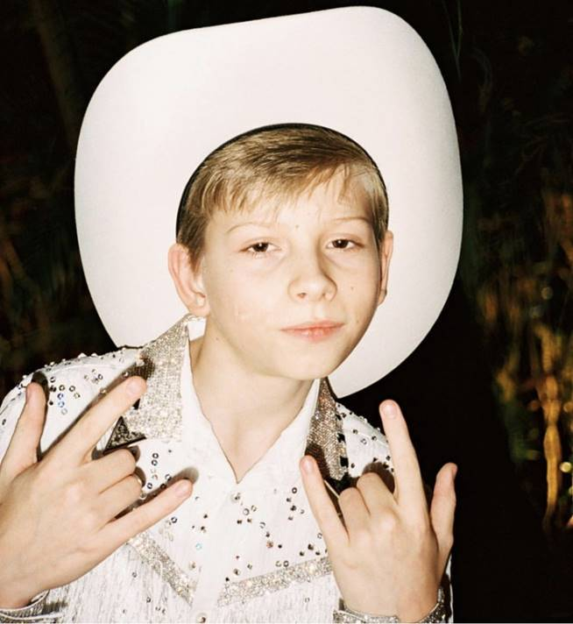

*Photo Credit: Sam Damesheck*

**MEDIA CONTACTS:**

Jason Davis, Atlantic Records (National)

[Jason.Davis@atlanticrecords.com](mailto:Jason.Davis@atlanticrecords.com)

Andrew George, Atlantic Records (Tour/Online)

[andrew.george@atlanticrecords.com](mailto:andrew.george@atlanticrecords.com)

Jensen Sussman, Sweet Talk Publicity

[jensen@sweettalkpr.com](mailto:jensen@sweettalkpr.com)

Julianne Cassidy, Sweet Talk Publicity

[jcassidy@sweettalkpr.com](mailto:jcassidy@sweettalkpr.com)