FOR IMMEDIATE RELEASE
SEPTEMBER 6, 2019

MELANIE MARTINEZ UNVEILS “K-12”

MULTI-TALENTED POP PHENOMENON’S EAGERLY AWAITED NEW ALBUM & FEATURE FILM OUT NOW

WATCH K-12 THE FILM HERE
LISTEN TO “K-12” THE ALBUM HERE

PERFORMANCE ON ABC’S JIMMY KIMMEL LIVE! OUTDOOR STAGE SET FOR MONDAY, SEPTEMBER 16TH

“THE K-12 TOUR” TO PRESENT UNIQUE THEATRICAL PERFORMANCES AROUND THE WORLD

NORTH AMERICAN DATES GET UNDERWAY OCTOBER 13TH IN WASHINGTON, D.C.
EUROPEAN RUN BEGINS DECEMBER 2ND IN DUBLIN, IRELAND

U.S. TOUR TO BENEFIT THE TREVOR PROJECT



Atlantic Records is proud to announce today’s release of “K-12,” the hugely anticipated new album and accompanying full-length film from Melanie Martinez. “K-12” is available now at all music retailers and streaming services.

“K-12” marks Martinez’s long anticipated follow-up to her RIAA platinum certified, 2015 debut album, “CRY BABY.” Produced by Michael Keenan with the exception of one song produced by Kinetics & One Love, the album serves as a soundtrack companion to an eerily enchanting new musical film, written, directed, and starring Martinez. K-12 is streaming now at DSPs as well as Melanie Martinez’s official YouTube channel. The film is also available on iTunes, Amazon, Amazon Prime, Google Play, Fandango Now, Vudu US, Comcast cable, Cox cable, Microsoft Store US, and Stingray/Qello.

K-12 had its official world premiere with events held earlier this week at Hollywood’s famed Arclight Cinerama Dome and New York City’s AMC Empire 25 in Times Square, with both premieres officially sold out within 24 hours of their announcement. Martinez made a spectacular entrance on both coasts, arriving at the premiere in the distinctive pink school bus prominently featured in the film. In addition, customized K-12 school busses will be traveling across the country selling exclusive merch in 15 cities from September 6th to September 16th fueled by Hot Topic. For complete details, please see hottopic.com.

Last night K-12 was shown in cinemas as a one-night-only global event with over 425 screenings around the world. Presented by preeminent global theatrical distributor Abramorama, K-12 screened in over 32 countries internationally, including the United Kingdom, Australia, Canada, Spain, Mexico, Brazil, New Zealand, Ireland, Argentina and Turkey to name but a few.

Visual expression has always been incredibly important to Melanie who has said she can’t finish a song unless she can see a full music video ahead. In 2014, Martinez posted the official music video for “Dollhouse,” off her debut album “Cry Baby.” She then went on to release 12 more music videos – all but one self-directed – for the tracks on the album between 2014-2017 that have collectively amassed over 1 billion views. YouTube and YouTube Music continue to be a critical vehicle for Melanie to authentically create and share her aesthetic and build deep connections with her global fan base of nearly 8 million subscribers. This combination makes YouTube a perfect home for K-12, a visually expressive work of art meant to be shared with the world. In the coming weeks, to bring fans even closer to the film, Melanie’s YouTube channel will feature new videos showcasing her creative process, behind-the-scenes stories and more.

“Melanie Martinez has put her life into K-12” added Julie Greenwald, COO of Atlantic Records, “that’s why we knew we needed to work with YouTube and YouTube Music to share this visual masterpiece with her global fanbase. The film and album, combined with much more content on her YouTube channel in the coming months, will be an ongoing invitation to the visually enticing K-12 world Melanie created.”

Martinez will further introduce “K-12” to the world with an eagerly awaited performance on ABC’s Jimmy Kimmel Live!, set for Monday, September 16th (check local listings). Additional high-profile media appearances include an in-depth interview with Apple Music’s Zane Lowe on Beats 1, airing Monday, September 9th.

Widely applauded for her remarkably creative live performances, Martinez will celebrate “K-12” by presenting a unique theatrical production on a major world tour. “The K-12 Tour” gets underway October 13th at Washington, D.C.’s All Things Go Fall Classic and then travels North America through late November; European dates follow, beginning December 2nd at Dublin, Ireland’s Olympia Theatre and then continuing through mid-December. Support throughout the North American run comes from Lauren Ruth Ward; with support from Naaz on the European run. For complete details and additional information, please see melaniemartinezmusic.com.

“The K-12 Tour” is presented in partnership with PLUS1, with $1 from every ticket sold going to support organizations bringing dignity, equity, and access to communities who need it. In the U.S., $1 per ticket sold will benefit The Trevor Project and their work providing crisis intervention and suicide prevention services for LGBTQ youth. For more information, please visit www.plus1.org.

DOWNLOAD PRESS MATERIALS HERE

# # #

ABOUT PLUS1
PLUS1 is an initiative that channels the collective energy of a concert to catalyze social change. By partnering with performing artists, PLUS1 raises and grants millions of dollars to high impact nonprofits addressing our most serious global challenges around Access, Equity, and Dignity. The work begins with a $1 per ticket add-on that makes fundraising simple and seamless. Beyond the dollar, PLUS1 supports artists as educators and advocates, fueling their passion, reach, impact. To date, PLUS1 has raised and granted over $7 million, and served as the connective tissue between over 100 artists, millions of their fans, and 100s of leading social justice organizations tackling global injustice. For more information, please visit www.plus1.org.

MELANIE MARTINEZ
THE K-12 TOUR – NORTH AMERICA/EUROPE 2019
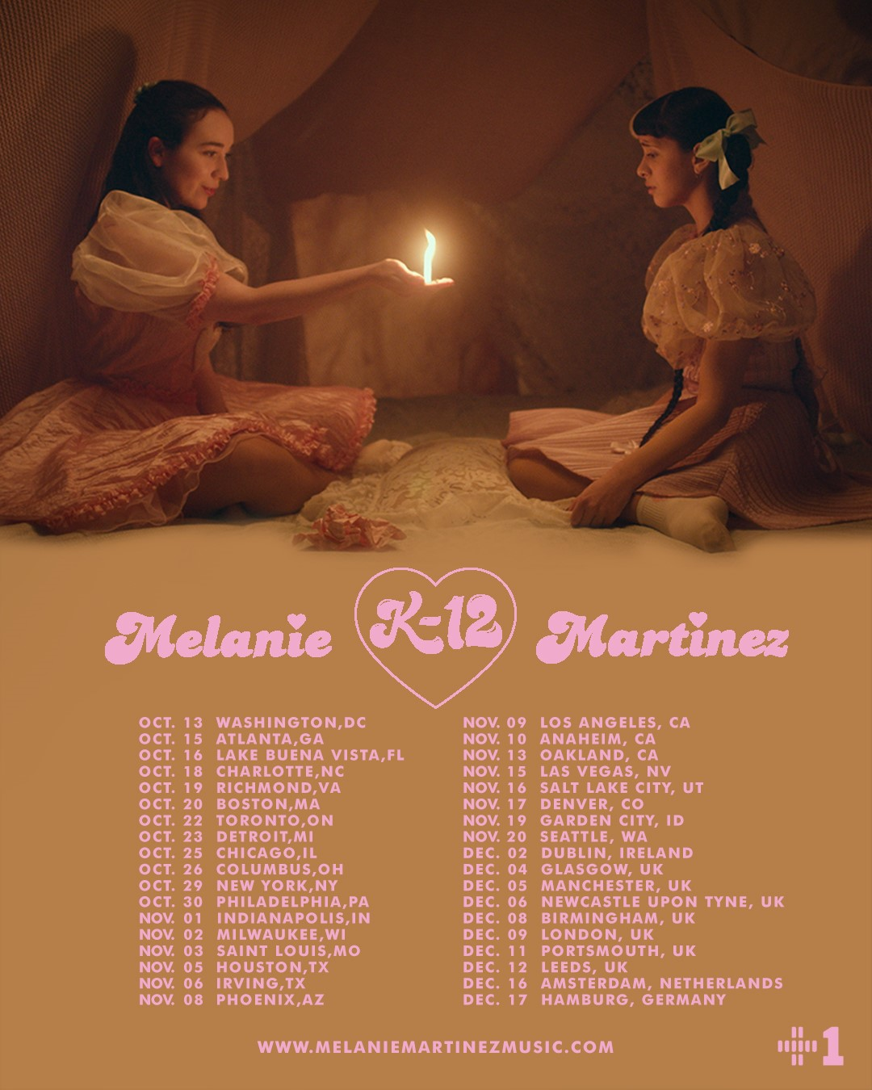

OCTOBER
13 Washington, DC All Things Go Fall Classic *
15 Atlanta, GA Coca-Cola Roxy
16 Lake Buena Vista, FL House of Blues Orlando
18 Charlotte, NC The Fillmore Charlotte
19 Richmond, VA The National
20 Boston, MA Orpheum Theatre
22 Toronto, ON Rebel
23 Detroit, MI The Fillmore Detroit
25 Chicago, IL Riviera Theatre
26 Columbus, OH Express Live!
29 New York, NY Manhattan Center Hammerstein Ballroom
30 Philadelphia, PA The Fillmore Philadelphia

NOVEMBER
1 Indianapolis, IN Murat Theatre
2 Milwaukee, WI The Eagles Ballroom
3 Saint Louis, MO The Pageant
5 Houston, TX Revention Music Center
6 Irving, TX The Pavilion at Toyota Music Factory
8 Phoenix, AZ The Van Buren
9 Los Angeles, CA Hollywood Palladium
10 Anaheim, CA House of Blues Anaheim
13 Oakland, CA Fox Theater
15 Las Vegas, NV The Pearl Concert Theater at Palms Casino Resort
16 Salt Lake City, UT The Union
17 Denver, CO Paramount Theatre
19 Garden City, ID The Revolution Center
20 Seattle, WA Paramount Theatre

DECEMBER
2 Dublin, IR Olympia Theatre
4 Glasgow, UK O2 Academy Glasgow
5 Manchester, UK O2 Apollo Manchester
6 Newcastle Upon Tyne, UK Newcastle City Hall
8 Birmingham, UK O2 Academy Birmingham
9 London, UK O2 Shepherd’s Bush Empire
11 Portsmouth, UK Guildhall
12 Leeds, UK O2 Academy Leeds
16 Amsterdam, NE Melkweg
17 Hamburg, DE Docks

* FESTIVAL PERFORMANCE
10/15-11/20 w/ Special Guest Lauren Ruth Ward

# # #

CONNECT WITH MELANIE MARTINEZ
OFFICIAL
INSTAGRAM
YOUTUBE
FACEBOOK
TWITTER

Contact Information:
Christina Kotsamanidis
212.707.2241
Christina.Kotsamanidis@atlanticrecords.com

