AVA MAX
DEBUTS ACOUSTIC VERSION FOR LATEST SINGLE
“MY HEAD & MY HEART”

WITH ACCOMPANYING VIDEO

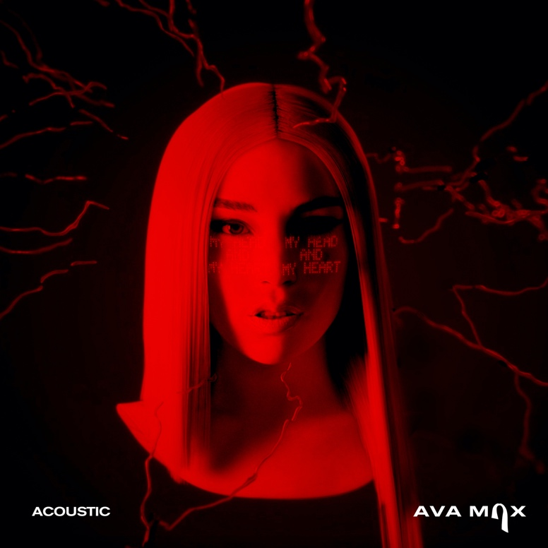

Pop sensation Ava Max debuts acoustic version and video for her latest single, “My Head & My Heart,” out now! The single recently entered the Top 40 at Pop Radio and is currently positioned at #20.

Watch “My Head & My Heart” Acoustic Video HERE
Listen to “My Head & My Heart” HERE

Her single “Kings & Queens” is currently #2 on the Hot AC Chart with over 848 Million streams globally. The smash hit “King’s & Queens” previously held #1 on the Hot AC chart for 7 straight weeks.

Ava Max is the daughter of Albanian immigrants and has grinded since grade school, exploding in the music world on a global scale with her 2018 triple-platinum smash “Sweet but Psycho.” Streamed over 2.1 billion times by 2020, the song clinched a spot in the Top 10 of the Billboard Hot 100 for three weeks. Ava Max only accelerated this rapid rise to pop superstardom with the gold-selling “So Am I” [806 Million Global Streams], “Salt” [1.5 Billion Global Streams], and “Kings & Queens” [678 Million Global Streams] and “Who’s Laughing Now” [225 Million Global Streams]. In the middle of this whirlwind, she pieced together her 2020 full-length debut album, Heaven & Hell.

“Ava Max Claims Her Throne on ‘Kings and Queens’” – Rolling Stone

‘Kings & Queens’ continues her brazen, loyal-little-monster updating of Gaga’s glitter” –
The New York Times

“Ava Max sheds her princess of pop title and crowns herself among elevated ‘Kings & Queens.’ This one has all the goods for delivering another home run with its great melody and solid, hook-driven pop appeal.” - Billboard

FOLLOW AVA MAX:
Website | Instagram | Facebook | Twitter | TikTok | YouTube | Spotify | Apple Music

PRESS CONTACTS:
DPR
Carleen Donovan
carleen@donovanpublicrelations.com
Amanda Brophy
amanda@donovanpublicrelations.com
Micaela Cohen
micaela@donovanpublicrelations.com

Atlantic Records
Andrew George
andrew.george@atlanticrecords.com

