FOR IMMEDIATE RELEASE
MARCH 4, 2016

MIIKE SNOW RAISE THE CURTAIN ON “iii”

SWEDISH/AMERICAN TRIO RETURN WITH LONG AWAITED THIRD ALBUM,
FEATURING ACCLAIMED SINGLE, “”GENGHIS KHAN,”

NORTH AMERICAN HEADLINE TOUR UNDERWAY NOW

HIGHLIGHTS INCLUDE HEADLINE DATES AND FESTIVAL APPEARANCES
AT COACHELLA, MOOGFEST, HANGOUT, BOSTON CALLING, GOVERNORS BALL, AND MORE

“iii” AVAILABLE EVERYWHERE TODAY

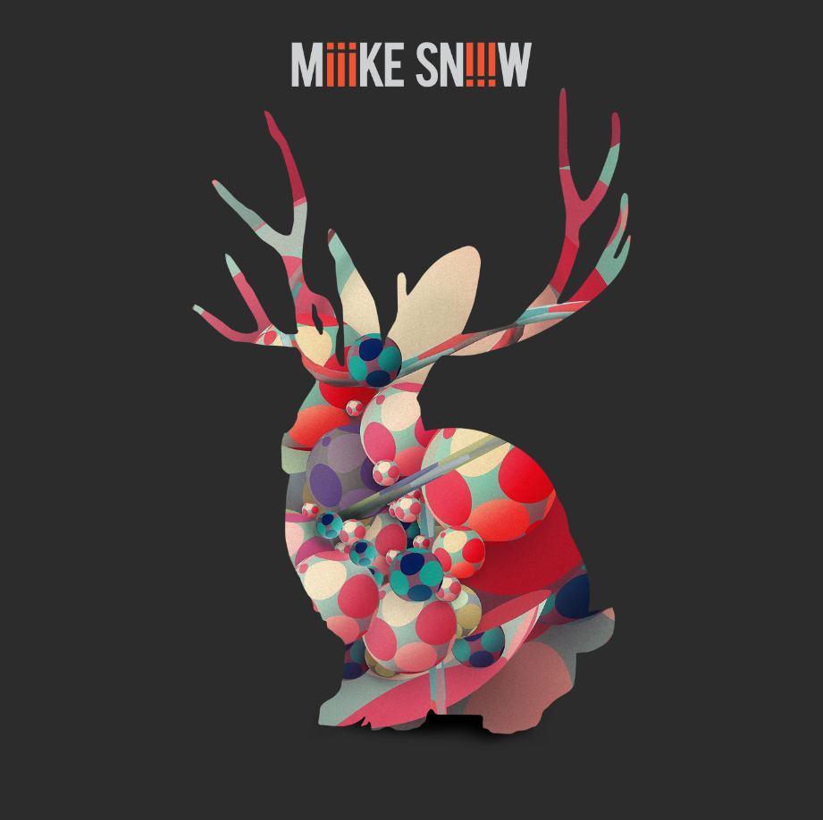
Downtown/Atlantic recording group Miike Snow has announced today’s release of iii. The band’s third studio album is available now in stores and at all online retailers. In addition, limited edition picture disc vinyl is available exclusively via Miike Snow’s official webstore.

Miike Snow is celebrating “iii” with a major North American headline tour, the Swedish/American trio’s first in more than three years. The dates – now almost completely sold out – began last night at New York’s Le Poisson Rouge and travel the continent before returning to the Big Apple for a performance at the annual Governor’s Ball NYC Music Festival on June 4th (see attached itinerary). The tour will make stops at a number of top music festivals, highlighted by a prominent Sunday slot at Indio, CA’s Coachella Valley Music and Arts Festival, slated for April 17th and 24th. Other upcoming festies include Miami, FL’s Ultra Music Festival (March 18th), Durham, NC’s Moogfest (May 19th), Gulf Shores, AL’s Hangout Music Festival (May 21st-22nd), Boston, MA’s Boston Calling (May 28th). For complete details and remaining ticket information, please see www.miikesnow.com.

Miike Snow made a major network TV appearance earlier this week, performing “Genghis Khan” and “Heart Is Full” on ABC’s Jimmy Kimmel Live! “At first, it seemed like (Miike Snow’s) take on ‘Heart’ would be a more subdued, acoustic affair,” wrote SPIN of the performance, “but they switched things up by infusing the track with a wild, funky blast of energy. It’s perhaps only topped by the addition of horns blasting to the wonky tune of ‘Genghis Khan.’”

“Genghis Khan” is currently spending its third consecutive week atop SiriusXM’s Alt Nation Alt 18 Countdown while also ascending the top 15 at Alternative outlets nationwide. The anthemic single – available now on the iTunes Store and all DSPs – is accompanied by a strikingly provocative companion video. Directed by Ninian Goff (Migos, Royal Blood, The Chemical Brothers), “Genghis Khan” has already drawn more than 2.5 million individual YouTube views as well as online attention from Buzzfeed, which declared the “campy, dance-filled clip” to be “delightfully out there.”

“Genghis Khan” has drawn euphoric critical attention, with Billboard commending the track as “more proof that (Miike Snow) are reinventing themselves yet again.” Exclaim.ca decreed “Genghis Khan” to be “a slinky electro-pop number in which bouncy beats anchor a simple arrangement of synth stabs and sexy, seductive falsetto melodies,” while SPIN saluted the track’s “crisp kick-snare-fill punch and sterling pianos,” declaring it “very much a return to form for the trio.” “A bright, funky reminder of Miike Snow's serious pop chops,” affirmed Rolling Stone in an exclusive interview with the trio’s Andrew Wyatt, whileNoisey hailed “Genghis Khan” for its “booming synth hits, and a melt of different vocals layering over each other, making the track another certified banger.”

“iii” also includes the acclaimed track, “Heart Is Full,” which drew copious acclaim upon its arrival last year. “A bold comeback track,” commended Consequence of Sound, “brimming with rich, soul samples, thundering beats, and larger-than-life melodies that’ll make you forget Miike Snow was ever gone to begin with.”“It’s a big, bold metropolitan pop track bolstered by a walloping boom-bap drum loop, blaring soul samples,” raved Stereogum while SPIN declared it to be “a bold, almost jazzy new track that’s a bit of a departure from the rest of (Miike Snow’s) music, though their signature, wintery vibes shine through in the chorus.”

“Heart Is Full” is joined by a compelling and dystopic companion video. The clip – directed by Lance Drake (Rob Roy, Twin Shadow) – premiered late last year via Miike Snow’s official Facebook page and is streaming now at the trio’s official YouTube channel. In addition, the extraordinary “Heart Is Full (Feat. Run The Jewels) [Remix]” premiered via The Fader, which praised the original track for its “pleading horns, chopped-up soul samples, and thick, DJ Premier-recalling drums” before commending “powerhouse rap duo Run The Jewels” for contributing “a pair of boom bap-friendly verses of their own. It's an unlikely combination, but a fitting one for the gritty love song.”

Formed in 2007 by Swedish musicians Christian Karlsson and Pontus Winnberg (a.k.a. production duo Bloodshy & Avant) and American singer/songwriter Andrew Wyatt, Miike Snow unveiled their self-titled debut album two years later, earning international acclaim for the distinctive fusion of plaintive pop songcraft and atmospheric electronics found on tracks like the breakthrough single, “Black & Blue.”

“HAPPY TO YOU” followed in 2012, drawing critical applause from such high profile outlets as Entertainment Weekly, which praised Miike Snow’s “meticulous sonic-palette landscapes,” noting, “The spirit of ‘HAPPY TO YOU’ is indie rock, but the sound is as addictively sharp as anything in the Top 40.”

The members of Miike Snow have spent much of time since traveling fresh creative avenues, including solo albums, the formation of new bands, and a wide variety of production and songwriting collaborations. The trio first began work on “iii” in late 2013 and then continued over the next two years, the far-flung members convening in studios in New York, Los Angeles, and Stockholm, oft times teaming with other songwriters and producers in search of new sonic and emotional approaches. The result is Miike Snow’s most innovative and creatively unified work thus far, typified by the propulsive pop soul of tracks like “For U (Feat. Charli XCX).”
For more, please see www.miikesnow.com, facebook.com/miikesnow, twitter.com/miikesnow, youtube.com/miikesnow, soundcloud.com/miikesnow, and www.atlanticrecords.com.

UPCOMING MIIKE SNOW TOUR DATES:
MARCH
March 3 New York, NY Le Poisson Rouge (SOLD OUT)
March 5 Philadelphia, PA Theatre of The Living Arts (SOLD OUT)
March 9 Washington, DC 9:30 Club
March 11 Atlanta, GA Buckhead Theatre
March 12 New Orleans, LA Buku Music & Art Project
March 13 Houston, TX House of Blues
March 15 Dallas, TX Granada Theater
March 18 – 20 Miami, FL Ultra Music Festival

APRIL
April 9 Vancouver, BC Commodore Ballroom (SOLD OUT)
April 10 Seattle, WA The Showbox
April 11 Portland, OR Roseland Theater
April 13 San Francisco, CA The Independent (SOLD OUT)
April 14 San Francisco, CA The Independent (SOLD OUT)
April 16 Las Vegas, NV Boulevard Pool at The Cosmopolitan
April 17 Indio, CA Coachella
April 20 Los Angeles, CA The Fonda Theatre
April 21 Pioneertown, CA Pappy and Harriet’s
April 24 Indio, CA Coachella

MAY
May 20 Nashville, TN Marathon Music Works
May 20 - 23 Gulf Shores, AL Hangout Music Festival
May 23 St. Louis, MO The Pageant
May 24 Louisville, KY Headliners Music Hall
May 26 Columbus, OH Newport Music Hall
May 27 Pittsburgh, PA Mr. Smalls Theatre
May 30 Montreal, QC Metropolis
May 31 Toronto, ON Danforth Music Hall

JUNE
June 1 Toronto, ON Danforth Music Hall
June 2 Detroit, MI Majestic Theatre
June 3 - 5 New York, NY Governors Ball Music Festival

