**MIIKE SNOW PREMIERE “GENGHIS KHAN” EMPRESS OF REMIX –**[**LISTEN NOW**](https://soundcloud.com/miikesnow/miike-snow-ghengis-khan-empress-of-remix)

**5 TRACK “GENGHIS KHAN” REMIX PACKAGE OUT JANUARY 29**

**NEW ALBUM iii OUT MARCH 4**

*“…this remix comes laced with a sense of fervor and urgency. If* [*the original track*](https://youtu.be/8uHoww0gpyc)*’s swift grooves weren’t enough to elicit a little hip shakin, surely Empress Of’s take will help pack dance floors worldwide, one accentuated, determined beat at a time.” -*  [Consequence of Sound](http://consequenceofsound.net/2016/01/empress-of-remixes-miike-snows-genghis-khan-listen/)

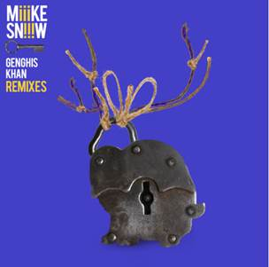

[Miike](http://press.wearebigbeat.com/artists/cashcash/) Snow will release a new remix bundle for their lead single “Genghis Khan,” available via all digital retailers on January 29th.The package features official remixes from **Empress Of**, **Louis The Child, Hook N Sling**, **CID** and **Yacht Club**.

The package launches today with **Empress Of’**s big room remix, which [Consequence of Sound](http://consequenceofsound.net/2016/01/empress-of-remixes-miike-snows-genghis-khan-listen/)predicts the remix will “help pack dance floors worldwide, one accentuated, determined beat at a time.” The band will continue to roll out the remaining remixes throughout the month. In more news, the band will hit the desert to perform at Coachella’s annual music festival this year.

Miike Snow’s third studio album,*iii*, is available for pre-order now and is accompanied by a trio of instant grat downloads: “Genghis Khan,”  “Heart Is Full,” and Run The Jewels remix of “Heart Is Full” (pre-order here:<http://smarturl.it/MiikeSnowiii>).  Watch the cinematic video for “Heart Is Full” here: <https://www.youtube.com/watch?v=EWJHK0JT_Xc>

Stay tuned…more news to come soon!