FOR IMMEDIATE RELEASE
FEBRUARY 1, 2022

MISSY ELLIOTT MAKES HISTORY ONCE AGAIN

2005’S THE COOKBOOK RECEIVES RIAA PLATINUM CERTIFICATION,
AFFIRMING ELLIOTT AMONG OTHER FEMALE RAPPERS AS THE ONLY ONE EVER
TO EARN PLATINUM OR BETTER FOR SIX OR MORE STUDIO ALBUMS

AS A THANK YOU TO FANS MISSY ELLIOTT RELEASES
LIMITED NUMBER OF THE COOKBOOK AS ORIGINAL VINYL DOUBLE LPs TODAY
VIA THE ATLANTIC RECORDS WEB STORE
AVAILABLE HERE

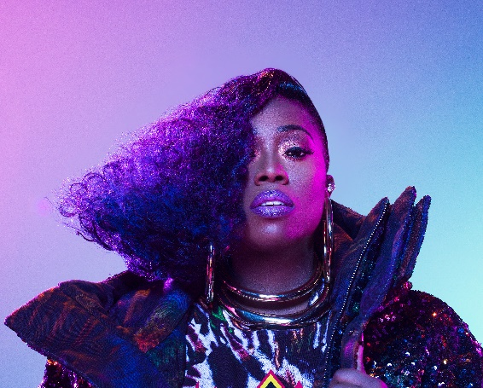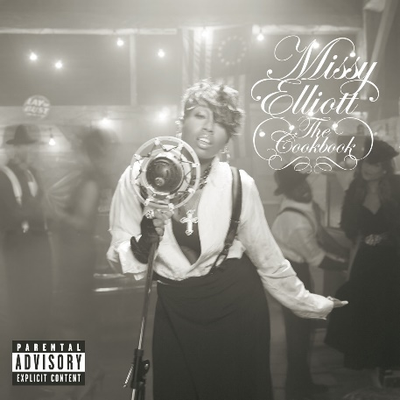
Download press shots HERE | Download The Cookbook cover art HERE
GRAMMY® Award-winning icon Missy Elliott has made musical history once again with the RIAA platinum certification of 2005’s GRAMMY®-nominated THE COOKBOOK – her sixth platinum certified album to date, marking her among other female rappers as the only one ever to achieve that remarkable accomplishment. With this certification, all of Elliott’s six classic studio albums have now been certified RIAA platinum certified or better. To celebrate the album’s platinum certification and as a thank you to fans, Missy Elliott has released a limited number of The Cookbook as original vinyl double LPs today via the Atlantic Records webstore, available HERE.

Missy’s sixth studio album, THE COOKBOOK made a #1 debut atop Billboard’s “Top Rap Albums” and “Top R&B/Hip-Hop Albums” charts upon its July 4th, 2005 release, fueled in part by such hits as the GRAMMY® Award-winning global smash, “Lose Control (Feat. Ciara & Fatman Scoop)” and the GRAMMY®-nominated “We Run This.” Hailed by The Guardian as “unique and startling and formidable as ever,” the album earned Elliott a GRAMMY® Award nomination for “Best Rap Album” – her fourth nod in that category over six career LPs.

One of the most significant female artists in contemporary music history, Missy Elliott is an avant-garde solo superstar, pioneering songwriter-producer, and across-the-board cultural icon. The four-time GRAMMY® Award winner has attained unprecedented success, including 22 GRAMMY® nominations spanning three decades, eight MTV Video Music Awards, and sales now exceeding 30 million in the U.S. alone.

Elliott’s most recent work, 2019’s acclaimed EP, ICONOLOGY, drew instant applause upon its surprise release, with USA Today declaring it “a master class at the school of Missy Misdemeanor Elliott…The project brings back the Missy fans know and love, with booming bass beats that are the perfect backdrop to showcase her lyrical prowess.” The EP includes the hit singles “Throw It Back,” “DripDemeanor (Feat. Sum1),” and the aforementioned “Why I Still Love You,” all of which are joined by spectacular companion visuals streaming now via YouTube.

That same year saw the iconic Elliott making history as the first female rapper ever to receive the MTV Video Music Awards’ prestigious Michael Jackson Video Vanguard Award. 2019 also saw her break new ground as the first female hip-hop artist and third-ever rapper to be inducted into the Songwriters Hall of Fame. In addition, Elliott became the first female rapper to receive an honorary Doctor of Music degree from Berklee College of Music, celebrating her lasting contributions to music and popular culture. Further accolades followed in 2021, with Elliott named among the twelve inaugural inductees for the new Atlanta landmark, The Black Music & Entertainment Walk of Fame, and later honored with her own star on the world famous Hollywood Walk of Fame.

CONNECT WITH MISSY ELLIOTT
OFFICIAL | TWITTER | INSTAGRAM | YOUTUBE | FACEBOOK

Please visit Missy Elliott’s press site for additional assets HERE

PRESS CONTACT
Fairley McCaskill | Fairley.McCaskill@atlanticrecords.com

