GOLD-CERTIFIED SINGER-SONGWRITER MATT MAESON BECOMES FIRST MALE SOLO ARTIST TO ACHIEVE TWO BILLBOARD #1 ALTERNATIVE HITS ON A DEBUT ALBUM, JOINING THE COMPANY OF ALANIS MORISSETTE (WITH JAGGED LITTLE PILL) AND BUSH (WITH SIXTEEN STONE) AS THE ONLY ARTISTS EVER TO ACHIEVE THIS FEAT
MATT ALSO BECOMES THE 5TH MALE SOLO ARTIST IN HISTORY WITH TWO BILLBOARD #1 ALT HITS TO HIS NAME AFTER BECK, MORRISSEY, ELVIS COSTELLO AND PETER GABRIEL; MATT IS THE ONLY MALE SOLO ARTIST TO ACHIEVE THIS FEAT ON ONE ALBUM
“HALLUCINOGENICS” JUMPS FROM #4 TO #1 AT ALTERNATIVE RADIO THIS WEEK
WATCH THE OFFICIAL MUSIC VIDEO HERE
FOLLOWING #1 RIAA-CERTIFIED GOLD SINGLE “CRINGE”
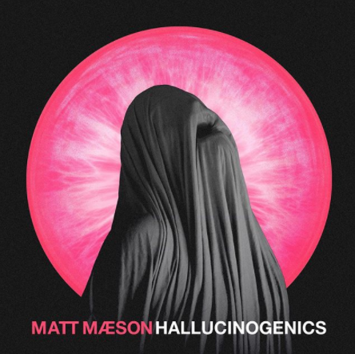
Acclaimed singer-songwriter Matt Maeson has achieved another Alternative Radio #1 hit with “Hallucinogenics,” taken from his 2019 debut album Bank On The Funeral. “Hallucinogenics” marks Maeson’s 2nd #1 at Alt Radio in 12 months, following his single “Cringe” that hit #1 this same week last year. Matt’s poignant new track “Giants” was recently released as part of Atlantic Records’ upcoming At Home With The Kids compilation in support of Save The Children. He has also been working on a new artist project, which will make its debut very soon.
2019 was a monumental year for Maeson, releasing his debut album Bank On The Funeral and receiving his first Alt Radio #1 and RIAA-Gold certification for “Cringe,” which spent four consecutive weeks at #1 on Billboard’s Alt Songs chart after a steady 25-week climb.
Matt Maeson’s extraordinary debut EP BANK ON THE FUNERAL – available now at all DSPs and streaming services HERE – earned wide-ranging critical applause upon its April 2019 release. “Maeson has been impressing the world with his dynamically emotional lyrics and equally powerful melodies with every song he releases,” raved Ones To Watch, “and BANK ON THE FUNERAL is no different. His authoritative voice commands the attention of anyone in earshot. Maeson strays on the lines between folk and alternative-pop, showcasing his diverse inspirations ranging from Johnny Cash to Kurt Cobain.”
Hailed by American Songwriter for “(creating) a sound unlike much else out there,” Matt Maeson has been on a remarkable journey all his life. The Chesapeake Bay, VA-native grew up on tour, traveling and performing with his parents’ prison ministry at maximum-security penitentiaries across America. His experiences – which include winning over crowds of naked women and Hells Angels at the world-famous Sturgis Motorcycle Rally in South Dakota – inspired him to begin writing songs, spare and powerful confessionals infused with additional strength via his raw, soulful vocal approach.
Maeson posted his first songs online in late 2015 and immediately drew attention as a major new songwriting voice. In summer 2016, Maeson embarked on his first US headline tour, presented by Communion, the influential artists’ collective co-founded by Mumford and Sons’ Ben Lovett and responsible for kickstarting the careers of such like-minded artists as Ben Howard, Michael Kiwanuka, and Catfish & The Bottlemen. Since then, Maeson has continued to live much of his life on the road, touring alongside artists like Jaymes Young, Bishop Briggs, and Vallis Alps while also lighting up on his own at such top festivals as Bonnaroo, Lollapalooza, Forecastle, and more.
CONNECT WITH MATT MAESON
MATTMAESON.COM | FACEBOOK | TWITTER | INSTAGRAM | NEON GOLD | PRESS SITE
Press contact: Corey.brewer@atlanticrecords.com

