LANA DEL REY AND MATT MAESON DUET ON HIS #1 ALTERNATIVE AND TRIPLE A RADIO SINGLE “HALLUCINOGENICS”
FOLLOWING A LIVE PERFORMANCE OF THE SONG LAST YEAR AT LANA’S OKLAHOMA CITY SHOW

WITH “HALLUCINOGENICS” HITTING #1 AT ALTERNATIVE FOR 3 CONSECUTIVE WEEKS EARLIER THIS MONTH, MATT MAESON JOINS ALANIS MORISSETTE AS ONLY THE 2ND SOLO ARTIST IN HISTORY TO ACHIEVE 2 BILLBOARD #1 ALT HITS ON A FULL-LENGTH DEBUT ALBUM

MATT ALSO BECOMES THE 5TH MALE SOLO ARTIST IN HISTORY WITH 2 BILLBOARD #1 ALT HITS TO HIS NAME; THE ONLY MALE SOLO ARTIST TO ACHIEVE THIS FEAT ON ONE ALBUM

LISTEN HERE: https://atlantic.lnk.to/HallucinogenicsFtLDR

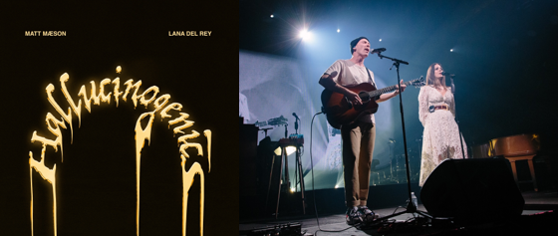
DL photos here

Last year, Lana Del Rey invited Matt Maeson to the stage at her headline show in Oklahoma City, and they performed a special version of Matt’s Alt Radio #1 “Hallucinogenics” together. A year later, they’re releasing a studio version of the haunting track. Listen HERE.

“Hallucinogenics” (taken from his 2019 debut album Bank On The Funeral) marks Matt’s 2nd Alternative Radio #1 hit, as he follows in the footsteps of Alanis Morrissette as only the second solo artist in history with 2 Billboard #1 Alternative hits on a full length debut album. “Hallucinogenics” follows his debut single “Cringe,” which hit #1 in the same week last year and spent four consecutive weeks at #1 on Billboard’s Alt Songs chart after a steady 25-week climb. "Hallucinogenics" remains in the Top 5 at alternative after three weeks at #1 and is currently #1 at AAA Radio for a second straight week, making this Matt's first multi-format number one.

Hailed by American Songwriter for “(creating) a sound unlike much else out there,” RIAA Gold-certified singer/songwriter Matt Maeson has been on a remarkable journey all his life. The Chesapeake Bay, VA-native grew up on tour, traveling and performing with his parents’ prison ministry at maximum-security penitentiaries across America. His experiences – which include winning over crowds of naked women and Hells Angels at the world-famous Sturgis Motorcycle Rally in South Dakota – inspired him to begin writing songs, spare and powerful confessionals infused with additional strength via his raw, soulful vocal approach. Maeson posted his first songs online in late 2015 and in summer 2016 embarked on his first US headline tour, presented by Communion, the influential artists’ collective co-founded by Mumford and Sons’ Ben Lovett and responsible for kickstarting the careers of such like-minded artists as Ben Howard, Michael Kiwanuka, and Catfish & The Bottlemen. Since then, Maeson has continued to live much of his life on the road, touring alongside artists like Jaymes Young, Bishop Briggs, and Vallis Alps while also lighting up his own headline tours and at such top festivals as Bonnaroo, Lollapalooza, Forecastle, and more.

CONNECT WITH MATT MAESON
MATTMAESON.COM | FACEBOOK | TWITTER | INSTAGRAM | NEON GOLD | PRESS SITE
Matt Maeson Press contact: Corey.brewer@atlanticrecords.com

