FOR IMMEDIATE RELEASE
OCTOBER 4, 2019

OLIVER TREE RECRUITS ZEDS DEAD FOR “MIRACLE MAN” REMIX

EPIC REWORK OF HIT SONG OFF OF TREE’S SOPHMORE EP DO YOU FEEL ME?

GOODBYE, FAREWELL TOUR COMPLETELY SOLD OUT
IN MAJOR MARKETS INCLUDING ATLANTA, NEW YORK, BOSTON, CHICAGO, AND MORE

“MIRACLE MAN” [ZEDS DEAD REMIX] AVAILABLE NOW
http://olivertree.lnk.to/MiracleManZedsDeadPR
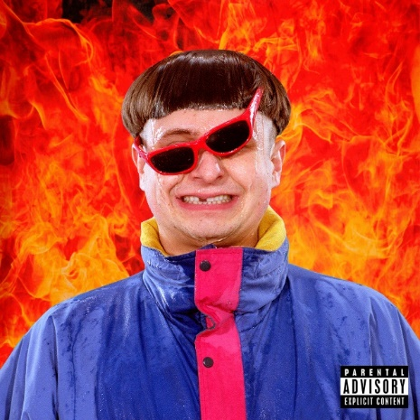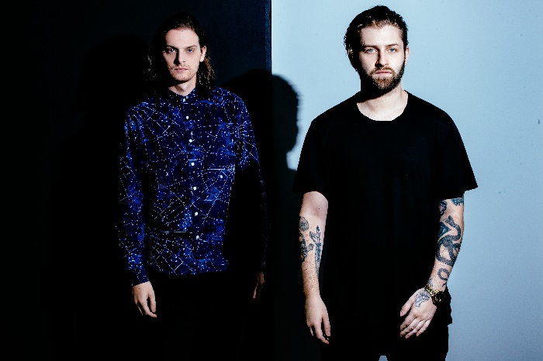
DOWNLOAD ARTWORK
DOWNLOAD ZEDS DEAD PRESS PHOTO

Genre-defying singer-songwriter-producer-professional scooter rider Oliver Tree has teamed up with electronic duo Zeds Dead for an epic remix of Oliver’s hit song “Miracle Man” – now available at all DSPs and streaming services HERE.

“Miracle Man” was an immediate fan favorite off Tree’s acclaimed sophomore EP - DO YOU FEEL ME? - available now at all DSPs and streaming services HERE. DO YOU FEEL ME? also features Tree’s breakthrough hit singles “Hurt,” and “Alien Boy.” The EP was instantly met with praise with Zane Lowe declaring the project a “strong new sound from the Bowled Wonder himself.”

“Miracle Man” is accompanied by an eye-catching companion visual, streaming now at Oliver’s official YouTube channel HERE. The song has a catchy beat, a killer guitar on the chorus, and key vocals from Oliver Tree that twist this track into an honest, and angry rant about someone who didn’t try hard enough and messed up their life. Perhaps Alternative Press said it best: “This song is everything.”
Hailed by Billboard as “alt-pop’s merry prankster,” Oliver recently unveiled plans for a landmark headline tour, with dates in all major markets selling out. The “Goodbye, Farewell Tour” kicked off September 13th at Vancouver, BC’s Commodore Ballroom and will continue on to multiple stops around Europe throughout November. Highlights include stops at such legendary venues as New York City’s newly revived Webster Hall (October 25th), and Austin City Limits (October 4th). For complete details and remaining ticket availability, please visit olivertreemusic.com.

A multitalented vocalist and producer, as well as creative director of all of his inspired audiovisual projects, Oliver Tree is among the most category-defying artists of this or any other generation. Indeed, The Huffington Post has applauded his work as “an enigma of genre. While (Tree is) primarily a pianist, guitarist and producer, his real-instruments-based-production incorporates rap, male and female vocal harmonies, poetic lyrics, strings and a hearty dose of synth…as much philosopher as musician, and a big dreamer at that, (Tree’s) goal is to push the art form forward, and beyond the electronic scene, he aims to have his work reach the world and in doing so, better his listeners’ lives.”

ABOUT ZEDS DEAD
Toronto-based electronic music act Zeds Dead -- named after a line from Quentin Tarantino's 1994 film Pulp Fiction -- are a production duo consisting of DC (Dylan Mamid) and Hooks (Zachary Rapp-Rovan). The two first formed the hip-hop-oriented Mass Productions in 2004 and released an independent album, Fresh Beetz, three years later. They switched to Zeds Dead in 2009, embracing house and the direct, physical side of dubstep. Their debut song, the All Seeing I-sampling "Journey of a Lifetime," arrived in 2009. It would be the first of many downloadable releases made available for free. The track was quickly followed by more free downloads, as well as a remix of Barletta's "Panther."

Throughout 2010 and 2011, they were increasingly active. They released material on a number of labels, including Kissy Sell Out's San City High, Steve Aoki's Dim Mak, and Diplo's Mad Decent; remixed tracks by Blue Foundation and the Electric; and they also toured extensively throughout the U.S. Their first release of 2012 was Adrenaline, an EP issued on Inspected that balanced blitzing dubstep tracks with lower-key breakbeat workouts. The Living Dead (Ultra) arrived months later, before a trio of Mad Decent EPs followed each subsequent year: Victor (2012), Hot Sauce (2013), and Somewhere Else (2014). The latter featured appearances by Twin Shadow and Perry Farrell and entered the Billboard 200. The duo's debut LP arrived in late 2016. Released on their own Deadbeats label, Northern Lights included collaborations with Diplo, Pusha T, Weezer's Rivers Cuomo, Jadakiss, Styles P, and more. Following the release of their long awaited debut album, Zeds Dead have continued to surprise old fans and gain new ones with a series of collaborations with Illenium, Jauz, Ganja White Night, Delta Heavy, 1000volts (Redman & Jayceeoh), Dion Timmer, Droeloe and Snails. This new track comes right in the heart of Zeds Dead's 3rd Annual Deadbeats North American and European tour which wraps up at the end of 2019 in Chicago with two nights at the Aragon Ballroom.

CONNECT WITH OLIVER TREE:
OFFICIAL WEBSITE | TWITTER | INSTAGRAM | FACEBOOK | SOUNDCLOUD

