OLIVER TREE TAPS DILLON FRANCIS AND GRANDSON FOR FRESH DANCE REMIX OF “CASH MACHINE”

DEBUT NO. 1 ALBUM ‘UGLY IS BEAUTIFUL’ OUT NOW ON ATLANTIC RECORDS

LISTEN TO “CASH MACHINE” (REMIX) [FEAT. DILLON FRANCIS & GRANDSON]:
https://olivertree.lnk.to/CashMachineRemixPR

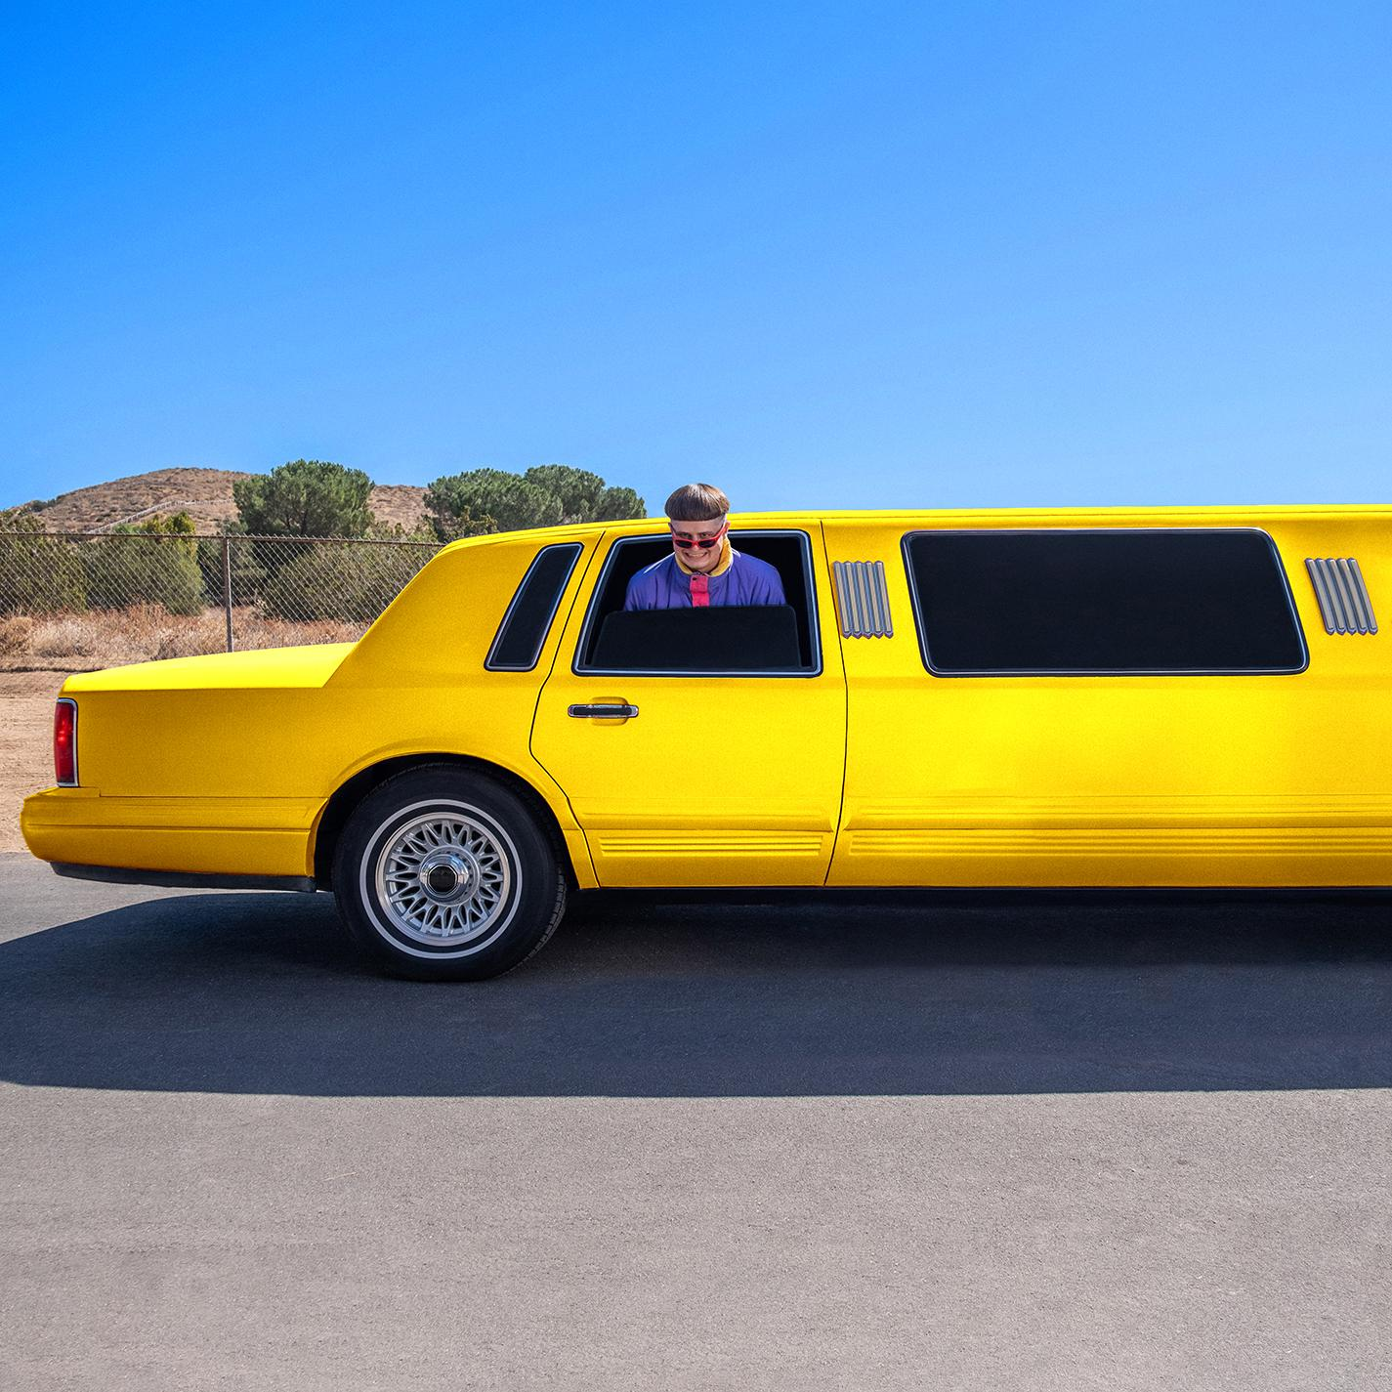

Oliver Tree’s “Cash Machine” is a highlight off his debut album ‘Ugly is Beautiful’ with over 50 million streams to date. Today, thanks to DJ and producer Dillon Francis and Canadian singer grandson, we get to hear a newly energized take on the track, trading acoustic strums for electric power chords - and a signature Francis drop, assisted by grandson’s "new wave nostalgia” grit. Listen: https://olivertree.lnk.to/CashMachineRemixPR

Earlier this summer, Tree’s album ‘Ugly is Beautiful’ debuted at the #1 spot on Billboard’s Top Rock Albums Chart and Alternative Albums Chart, and now he continues to spread his bowl-cut gospel.

Most recently he traveled to Australia to face off against the 3x Gold-winning X-Games scooter competitor R-Willy, gave a tour of his fridge for Complex's First We Feast, was featured in Vogue for his go-to pant - the JNCO jeans - talked to Billboard about his favorite scooters, and Esquire: “If you're at all familiar with the genre-less/maybe a rapper? scene (think: Tyler, the Creator, or anyone from his OFWGKTA crew), you know the name Oliver Tree.”

Not only did he break the Guinness World Record for building the world’s largest kick-scooter (which he crashed), Tree also partnered up with his 90’s punk heroes blink-182 for a rework of his song “Let Me Down,” which debuted at #24 on Billboard’s Hot Alternative Songs Chart. He also entered a screaming match with The Needle Drop’s Anthony Fantano on Twitch, and he was called “dense and unappetizing, like a Twinkie squashed under hot car cushions for weeks” by Pitchfork in a deliciously scathing review.
PRAISE FOR ‘UGLY IS BEAUTIFUL’
“Injecting humour into everything he does while offering a surrealist escape from the mundane everyday – it’s easy to see how Tree’s outlandishness has made him the digital age’s definitive rockstar.”
-NME

“With ‘Ugly is Beautiful’...the Gen-Z jester has declared his arrival onto the internet’s airwaves.”
-Interview

“The trickster laureate of pop's viral era…”
-MTV

“...somewhere between a meme and creative polymath.”
-HYPEBEAST

“‘Ugly is Beautiful’ is brimming with such nostalgia-inducing yet daring flashes of genius.”
-Ones To Watch

BUY/STREAM ‘UGLY IS BEAUTIFUL’
https://olivertree.lnk.to/UglyisBeautiful

MORE INFO ON OLIVER TREE
Website
Facebook
Twitter
Instagram

