FOR IMMEDIATE RELEASE
DECEMEBER 17, 2021

OLIVER TREE TEAMS UP WITH TRIPPIE REDD AND SKI MASK THE SLUMP GOD
FOR “LIFE GOES ON” REMIX

INTERNET SENSATION TAPS RIAA CERTIFIED RAPPERS FOR REWORK OF RUNAWAY HIT

ORIGINAL TRACK BOASTS OVER 500 MILLION STREAMS, NAMED TIKTOK’S #6 TOP GLOBAL TRACK OF 2021 + TOP 10 ON BILLBOARD’S HOT ROCK & ALTERNATIVE SONGS CHART

TREE NAMED #5 MOST VIEWED ARTIST ON TIKTOK IN 2021

OFFICIAL VIDEO RELEASED TODAY ON LYRICAL LEMONADE FEATURES ALL THREE SUPERSTAR ARTISTS AND WORLD-RENOWNED DJ DIPLO

TREE KICKS OFF LARGEST HEADLINING COWBOY TEARS TOUR IN FEBRUARY 2022
TICKETS ON SALE NOW HERE

LISTEN TO “LIFE GOES ON (FEAT. TRIPPIE REDD AND SKI MASK THE SLUMP GOD)” HERE
WATCH THE OFFICIAL VIDEO HERE
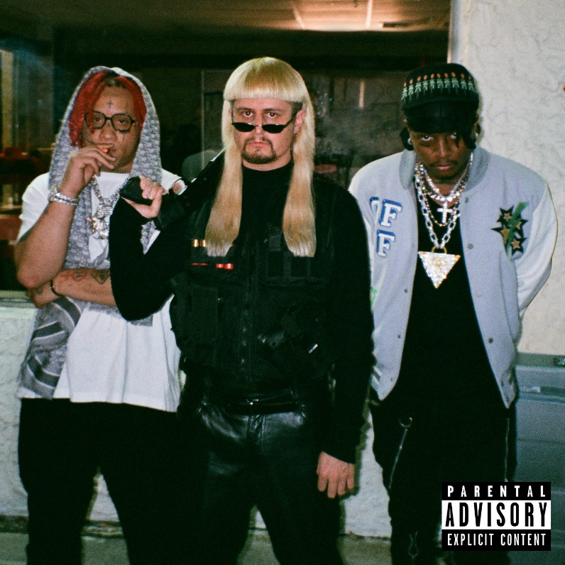
DOWNLOAD ARTWORK HERE

Chart-topping phenomenon Oliver Tree has recruited RIAA certified rappers Trippie Redd and Ski Mask The Slump God for a rework of his viral smash hit “Life Goes On” – listen to “Life Goes On (feat. Trippie Redd and Ski Mask The Slump God)” now HERE. The superstar remix arrives today with an official video featuring superstar DJ Diplo and directed by Cole Bennett of Lyrical Lemonade, streaming now HERE.

Recently joined by remixes from GRAMMY award winning trio Clean Bandit, platinum selling global superstar Ty Dolla $ign and Brazilian superstar ALOK and a stripped-back acoustic version, the original track was featured on the deluxe edition of Tree’s acclaimed debut album Ugly is Beautiful: Shorter, Thicker & Uglier. The viral track is making waves across all platforms. Currently boasting over 500 million streams, 150 million video views, 3 million Instagram reels and 3 million Shazams. With over 20 million TikTok videos created with the sound, “Life Goes On” has amassed over 30 billion TikTok views across all videos, landing it at TikTok’s #6 global track of 2021 and Oliver as the #5 most viewed artist on the platform.

Oliver recently announced his largest North American headline tour to date and last tour ever. The Cowboy Tears tour kicks off February 19, 2022 at Los Angeles, CA’s legendary venue, The Shrine Expo Hall, and continues through late March with support from RIAA certified singer/producer and viral phenomenon Sueco as well as 18-year-old Canadian DIY artist 347aidan. The acclaimed live performer will also light up the stage at Ultra Music Festival in March 2022. Full all touring details, please visit www.olivertreemusic.com.

With over 2 billion global streams to date, over 700 million video views on YouTube alone, and 12 million TikTok followers, Oliver Tree is undeniably among the most popular – and most provocative – artists of the Gen-Z era. Oliver kicked off 2021 by teaming up with rap superstar Lil Yachty for the acclaimed collaboration, “Asshole.” Most recently, Oliver teamed up with Russian viral hitmakers Little Big for the revolutionary joint EP, Welcome To The Internet. The project was first heralded by the lead single, “Turn It Up,” featuring Estonian rapper Tommy Cash. The project also included standout track “The Internet” which was accompanied by a meme-filled official video, streaming now HERE.

OLIVER TREE
COWBOY TEARS TOUR
Featuring special guests Sueco and 347aidan

FEBRUARY 2022
19 – Los Angeles, CA – Shrine Expo Hall
22 – San Francisco, CA – The Warfield Theatre
25 – Seattle, WA – Showbox SoDo
26 – Vancouver, BC – PNE Forum

MARCH 2022
1 – Salt Lake City, UT – The Complex
2 – Denver, CO – The Mission Ballroom
4 – Chicago, IL – Radius
5 – Detroit, MI – The Fillmore Detroit
7 – Toronto, ON – History
9 – Montreal, QC – MTELUS
11 – Boston, MA – House of Blues
12 – New York, NY – Hulu Theatre at Madison Square Garden
14 – Pittsburgh, PA – Stage AE
16 – Philadelphia, PA – The Fillmore Philadelphia
17 – Silver Spring, MD – The Fillmore Silver Spring
18 – Charlotte, NC – The Fillmore Charlotte
19 – Atlanta, GA – The Tabernacle
22 – Nashville, TN – Marathon Music Works
24 – Dallas, TX – The Factory
25 – Houston, TX – 713 Music Hall
26 – Austin, TX – Stubb's Waller Creek Amphitheater

ABOUT OLIVER TREE
An internet-based vocalist, producer, writer, director and performance artist, Oliver Tree explores the intersection where pop and alternative meet sonically and has arrived where art and entertainment collide visually. From comedy to action sports, mock reality TV drama to WWF wrestling in his live shows, the world of Oliver Tree is unlike any artist who has come before him.

A Santa Cruz, California native, Tree has emerged as a polymath from many different projects and iterations over the last 10 years. As unpredictable as one artist can be, no one can seem to put their finger on what Oliver Tree will do next. Unafraid to make you laugh, cry, think profoundly or feel completely uncomfortable for the length of a 4 minute music video, he is on the road to developing his own blueprint for packaging and marketing pop culture in the internet era. Versatile in every sense of the word, Tree not only explores every type of entertainment but also every type of genre in his music alike. The box he puts himself in is limitless. It has no boundaries. Oliver Tree has built a multimedia project designed to challenge people’s perspective of what art is, and he’s not the slightest bit concerned with what anyone has to say about it!

CONNECT WITH OLIVER TREE
WEBSITE | FACEBOOK | TWITTER | INSTAGRAM | YOUTUBE | SPOTIFY | TIK TOK
For press inquiries, please contact:
Jessica Nall // Jessica.Nall@atlanticrecords.com
Nina Lee // nina@theoriel.co

