FOR IMMEDIATE RELEASE
OCTOBER 12, 2021

OLIVER TREE ANNOUNCES COWBOY TEARS TOUR

CHART-TOPPING VIRAL PHENOMENON UNVEILS BIGGEST LIVE SCHEDULE TO DATE
FOR HIS LAST TOUR EVER

EPIC NORTH AMERICAN HEADLINE TOUR BEGINS FEBRUARY 19, 2022 IN LOS ANGELES

ALL DATES FEATURE RIAA CERTIFIED VIRAL ARTIST SUECO AND BREAKOUT STAR 347AIDAN

TICKET PRESALES START WEDNESDAY, OCTOBER 13TH
GENERAL ON-SALES BEGIN FRIDAY, OCTOBER 15TH
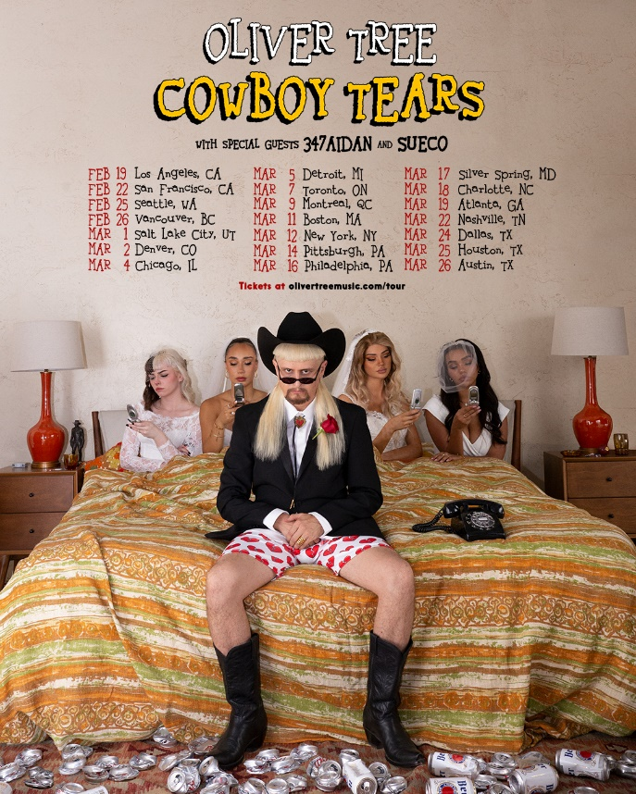
DOWNLOAD ADMAT HERE

Chart-topping, genre-bending artist Oliver Tree has announced the Cowboy Tears tour, his largest North American headline tour to date and last tour ever. The highly anticipated tour kicks off February 19, 2022 at Los Angeles, CA’s legendary venue, The Shrine Expo Hall, and continues through late March. While on the road, Oliver will be joined by RIAA certified singer/producer and viral phenomenon Sueco as well as 18-year-old Canadian DIY artist 347aidan. Presales begin Wednesday, October 13th at 10 am local time. General tickets go on sale Friday, October 15th at 10 am local time. For complete details, please visit www.olivertreemusic.com.

With over 2 billion global streams to date and over 580 million video views on YouTube alone, Oliver Tree is undeniably among the most popular – and most provocative – artists of the Gen-Z era. Currently at work readying his eagerly awaited second solo project, Oliver kicked off 2021 by teaming up with rap superstar Lil Yachty for the acclaimed collaboration, “Asshole.” This spring saw Oliver unveil Ugly is Beautiful: Shorter, Thicker & Uglier, a deluxe version of his chart-topping 2020 debut album joined by seven additional new songs including the long-awaited official release of “Life Goes On.” The single has become a global hit with 250 million streams, 100 million video views, 13 million TikTok videos, and 1.7 million Shazams to date.

Most recently, Oliver teamed up with Russian viral hitmakers Little Big for the revolutionary joint EP, Welcome To The Internet. The project was first heralded by the lead single, “Turn It Up,” featuring Estonian rapper Tommy Cash. Declared “a stimulating new party jam” by Entertainment Weekly and one of “the best new songs we heard this week,” the Tree-produced “Turn It Up” is joined by a wildly eccentric video filmed in Russia by directors Tree and Little Big’s Alina Pasok and Iliya Prusikin, now boasting over 15M views HERE having also landed the #1 spot on Apple Music Russia. The EP was also highlighted by standout track, “The Internet,” joined by an official video streaming now HERE.

First released last July, Ugly is Beautiful saw Oliver Tree taking his millions of followers on an unpredictable roller coaster ride through a cracked world full of comic disaster. Hailed by Ones To Watch as “a breath of air in a music industry that seems to trade in genuine talent for novel, marketable risk or vice versa,” the album immediately rocketed to #1 on Billboard’s “Top Rock Albums” and “Top Alternative Albums” charts while also debuting among the Top 15 on the overall SoundScan/Billboard 200. Now boasting more than 1B worldwide streams, the album features an array of iconoclastic hit singles including the RIAA platinum certified “Alien Boy“ and RIAA gold certified “Hurt,” both of which are joined by wildly inventive companion videos streaming now at Oliver Tree’s hugely popular official YouTube channel. Additional highlights include “Cash Machine,” “I’m Gone,” “Bury Me Alive,” and “Let Me Down,” among others.

ABOUT OLIVER TREE
An internet based vocalist, producer, writer, director and performance artist, Oliver Tree explores the intersection where pop and alternative meet sonically and has arrived where art and entertainment collide visually. From comedy to action sports, mock reality TV drama to WWF wrestling in his live shows, the world of Oliver Tree is unlike any artist who has come before him.

A Santa Cruz, California native, Tree has emerged as a polymath from many different projects and iterations over the last 10 years. As unpredictable as one artist can be, no one can seem to put their finger on what Oliver Tree will do next. Unafraid to make you laugh, cry, think profoundly or feel completely uncomfortable for the length of a 4 minute music video, he is on the road to developing his own blueprint for packaging and marketing pop culture in the internet era. Versatile in every sense of the word, Tree not only explores every type of entertainment but also every type of genre in his music alike. The box he puts himself in is limitless. It has no boundaries. Oliver Tree has built a multimedia project designed to challenge people’s perspective of what art is, and he’s not the slightest bit concerned with what anyone has to say about it!

ABOUT SUECO
Sueco has gleefully defied expectation right from the jump, fusing electric alt-pop energy with punk rock furor and off-kilter hip-hop to create something altogether without precedent and entirely his own. Now boasting over 550M worldwide streams, the Los Angeles-based singer/producer/multi-instrumentalist proved an online sensation with 2019’s RIAA certified breakthrough hit single, “fast.” Hailed by Rolling Stone as “a low-slung, battering ram of a record,” the track rocketed to the top spot at TikTok and #1 on Spotify’s “Viral 50 - Global” and “Viral 50 - US” charts. Sueco followed “fast” with his full-length debut project, MISCREANT, but then quickly shook up his electrifying sound with a string of increasingly pop-punk releases, including “PRIMADONA,” “SOS (Feat. Travis Barker),” and the viral sensation “Paralyzed.” After posting a teaser of “Paralyzed” on TikTok, the John Feldmann (Machine Gun Kelly, JXDN, 5SOS, Avril Lavigne)-produced track quickly racked up over 70M views, 11M likes and continues to grow. Upon release, “Paralyzed” landed on top playlists like the coveted New Music Friday and gave Sueco his first entry on both the Rolling Stone and Billboard charts.

Sueco has proven a diverse, in-demand collaborator, busting out remixes featuring such icons as Offset and A Boogie Wit Da Hoodie, joining forces with global superstars Ty Dolla $ign, Wiz Khalifa, and Lil Yachty for 2020’s “Speed Me Up,” and lighting up Papa Roach’s 2021 single, “Swerve (Feat. FEVER 333 & Sueco).” Having earned applause from Billboard, MTV, NYLON and Alternative Press, Sueco is currently hard at work on his eagerly awaited new project, now as always expanding the parameters of his forward-thinking musical approach with idiosyncratic invention, powerhouse passion, and unstoppable creativity.

ABOUT 347AIDAN
Growing up in Cambridge, Ontario, 347aidan had a pretty normal childhood. Music entered his life early, the now 18-year-old says. Aidan recorded his first track "Mental Health Variety" in eighth grade, a smooth Hip-Hop fusion track, which reflected his early love of Cloud Rap. It also showcased his versatility for both singing and rhyming. Aidan began recording track after track in his bedroom, uploading them to Soundcloud. He ultimately began cracking the six figure mark over Soundcloud, a clear indicator for what was to come. In the visuals for his viral hit "Demons & Monsters," 347aidan paints a virtual reality, one plagued by his own dark thoughts. The track speaks to the 17-year-old's relatability as an artist, as the Canadian bred musical wunderkind taps into the psyche of his fan base, simply by being himself. The stats prove it: "Demons & Monsters" skyrocketed in streams, up to a staggering million within a week of its release. It's a testament to 347aidan' s authenticity, continuing the momentum with "Dancing In My Room,"

Kenny Beats collaboration “IDWK” and most recently, the single “HARMONY” off his debut EP CHASING HARMONY executive produced by John Cunningham (XXXTENTACION, Halsey, Lil Nas X). 347 is his Angel number, a Divine representation of what he's here to do through his music. "My mission is to change the world for the better. That's it," he says, "I just want to make the world a better place."

OLIVER TREE
COWBOY TEARS TOUR
Featuring special guests Sueco and 347aidan

FEBRUARY 2022
19 – Los Angeles, CA – Shrine Expo Hall
22 – San Francisco, CA – The Warfield Theatre
25 – Seattle, WA – Showbox SoDo
26 – Vancouver, BC – PNE Forum

MARCH 2022
1 – Salt Lake City, UT – The Complex
2 – Denver, CO – The Mission Ballroom
4 – Chicago, IL – Radius
5 – Detroit, MI – The Fillmore Detroit
7 – Toronto, ON – History
9 – Montreal, QC – MTELUS
11 – Boston, MA – House of Blues
12 – New York, NY – Hulu Theatre at Madison Square Garden
14 – Pittsburgh, PA – Stage AE
16 – Philadelphia, PA – The Fillmore Philadelphia
17 – Silver Spring, MD – The Fillmore Silver Spring
18 – Charlotte, NC – The Fillmore Charlotte
19 – Atlanta, GA – The Tabernacle
22 – Nashville, TN – Marathon Music Works
24 – Dallas, TX – The Factory
25 – Houston, TX – 713 Music Hall
26 – Austin, TX – Stubb's Waller Creek Amphitheater

# # #

CONNECT WITH OLIVER TREE
WEBSITE | FACEBOOK | TWITTER | INSTAGRAM | YOUTUBE | SPOTIFY | TIK TOK

For press inquiries, please contact:
Jessica Nall // Jessica.Nall@atlanticrecords.com

