**OLIVER TREE**

**RELEASES NEW SINGLE** [**“UPSIDE DOWN”**](https://youtu.be/jNtu19SpuWA)

**“UPSIDE DOWN” ARRIVES EVERYWHERE TODAY!**

**[LISTEN HERE](https://youtu.be/jNtu19SpuWA)**

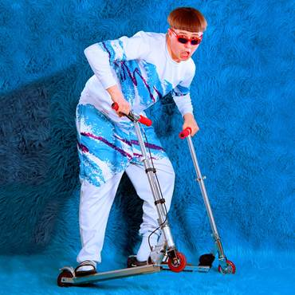

Oliver Tree, the Los Angeles-based genre-defying singer/songwriter/producer is back with new single, “Upside Down.” “Upside Down” blends Tree’s electronic influences with his signature distorted vocals. The track is now available at all DSPs and streaming services [**here.**](https://lnk.to/UpsideDown)

The new track is the follow up to September’s “Enemy,” which saw Oliver team up with friend and frequent collaborator, Whethan with whom he also joined on select dates of The Chainsmokers’ “Memories” Tour last year.

Last month, Oliver joined Louis The Child on select dates which included a sold-out show at Los Angeles’ Hollywood Palladium. This tour was just the next on the ever-growing list of live shows for Oliver Tree since making his festival debut this past summer with solo sets at Lollapalooza and Outside Lands.

Always creating new and exciting comedic content, Oliver Tree recently teamed up with meme sensation Fuck Jerry (13M followers) to create original content for the brand’s hugely popular Instagram page earlier last year.

Having made a striking debut with a visionary, Thom Yorke-approved cover of Radiohead’s “Karma Police,” Tree soon shook up the music scene with featured collaborations including Whethan vs. Oliver Tree’s “[When I’m Down](https://www.youtube.com/watch?v=eWMlwFFbf_0)” and Getter’s “[Forget It (Feat. Oliver Tree)](https://www.youtube.com/watch?v=vgIBr2FpGss).” Tree recently lit up Coachella with his distinctive look – featured in LA Weekly’s “[The Best (And Weirdest) Fashion At Coachella 2017](http://www.laweekly.com/slideshow/the-best-and-weirdest-fashion-at-coachella-2017-8136207/20)” – and memorable live appearance alongside frequent collaborator Whethan. In addition, Tree recently made his network television debut by joining Getter for a live rendition of “Forget It” on NBC’s Last Call with Carson Daly.

**Huffington Post** has applauded his work as “an enigma of genre. While (Tree is) primarily a pianist, guitarist and producer, his real-instruments-based-production incorporates rap, male and female vocal harmonies, poetic lyrics, strings and a hearty dose of synth…as much philosopher as musician, and a big dreamer at that, (Tree’s) goal is to push the art form forward, and beyond the electronic scene, he aims to have his work reach the world and in doing so, better his listeners’ lives,” while **NYLON** encourages everybody to “get weird to the sweet, sweet sounds of Oliver Tree.”