FOR IMMEDIATE RELEASE
OCTOBER 1, 2021

OLIVER TREE AND LITTLE BIG DROP WELCOME TO THE INTERNET

CHART-TOPPING ARTIST AND RUSSIAN VIRAL HITMAKERS RELEASE HIGHLY ANTICIPATED JOINT EP
WELCOME TO THE INTERNET

LEAD SINGLE “TURN IT UP” BOASTS OVER 6 MILLION GLOBAL STREAMS
+ 13 MILLION VIDEO VIEWS IN LESS THAN A MONTH

STANDOUT TRACK “THE INTERNET” ARRIVES WITH OFFICIAL VIDEO STREAMING NOW HERE

LISTEN TO WELCOME TO THE INTERNET HERE
WATCH “THE INTERNET” HERE
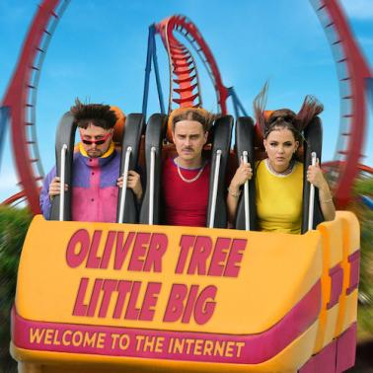
DOWNLOAD ARTWORK HERE

Chart-topping, genre-bending artist Oliver Tree and Russian viral hitmakers Little Big have released their join EP Welcome To The Internet. The project is highlighted by standout track “The Internet” which is accompanied by an official video, streaming now HERE.

The revolutionary joint project was herald by lead single “Turn It Up” featured Estonian rapper Tommy Cash. Released earlier this month, “Turn It Up” racked up 6 million streams and over 150 million views across all TikTok videos. The Tree-produced track was joined by an eccentric video directed by Oliver Tree and Little Big’s Alina Pasok and Iliya Prusikin. Filmed in Russia, the video currently boasts over 13 million views and landed the #1 spot on Apple Music Russia. The track also garnered widespread praise with Entertainment Weekly naming it one of the best new songs of the week and stating “this stimulating new party jam will certainly elicit stares from any passersby who overhear its discordant demands to ‘go dumb’ blasting out your car stereo. Hit a red light long enough, though, and stunned game pedestrians will soon be yelling at you to ‘turn it up’ too.”

“We worked on this collaboration for 1 year, sending stuff back and forth online prepping before executing the concepts together in person,” shares Oliver Tree. “I did extensive research on Russian dance music, watched as many documentaries as I could find about the Post-Soviet scene and read multiple theises on the topic. I even moved there for 4 months and went to every underground club and warehouse party I could attend. For me the most important song is titled “The Internet”. We are artists collaborating through the internet and although we live on other sides of the world, we both deal with a lot of the same issues. As artists who exist primarily in the online space, I feel there are not many examples of powerful art pieces that express the user experience of living and making art online in the 21st century. I consider the material to be very potent and feel we are exploring a profound subject while presenting it as silly and tongue and cheek so that it can be mass consumed without coming off as pretentious.”

''While writing Welcome To The Internet It was important to us to create a hybrid of different styles instead of focusing on one specific style,'' Little Big adds.

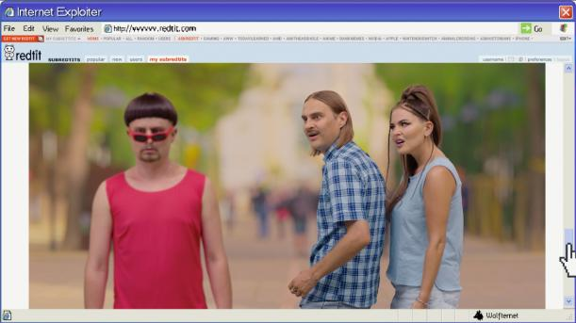
DOWNLOAD PHOTO HERE

ABOUT OLIVER TREE:
With over 2 billion global streams to date and over 500 million video views on YouTube alone, Oliver Tree is undeniably among the most popular – and most provocative – artists of the Gen-Z era.

Currently at work readying his eagerly awaited second solo album, Oliver kicked off 2021 by teaming up with rap superstar Lil Yachty for the acclaimed collaboration, “Asshole.” This spring saw Oliver unveil Ugly is Beautiful: Shorter, Thicker & Uglier, a deluxe version of his chart-topping 2020 debut album joined by seven additional new songs including the long-awaited official release of “Life Goes On.” The single has become a global hit with 100 million streams, 75 million video views, 4 million TikTok videos and 1.2 million Shazams to date.

First released last July, Ugly is Beautiful saw Oliver Tree taking his millions of followers on an unpredictable roller coaster ride through a cracked world full of comic disaster. Hailed by Ones To Watch as “a breath of air in a music industry that seems to trade in genuine talent for novel, marketable risk or vice versa,” the album immediately rocketed to #1 on Billboard’s “Top Rock Albums” and “Top Alternative Albums” charts while also debuting among the top 15 on the overall SoundScan/Billboard 200. Now boasting more than 1 billion worldwide streams, the album features an array of iconoclastic hit singles including the RIAA platinum certified “Alien Boy“ and RIAA gold certified “Hurt,” both of which are joined by wildly inventive companion videos streaming now at Oliver Tree’s hugely popular official YouTube channel. Additional highlights include “Cash Machine,” “I’m Gone,” “Bury Me Alive,” and “Let Me Down,” among others.

Welcome To The Internet marks the latest in what has proven a wildly eclectic string of collaborations for Tree, including creative partnerships with Dillon Francis, grandson, Whethan, and 90s punk-pop heroes blink-182, uniting with the latter for an exclusive rework of “Let Me Down” that debuted at #24 on Billboard’s “Hot Alternative Songs” chart.

ABOUT LITTLE BIG
Little Big is a punk/pop/rave band from Saint Petersburg. Founded in 2013, they’ve been on a steady rise ever since, dropping one viral hit after another. As of July 2021, their music videos boast over 2.5B YouTube views. “Skibidi” was viewed over 546M times, becoming the most popular video on Russian YouTube. Their Eurovision 2020 single, “UNO,” went global and became the most popular video on the Eurovision YouTube channel, reaching over 213M views to date. The band has also collaborated with several international artists including Tommy Cash on the acclaimed ''Give Me Your Money'', Clean Bandit on ‘’Arriba’’ and Finch Asozial on the smashing rave hit ‘’Rave Religion’’. Last year the band also had a chance to contribute with their C+C Music Factory ‘’Gonna Make You Sweat (Everybody Dance Now)’’ cover to the Sacha Baron Cohen’s ‘’Borat 2’’ official soundtrack.

The key to their international success is the band’s perfect blend of first-class showmanship and a knack for coming up with incredibly сatchy hooks. Little Big has proven their worldwide appeal and versatility with the release of Covers EP in June 2021, which saw the band putting its own unique stamp on hits by Aqua, Backstreet Boys, Ramones, Ricchi e Poveri, and Russian folk legend Nadezhda Kadysheva.

This summer saw Little Big teaming up with Crocs for the now-sold-out Little Big X Crocs Classic Black Clog, joined by an original song that has since been featured in over 3.3M TikTok videos. The band recently united with Eurovision Song Contest 2018 winner, sensational Israeli popstar Netta, for “Moustache,” another iconic and ironic banger with a music video worthy of instant viral fame (streaming HERE).

# # #

CONNECT WITH OLIVER TREE
WEBSITE | FACEBOOK | TWITTER | INSTAGRAM | YOUTUBE | SPOTIFY | TIK TOK

CONNECT WITH LITTLE BIG
WEBSITE | FACEBOOK | INSTAGRAM | YOUTUBE | SOUNDCLOUD | TIKTOK

For Oliver Tree press inquiries, please contact:
Jessica Nall // Jessica.Nall@atlanticrecords.com

For Little Big press inquiries, please contact:
Andrei Zozulya // andrei@littlebig.band

