POP POLYMATH
CHARLI XCX
ANNOUNCES NEW MIXTAPE POP 2 ALONGSIDE NEW SONG “OUT OF MY HEAD” FEAT. TOVE LO & ALMA!
Pop2 Mixtape arrives December 15th via Atlantic Records

Charli XCX’s Beats 1 Show ‘THE CANDY SHOP’ returns tonight!

LISTEN TO & POST “OUT OF MY HEAD”: https://www.youtube.com/watch?v=sZWmwHjFRPI

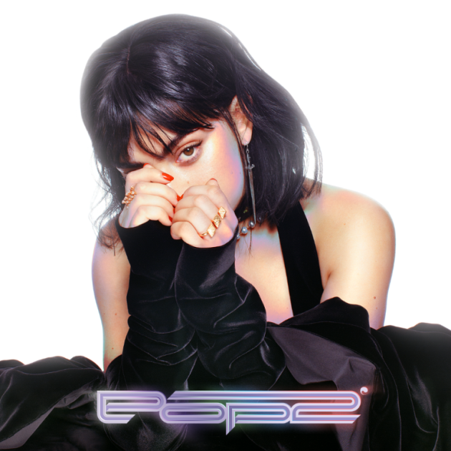

BUY/STREAM “OUT OF MY HEAD” + PRE-ORDER ‘Pop2’: https://atlanti.cr/pop2

Pop polymath Charli XCX reveals forthcoming mixtape ‘Pop2’ arriving on Friday, December 15th, celebrating the announce with a futuristic club track “Out Of My Head” featuring Tove Lo & ALMA. Listen here: https://www.youtube.com/watch?v=sZWmwHjFRPI

‘Pop2’ marks XCX’s second mixtape of the year and the next installment in Charli’s mixtape series, following her critically-acclaimed March 2017 release ‘Number 1 Angel’. Teaming-up with previous collaborators A.G Cook (who served as executive producer for the mixtape), and SOPHIE alongside King Henry (Beyoncé, Justin Bieber), David Gamson and EASYFUN (Charli XCX “3AM”) on production, ‘Pop2’ features an all-star cast of writers and vocalists including Caroline Polachek (Chairlift), MØ, Tove Lo, ALMA, Carly Rae Jepsen, Pabllo Vittar, Jay Park and many more. Recorded across the US while on tour with Halsey this fall, the new mixtape is another forward-thinking body of work from the pop talent and, as ever, another affirmation of the 25-year-old’s trailblazing flare.

An incredibly busy year for the UK native, XCX released her pop anthem “Boys” this summer. A worldwide sensation – the single has been streamed over 120 million times to date – Charli took full creative control across casting, directing and producing the accompanying official video, which featured an all-star male cast including the likes of Joe Jonas, Diplo, Stormzy, Mark Ronson, Brendon Urie, will.i.am, Mac DeMarco and Riz Ahmed. Currently featuring on David Guetta’s “Dirty Sexy Money” alongside French Montana (listen here), Charli closed this year’s EMA’s with a performance of the track at London’s Wembley Arena (watch here).

Recently wrapping two huge support tours with Halsey in the US and Sia in Australia, watch this space for more announcements. Charli’s third season of her Beats 1 show ‘The Candy Shop’ airs tonight at 5pm GMT/12pm ET with co-host Billie Eilish. The show will return in 2018, airing every other Friday with upcoming co-host slots from Tove Lo and ALMA (listen here: apple.co/charli).

Pop2 Tracklist
1. Backseat (feat. Carly Rae Jepsen)
2. Out Of My Head (feat. Tove Lo and ALMA)
3. Lucky
4. Tears (feat. Caroline Polachek)
5. I Got It (feat. Brooke Candy, CupcakKe and Pabllo Vittar)
6. Femmebot (feat. Dorian Electra and Mykki Blanco)
7. Delicious (feat. Tommy Cash)
8. Unlock It (feat. Kim Petras and Jay Park)
9. Porsche (feat. MØ)
10. Track 10

CONNECT WITH CHARLI XCX:
Website | Facebook | Twitter | Instagram | SoundCloud | YouTube | Press Site

##

For more information, contact:
Ted Sullivan | Ted.Sullivan@AtlanticRecords.com

