POP QUEEN CHARLI XCX RELEASES CHARLI
THIRD STUDIO ALBUM ARRIVES TODAY

ALSO TUNE INTO UPCOMING TELEVISION APPEARANCES:

9/16 - THE TONIGHT SHOW STARRING JIMMY FALLON on NBC

9/27 – LIVE FROM THE ARTISTS DEN on PBS

LISTEN: https://ad.gt/charli-thealbum

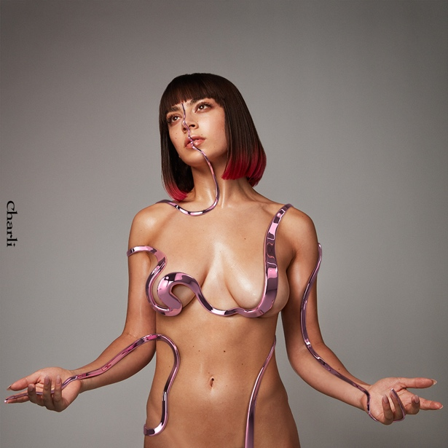
LP artwork created in partnership with AR makeup artist Ines Alpha
(Atlantic Records)

--

“The popstar of the future!” –PITCHFORK

“…state-of-the-art pop” –WALL STREET JOURNAL

“Charli’s Weird-Pop Reinvention” –ROLLING STONE

“Not another pop statistic” –SPIN

“Pop’s premiere futurist…” – FADER

“Neo-pop royalty” –ESQUIRE

“…master of futuristic pop…” –COMPLEX

“…British pop retro-futurist…” –VICE

“...idiosyncratic, futuristic pop star…” –STEREOGUM

“…pop auteur...” –PAPER

“…pop songstress…” –FORBES

“Charli XCX’s current era keeps getting better and better.” –IDOLATOR

Charli XCX – “Charli”

1. Next Level Charli
2. Gone feat. Christine and the Queens + video
3. Cross You Out feat. Sky Ferreira
4. 1999 feat. Troye Sivan + video
5. Click feat. Kim Petras and Tommy Cash
6. Warm feat. HAIM
7. Thoughts
8. Blame It On Your Love feat. Lizzo + video
9. White Mercedes
10. Silver Cross
11. I Don’t Wanna Know
12. Official
13. Shake It feat. Big Freedia, CupcakKe, Brooke Candy and Pabllo Vittar
14. February 2017 feat. Clairo and Yaeji
15. 2099 feat. Troye Sivan

TOUR DATES ENCLOSED BELOW + PRESS TOOLS: http://press.atlanticrecords.com/charlixcx/

2019 Charli LIVE:

September 20 - Atlanta, GA - Buckhead Theatre +
September 21 - Nashville, TN - Marathon Music Works +
September 23 - Houston, TX - White Oak Music Hall +
September 24 - Austin, TX - Emo’s + -- SOLD OUT
September 25 - Dallas, TX - House of Blues +
September 27 - Phoenix, AZ - The Marquee #
September 28 - San Diego, CA - House of Blues #

October 1 - Los Angeles, CA - The Wiltern # *
October 2 - Oakland, CA - Fox Theatre #
October 4 - Seattle, WA - Showbox Market # -- SOLD OUT
October 5 - Vancouver, BC - Commodore # -- SOLD OUT
October 6 - Portland, OR - Roseland Ballroom #
October 8 - Salt Lake City, UT - Union *
October 9 - Denver, CO - Ogden Theatre *
October 11 - Minneapolis, MN - First Avenue *
October 12 - Chicago, IL – House of Blues – SOLD OUT
October 14 - Toronto, ON – Rebel – SOLD OUT
October 15 - Montreal, QB - Corona Theatre %
October 17 - Boston, MA - House of Blues %
October 18 - Washington, DC - 9:30 Club – SOLD OUT
October 19 - Philadelphia, PA - Union Transfer * -- SOLD OUT
October 21 - New York, NY - Terminal 5
October 22 - New York, NY - Terminal 5 % -- SOLD OUT

SUPPORTS:
+ Tommy Genesis | # Brooke Candy | * Dorian Electra | % Allie X
Phoenix: Brooke Candy Direct / Dorian Electric 1st of 3

##

For more information please contact:
Ted Sullivan | Ted.Sullivan@AtlanticRecords.com

