IN CASE YOU MISSED IT…

AVA MAX PERFORMS GLOBAL HIT “SWEET BUT PSYCHO” ON THE ELLEN DEGENERES SHOW

WATCH HERE

“SWEET BUT PSYCHO” REACHES TOP 5 AT USA POP RADIO AND CLIMBING

INTERNATIONAL SINGLE HIT #1 IN THE UK FOR EIGHT WEEKS IN A ROW

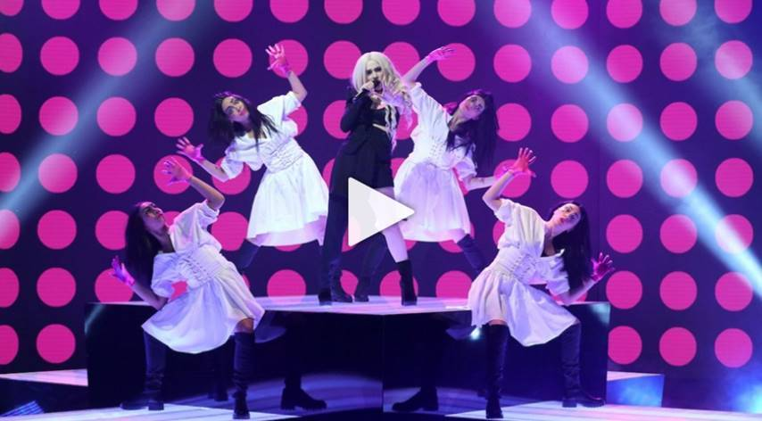
EMBED: <iframe width="560" height="315" src="https://www.youtube.com/embed/LgkbjHwnOu0" frameborder="0" allow="accelerometer; autoplay; encrypted-media; gyroscope; picture-in-picture" allowfullscreen></iframe>

Earlier today, 2019’s newest pop sensation Ava Max stopped by Ellen to perform her worldwide smash single “Sweet but Psycho.” Watch HERE.

Produced by GRAMMY® Award-nominated super-producer Cirkut (Maroon 5, Miley Cyrus, The Weeknd) and co-written with Madison Love (Camila Cabello), “Psycho” – which reached #1 on both Spotify’s “United States Viral 50” and Billboard’s “Dance Club Songs” – is currently Top 5 at USA Pop Radio and climbing while ascending to 19 on the Billboard’s “Hot 100.” The stateside success of “Sweet but Psycho” follows the track’s remarkable popularity abroad where it has held the #1 spot at European Radio for eight weeks in a row, spent four consecutive weeks atop the UK Singles Chart, and scored #1 rankings on charts in nearly 20 countries. “Sweet but Psycho” – which has earned more than ¾ of a billion streams and overall global sales consumption in excess of 2 million – is joined by an equally popular companion video, directed by Shomi Patwary (Beyoncé, The Weeknd) and now boasting over 257 million views via Ava Max’s official YouTube channel HERE. Earlier this year, the breakthrough pop artist made her U.S. TV debut with energetic performances of “Sweet but Psycho” on The Late Late Show with James Corden and The TODAY Show before going on to impressively hold the #1 spot on Billboard’s Emerging Artists Chart for 6 weeks in a row.

Last month, Ava released “So Am I,” her irresistibly catchy pop anthem and follow-up to “Sweet but Psycho.” The powerful companion video, which promotes a message of inclusivity and acceptance, has amassed nearly 19 million views on YouTube – watch HERE. Upon release, MTV News praised the song as a “big, melodic pop anthem that celebrates individuality and embracing one’s unique flaws and quirks in the same vein as Katy Perry’s ‘Firework’ or Lady Gaga’s ‘Born This Way.’”

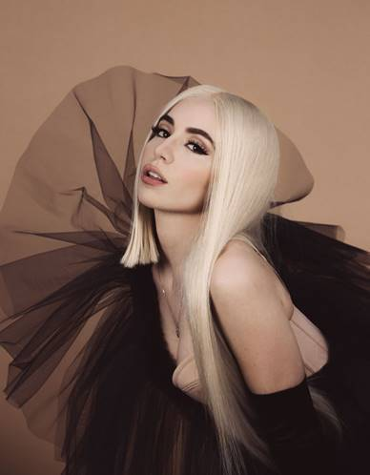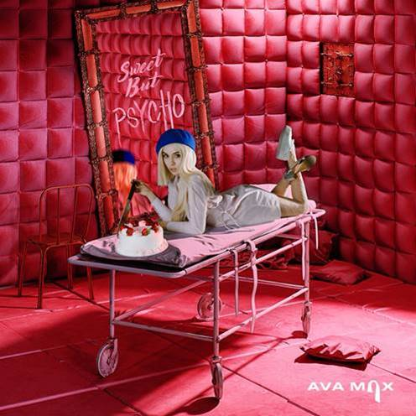
(Press Photo Credit: Lauren Dunn – download high res)

ABOUT AVA MAX:
Crafting pop anthems with a much-needed dose of fiery female empowerment, Ava Max is a unique new talent, blessed with a seismic voice, an individualistic high fashion mindset, and an undeniable knack for cinematic, theatrical popcraft. The daughter of Albanian immigrants, Max was born in Wisconsin but raised in Virginia where she began blowing away audiences long before even entering high school. Determined from a young age to grace the stage and equipped with a vibrant voice passed down by her opera singer mother, Max honed her skills performing at multiple singing competitions. Inspired by her parents’ courageous escape from the political turmoil that plagued their home country; she eventually made the move to Los Angeles to pursue her calling.

CONNECT WITH AVA MAX:
OFFICIAL I INSTAGRAM I TWITTER I FACEBOOK I SOUNDCLOUD I PRESS TOOLS

CONTACT:
Andrew George | andrew.george@atlanticrecords.com

