AVA MAX SHARES “SWEET BUT PSYCHO” (THE REMIXES)
CHECK OUT THE REMIXES HERE + DOWNLOAD/STREAM THE ORIGINAL HERE

RISING POP SENSATION TOPS BILLBOARD’S EMERGING ARTISTS CHART 2 WEEKS STRAIGHT

“SWEET BUT PSYCHO” SOARS TO #1 ON BILLBOARD’S DANCE CLUB SONGS CHART

BREAKTHROUGH INTERNATIONAL SINGLE HIT #1 IN THE UK 4 WEEKS IN A ROW

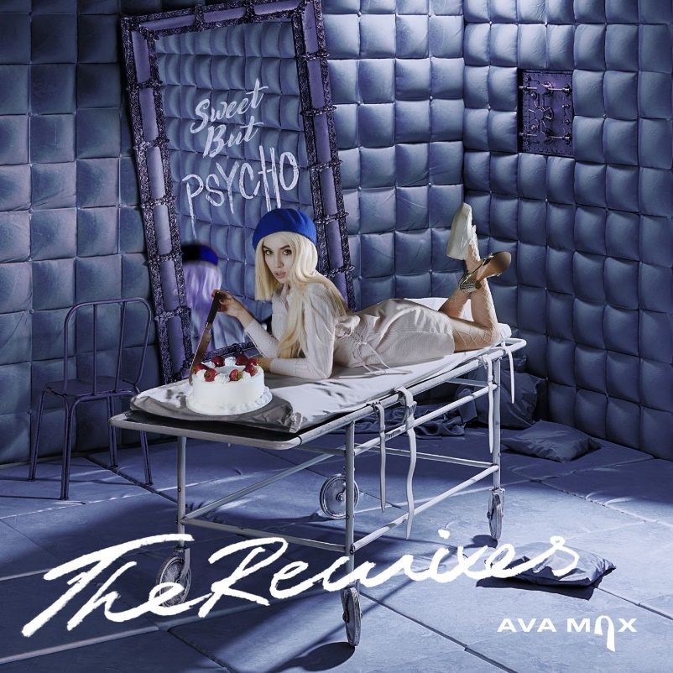
*Download Hi-Res*

Today, 2019’s newest pop sensation Ava Max has dropped an official remix package for her global hit “Sweet but Psycho” – featuring remixes from Leon Lour, Morgan Page, Paul Morrell, Kat Krazy and Elijah Hill, the compilation is available at all DSPs and streaming services HERE.

The rising star is taking the new year by storm as she tops Billboard’s Emerging Artists Chart for the second week in a row. Just in time for the release of “Sweet but Psycho” (The Remixes), the smash single is currently #1 on Billboard’s Dance Club Songs Chart. Last week, Ava made her U.S. TV debut with stunning performances of “Sweet but Psycho” on both CBS’ The Late Late Show with James Corden and NBC’s The TODAY Show. Since release, “Sweet but Psycho” has amassed over 376 million streams worldwide. The track has topped Spotify’s Global, US and UK Viral Charts while being added to the esteemed Today’s Top Hits playlist, Pop Rising, Young Wild & Free and more. With love for the single across the globe, “Sweet but Psycho” hit the #1 spot in the UK 4 weeks in a row and is currently the global #1 single on Shazam for the third week in a row. Climbing Top 20 at USA Pop Radio, the earworm is also Top 10 on U.S. iTunes. The official companion visual has gone on to amass over 103 million views on YouTube.

Produced by GRAMMY® Award-nominated super-producer Cirkut (Maroon 5, Miley Cyrus, The Weeknd) and co-written with Madison Love (Camila Cabello), “Psycho” was recently included on FADER’s list of “20 best new pop songs right now” with Idolator writing “Ava Max caught lightning in a bottle with ‘Sweet But Psycho,’ a ruthlessly catchy, deeply relatable bop about embracing all facets of your personality.” Publications including FLAUNT have also praised Ava as an artist “on her way to becoming music's next ‘It’ girl’” while Billboard included the pop newcomer on their list of “Ones to Watch” advising readers to “Get familiar with Ava Max, because her name is about to be everywhere.” In a recent profile, V Magazine wrote, “By re-appropriating language used to gaslight women, Ava Max creates an unlikely feminist anthem, written by and for someone who has nothing to hide, who, furthermore, has fought for herself to be seen completely.”

Max also co-wrote and is featured on David Guetta’s “Let It Be Me” off his album “7.” She recently collaborated with Vice and global multi-platinum recording artist Jason Derulo on “Make Up” – watch the video HERE – which PAPER called a “bop” describing the song and video as a “mix of sultry and upbeat pop funk.” Her beaming voice was first introduced to listeners through her stellar featured performance on LA-based Nü Disco Le Youth’s summer 2017 smash, “Clap Your Hands,” and has since generated attention for her first original single “My Way” as well as viral hit “Not Your Barbie Girl” which went on to amass over 10 million views across YouTube and Musical.ly.

CONNECT WITH AVA MAX:
OFFICIAL I INSTAGRAM I TWITTER I FACEBOOK I SOUNDCLOUD I PRESS TOOLS

CONTACT:
Andrew George | andrew.george@atlanticrecords.com

