FOR IMMEDIATE RELEASE

FEBRUARY 5TH, 2021

**HAYLEY KIYOKO ANNOUNCES NEW FRAGRANCE “HUE”**

**IN PARTNERSHIP WITH SLATE BRANDS**

**GROUNDBREAKING POP STAR’S FRAGRANCE ARRIVES ON MARCH 3RD**

**“HUE” BY HAYLEY KIYOKO IS AVAILABLE FOR PRE-ORDER NOW** [**HERE**](http://www.huebyhayley.com)

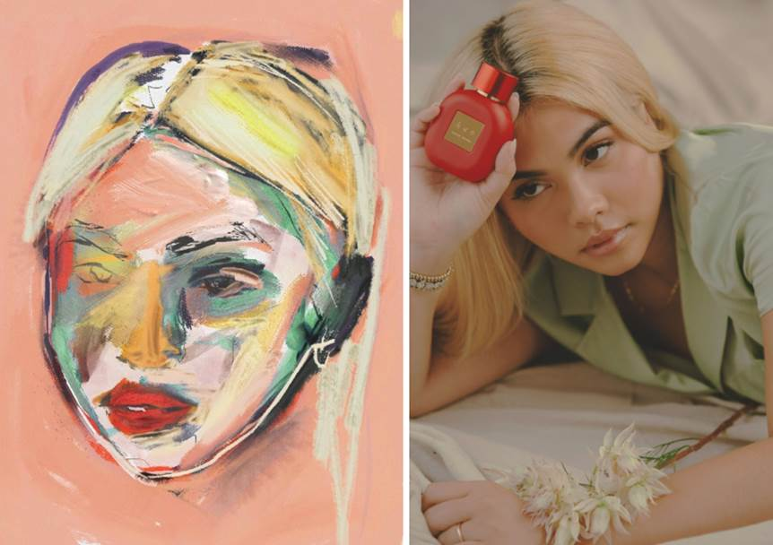

([Download High Res Images](https://warnermusicgroup.box.com/s/6oy2wu4697n175u5sjsqb35nbapkhvlv))

**Hayley Kiyoko** wants you to embrace what makes “HUE”, you. The trailblazing pop star has officially announced her new gender-inclusive fragrance, “HUE,” launching on Wednesday, March 3rd. Powered by Warner Music Artist services, Atlantic Records and Brands With Purpose, “HUE” is available for pre-order now at [www.huebyhayley.com](http://www.huebyhayley.com). All orders placed during the pre-order will include a limited-edition HUE-scented surprise and a special keepsake note from Hayley.

As an artist who creates a safe space for the LGBTQ+ community through her music, it was important to Hayley that her first fragrance embody acceptance and inclusivity. The packaging design features a portrait of Hayley illustrated by Liz Hirsch, which signifies the variety of hues amongst every individual.

*“Perfume has been a massive part of my queer experience,”* Hayley tells[*Vogue*](https://www.vogue.com/article/hayley-kiyoko-first-fragrance-hue)*. “I remember feeling famous in middle school because girls said that I smelled good. They wouldn’t date me. They didn’t have crushes on me. But they said I smelled good, and that was like a huge thing for me, and I’ve carried that throughout my life. I want to give that power and that armor to my fans, even if they’re sitting at home!”*

Hayley created the fragrance together with perfumer Constance Georges-Picot of Cosmo Fragrances in addition to development support by Bart Schmidt. Hayley and [Slate Brands](https://slatebrands.com/) decided to produce a concentrated Eau de Parfum version for longer wear and enhanced ambrosial notes. The fruity and floral creation includes many of their exclusive ingredients, such as Rose and Cacao Blanc Craftivity ®. The fragrance is also vegan, cruelty-free, phthalate-free, and paraben-free.

*“Like Hayley, we wanted the fragrance to be an expression of liberation, freedom, and self-empowerment. ‘Not easily defined, complicated, powerful and worthy’ were things Hayley reiterated numerous times,*” explains Constance.

Bold, energetic, and just a little disruptive, sparkling top notes of blood orange, watermelon and freesia unfold into an expressive, feminine heart of blooming peony petals, lychee, rose and pink magnolia. Warm and cocooning, the background develops into a simple aphrodisiac, as milky undertones of creamy cacao blanc merge with a soft, sensual trail of skin musk.

Atlantic Records worked with Warner Music Artist Services and Brands With Purpose to facilitate the partnership between Hayley Kiyoko and Slate Brands.

According to Slate Brands’ Judah Abraham, “*Hayley is the perfect partner since she knows exactly what she wants and takes control of the creative process*. *To create “HUE,” she met numerous times with the creative team and the perfumers. The pandemic made it all a bit more challenging to connect and meet, but we had plenty of virtual get-togethers and smelling sessions*.”

**ABOUT HAYLEY KIYOKO**

Hayley Kiyoko has become one of the most celebrated pop artists since releasing 2018’s landmark debut album [*EXPECTATIONS*](https://nam04.safelinks.protection.outlook.com/?url=https%3A%2F%2Fsecure-web.cisco.com%2F1KtuL6fvUO7v0oAyGCiKthvl_c1qK8Uw7gkJCyEFmzycDOUR_mWjpmvdOWpKqB_Hvw96IsTnXN_F8Yi18m8FE5fad7EcqIKuXPr6UaCpXiJb5vCIJFHpmv_6Z4UbZwyaoehu_Kig1qcVkANCrbqszfxP5mxdcumL2QFiEmwZEerN3lIZezkX8be7ADmrtn_N_8XjF1yLqQVB9SC7F6mISkeRTWw6n01ngA5meoer6QM4-ZMHJ2xR8vzSboRWcUKk-0eKPy5SMPYqihotWn5tz5jv1koU80hDYcm8wTLKS3oeFTOC6970Lyr80cGUSw3FwSBXBFcJvS6uBR0C7wAQnvFJpvAVfhVI8S8Ics__OBc5PtX9du4QIF6uu8cdCffcX%2Fhttps%253A%252F%252Fnam04.safelinks.protection.outlook.com%252F%253Furl%253Dhttps%25253A%25252F%25252Fprotect-us.mimecast.com%25252Fs%25252FHrMaCDkJ8zcN5k3ysWpPNg%2526data%253D02%25257C01%25257CAndrew.George%252540atlanticrecords.com%25257Cd1c0032bbeb349ea829b08d74da552ea%25257C8367939002ec4ba1ad3d69da3fdd637e%25257C0%25257C0%25257C637063244758172065%2526sdata%253DXScZ4cxzwHNDn3nIYu9EmxGBDARYJ6aAbNiJOdeZLws%25253D%2526reserved%253D0&data=04%7C01%7CTonian.Ortega%40wmg.com%7C05e531073d264546370508d8b982b266%7C8367939002ec4ba1ad3d69da3fdd637e%7C0%7C0%7C637463318272118964%7CUnknown%7CTWFpbGZsb3d8eyJWIjoiMC4wLjAwMDAiLCJQIjoiV2luMzIiLCJBTiI6Ik1haWwiLCJXVCI6Mn0%3D%7C1000&sdata=ltgUCu%2FocNyKWkEDDjY8rGLLXHG%2FFxzXhQtv7Cu214E%3D&reserved=0), which according to *Rolling Stone*, placed her “at the forefront of an unapologetically queer pop movement.” In #20GAYTEEN, Kiyoko was nominated for two VMAs where she performed “Curious” and won Push Artist Of The Year. Since her 2015 debut, Hayley has amassed over 780 million global streams, over 2.1 million YouTube subscribers and has accrued over 730 million lifetime YouTube views, in addition to selling out numerous venues across the country and abroad on her previous headline tour. Lauded as one of “The 21st Century's Most Influential Women Musicians” by *NPR* among other milestones, Hayley continues to impact and inspire her community. Through her honest storytelling and lyricism, she encourages hope as her resounding message. Last year, the pop star unveiled her newest collection of songs, *I’M TOO SENSITIVE FOR THIS SHIT*.

**CONNECT WITH HAYLEY KIYOKO:**

[WEBSITE](https://nam04.safelinks.protection.outlook.com/?url=http%3A%2F%2Fwww.hayleykiyokoofficial.com%2F&data=02%7C01%7CMegan.Rasmussen%40atlanticrecords.com%7C6f3855bd2fe449e7b43008d77ea316b7%7C8367939002ec4ba1ad3d69da3fdd637e%7C0%7C0%7C637117111229892055&sdata=5AG%2BkZl2OPd5UwyyFlhpbUCyK%2BcpySbnpbl1fZXMVPU%3D&reserved=0) | [FACEBOOK](https://nam04.safelinks.protection.outlook.com/?url=https%3A%2F%2Fwww.facebook.com%2FHayleyKiyoko%2F&data=02%7C01%7CMegan.Rasmussen%40atlanticrecords.com%7C6f3855bd2fe449e7b43008d77ea316b7%7C8367939002ec4ba1ad3d69da3fdd637e%7C0%7C0%7C637117111229902043&sdata=A7HReDNexKdvN3SDgpQPfZAdmijMaazNRf1ruDcdEjs%3D&reserved=0) | [TWITTER](https://nam04.safelinks.protection.outlook.com/?url=https%3A%2F%2Ftwitter.com%2FHayleyKiyoko&data=02%7C01%7CMegan.Rasmussen%40atlanticrecords.com%7C6f3855bd2fe449e7b43008d77ea316b7%7C8367939002ec4ba1ad3d69da3fdd637e%7C0%7C0%7C637117111229902043&sdata=oPen%2FXIvwOOIvQXxeRtbuqBUER803Qkz48437EreQ8U%3D&reserved=0) | [INSTAGRAM](https://nam04.safelinks.protection.outlook.com/?url=https%3A%2F%2Fwww.instagram.com%2Fhayleykiyoko%2F&data=02%7C01%7CMegan.Rasmussen%40atlanticrecords.com%7C6f3855bd2fe449e7b43008d77ea316b7%7C8367939002ec4ba1ad3d69da3fdd637e%7C0%7C0%7C637117111229912040&sdata=FQoLEGWMiQkZgZlPZ3C42lVj5Nzkyg2ZgKByh%2F65h1M%3D&reserved=0) | [YOUTUBE](https://nam04.safelinks.protection.outlook.com/?url=https%3A%2F%2Fwww.youtube.com%2Fchannel%2FUC00X4AUEmat8Pk772tDu8OA&data=02%7C01%7CMegan.Rasmussen%40atlanticrecords.com%7C6f3855bd2fe449e7b43008d77ea316b7%7C8367939002ec4ba1ad3d69da3fdd637e%7C0%7C0%7C637117111229912040&sdata=g%2BRflAT1XBamt%2Fmt%2BZF9lr2WQCB4pLZgv6mX9mYAGmk%3D&reserved=0) | [PRESS ASSETS](https://nam04.safelinks.protection.outlook.com/?url=http%3A%2F%2Fpress.atlanticrecords.com%2Fhayley-kiyoko%2F&data=02%7C01%7CMegan.Rasmussen%40atlanticrecords.com%7C6f3855bd2fe449e7b43008d77ea316b7%7C8367939002ec4ba1ad3d69da3fdd637e%7C0%7C0%7C637117111229922030&sdata=3gdHZsvgfwc1AUi%2Bib49HBm8SSJmkfFX%2BXuSTc6D3aI%3D&reserved=0)

**CONNECT WITH HUE:**

[WEBSITE](http://www.huebyhayley.com/) | [INSTAGRAM](https://www.instagram.com/huefragrance/)

**ABOUT SLATE BRANDS, INC.**

Slate Brands is a full-service beauty marketing and branding agency that gives celebrities, brands, influencers and entrepreneurs looking to enter the beauty space the freedom to take the creative lead with their own beauty brands. The company’s expertise extends across several beauty categories including fragrance, skin, color cosmetics, hair, nails, beauty tools, and supplements. Slate’s brand development services include private label, brand incubation for new-to-market beauty lines, exclusive celebrity and influencer products, as well as in-house brands developed exclusively by the company.

**CONTACTS:**

For Hayley Kiyoko Press Inquiries Please Contact:

Andrew George

Atlantic Records

[andrew.george@atlanticrecords.com](mailto:andrew.george@atlanticrecords.com)

Slate Brands, Inc.

Rachael Guida

Head of Marketing and PR

[rachael@slatebrands.com](mailto:rachael@slatebrands.com)