HAYLEY KIYOKO UNLEASHES “I WISH” (ROBOTAKI REMIX)

GROUNDBREAKING POP STAR TEAMS UP WITH CANADIAN DJ/PRODUCER ROBOTAKI
FOR FIRST OFFICIAL REMIX OF NEW SINGLE

CHECK OUT HAYLEY ON THE COVER OF BILLBOARD’S LATEST ISSUE ON STANDS NOW

LISTEN TO THE “I WISH” (ROBOTAKI REMIX) HERE
LISTEN TO “I WISH” HERE | WATCH THE SELF-DIRECTED VIDEO HERE

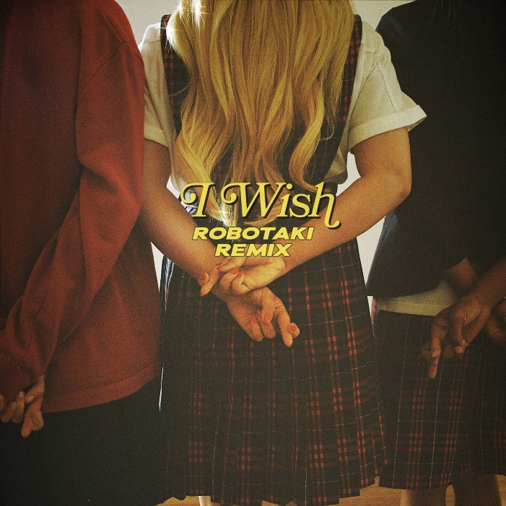
DOWNLOAD HIGH RES ART + PRESS PHOTOS HERE

“Kiyoko's latest bop is simultaneously energetic and dreamy, combative and yearning.” – NPR

“Kiyoko is back and better than ever” – BILLBOARD

“Hayley Kiyoko is back to remind us all that just because 20GayTeen is over, that doesn't mean she's done providing us all with the queer bops we deserve.” – NYLON

Last month, groundbreaking pop star Hayley Kiyoko unveiled her highly anticipated new single “I Wish” alongside a wickedly spellbinding self-directed companion video. Today, the track receives an exclusive new remix from Canadian DJ and producer Robotaki – the “I Wish” (Robotaki Remix) premiered earlier via Billboard Dance and is available now at all DSPs and streaming services HERE.

“I’m so excited to have had the chance to work with Robotaki on this remix of ‘I Wish,’” says Kiyoko. “It’s especially meaningful when I’m able to collaborate with other Asian American artists/producers and amplify our collective voice in pop music. I truly love what he was able to bring to the song and can’t wait for everyone to listen!”

"I feel super lucky that Hayley's team reached out right at the time they did,” says Robotaki. “I've been on the road a lot this summer, and have been focusing a lot of my original works, however this track triggered excitement immediately and the mix came together faster than ever. Her vocals and a number of the sounds in the original track sparked something, and I'm super happy with how it came together in the end!”

“I Wish” marks Hayley’s first new release since her breakthrough debut album EXPECTATIONS, which dropped in March of last year and was widely celebrated by fans and critics alike as one of #20GAYTEEN’s best albums. The song’s official video, which premiered via MTV, stars an all-female cast, is jampacked with fierce choreography and has garnered over 2.6 million views since release. Hayley is currently gracing the cover of Billboard Magazine’s newest issue (on stands now) alongside Tegan Quin, Adam Lambert, Big Freedia and ILoveMakonnen.

An inspiring, electrifying live artist, Kiyoko recently wowed audiences with her energetic and uplifting performances at Lollapalooza and Osheaga. Next up, she’ll take her live show to UK’s famed Reading/Leeds Festivals (August 23rd/24th). For complete details and ticket availability, please visit www.hayleykiyokoofficial.com. Leading up to the release of “I Wish,” the pop sensation celebrated her first-ever World Pride in NYC – check out a stunning photo diary on Harper’s Bazaar HERE. Hayley has also been gaining attention for starring in Taylor Swift’s music video for “You Need To Calm Down” – see behind-the-scenes footage on Taylor’s IG here.

ABOUT HAYLEY KIYOKO:
Hayley Kiyoko has become one of the most celebrated pop artists since releasing last year’s landmark EXPECTATIONS which according to Rolling Stone, placed her at “the forefront of an unapologetically queer pop movement.” In #20GAYTEEN, Kiyoko was nominated for two VMAs where she performed “Curious” and won Push Artist Of The Year. Hayley took her captivating live performance on the road for a nationwide headline tour, Coachella festival debut and support during Panic! At The Disco’s North American arena tour. She also came out as a surprise guest during Taylor Swift’s Reputation World Tour. On top of stunning on the covers of NYLON and PAPER, Kiyoko was named to NPR’s list “The 21st Century's Most Influential Women Musicians,” performed on Jimmy Kimmel Live! and Late Night with Seth Meyers and was honored with the Rising Star Award at Billboard’s annual Women in Music event.

ABOUT ROBOTAKI:
Coming in to the spotlight with his top-tier remix work, and mainly recognized for his impeccable sounds with a powerful new take on funk and disco, 27 year-old Canadian DJ and producer Robotaki has recently made remixes for Kaskade, Filous, 88rising, The Chainsmokers and more. Robotaki is playing to a sold out show at the Brooklyn Mirage with Gryffin this Friday 8/16 in NYC and is supporting Big Wild at Red Rocks next month.

CONNECT WITH HAYLEY KIYOKO:
WEBSITE | FACEBOOK | TWITTER | INSTAGRAM | YOUTUBE | PRESS ASSETS

CONNECT WITH ROBOTAKI:
SOUNDCLOUD | FACEBOOK | TWITTER | INSTAGRAM | YOUTUBE

PRESS CONTACTS:
Chelsey Northern/Atlantic Records (NATIONAL)
chelsey.northern@atlanticrecords.com

Andrew George/Atlantic Records (TOUR/ONLINE)
andrew.george@atlanticrecords.com

