JAYMES YOUNG ANNOUNCES DEBUT ALBUM + NORTH AMERICAN TOUR

LISTEN TO NEWLY RELEASED TITLE TRACK “FEEL SOMETHING” HERE:
http://atlantic.lnk.to/FeelSomething

EAGERLY AWAITED COLLECTION ALSO FEATURES
STREAMING HITS “WE WON’T (FEAT. PHOEBE RYAN)” AND “I’LL BE GOOD”

ALBUM AVAILABLE FOR PRE-ORDER NOW
“FEEL SOMETHING” TOUR KICKS OFF AT
THE TROUBADOUR IN LOS ANGELES ON JULY 11 AND INCLUDES A STOP
AT BOWERY BALLROOM IN NYC ON JULY 27

“FEEL SOMETHING” ARRIVES EVERYWHERE ON JUNE 23

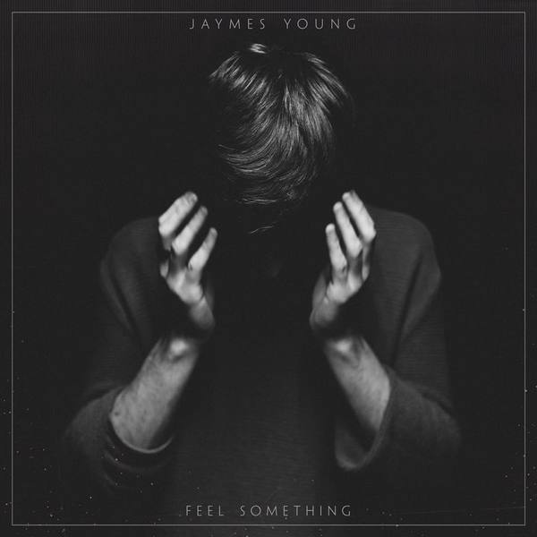
*Download Hi-Res Images HERE*

Please Rewind/Atlantic Records recording artist, Jaymes Young has officially announced the release of his eagerly awaited debut album “FEEL SOMETHING” arriving everywhere on Friday, June 23rd. After teasing the album release with the alternative R&B-tinged anthem "Stoned On You" - which premiered via Noisey earlier this month and garnered over 750K+ combined 1st week streams - Jaymes has now unveiled the album’s powerful title track about wasted youth and disillusionment with love. Listen to “Feel Something” HERE.
“FEEL SOMETHING” is available now for pre-order HERE. All album pre-orders include four instant gratification tracks: brand new tracks “Stoned On You” and “Feel Something” as well as streaming hits "We Won't" (feat. Phoebe Ryan)" – which reached #1 on Hype Machine and boasts over 30 million streams worldwide - and “I’ll Be Good” - previously included on 2014's "HABITS OF MY HEART" EP and also logging over 30 million streams. “I’ll Be Good” is also joined by a companion video, which has now with over 17 million views, and has been hailed by Stereogum as both a "gorgeous sadcore single" and "an equally heart-wrenching video...it's a scorching, introspective clip, with muted colors and surreal shots of fish swimming in IV bags."

Jaymes’ headlining “Feel Something” tour will kick off at the famed Troubadour in Los Angeles on July 11th and includes a stop at Bowery Ballroom in New York City on July 27th before wrapping up at the Exit/In in Nashville on August 2nd. General on-sale begins on Friday, April 28th at 10am Local Time. Pandora will launch a pre-sale beginning on Tuesday, April 25th at 10am Local through Thursday, April 27th at 10pm Local Time (pre-sale code: PANDORA). Jaymes has traveled the road nearly non-stop in recent years, including headline dates and tours alongside London Grammar and F-Stop/Atlantic recording artist Vance Joy. For complete details and ticket information, please visit www.jaymesyng.com.

****

Jaymes Young will assure you that he’s a “songwriter before a singer and performer.” That wise and self-aware summation cuts to the core of who the Seattle-born and Los Angeles-based musician/poet really is. Spending countless hours holed up in his bedroom carefully piecing together compositions, penning lyrics, and exploring sounds, he creates music that’s steeped in pop palatability, dusky cinematic electronics, and stark, stirring instrumentation.

2013 saw Jaymes independently release the critically acclaimed “DARK STAR” mixtape, gaining praise from Nylon, Pigeons & Planes, VICE’s Noisey and more. Following his signing to Atlantic Records, his “HABITS OF MY HEART” EP spawned viral hits such as the title track and “I’ll Be Good,” which both surpassed 20 million Spotify streams. Supporting the EP, he hit the road with the likes of London Grammar and Vance Joy. And fueled by fan fervor, 2015’s “We Won’t” with Phoebe Ryan caught on like proverbial wildfire, amassing over 25 million Spotify streams and 4 million Soundcloud plays and receiving praise from Billboard, Earmilk, IndieShuffle and more. 2017 brings the arrival of his much-anticipated, full-length debut, “FEEL SOMETHING.”

JAYMES YOUNG – FEEL SOMETHING LP TRACKLISTING:
1. Tied Down
2. Stoned On You
3. Don’t You Know
4. Stone
5. Sugar Burn
6. Feel Something
7. Black Magic
8. We Won’t
9 Naked
10. Two People
11. I’ll Be Good
12. Infinity

2017 NORTH AMERICAN SUMMER FEEL SOMETHING TOUR
7/11 – Troubadour – Los Angeles, CA
7/13 – Popscene @ Rickshaw Stop – San Francisco, CA
7/14 – Hawthorne Theater – Portland, OR
7/15 – The Biltmore Cabaret – Vancouver, BC
7/16 – The Crocodile – Seattle, WA
7/19 – Larimer Lounge – Denver, CO
7/21 – recordBar – Kansas City, MO
7/22 – Beat Kitchen – Chicago, IL
7/23 – The Shelter – Detroit, MI
7/25 – Velvet Underground – Toronto, ON
7/27 – Bowery Ballroom – New York, NY
7/28 – The Sinclair – Boston, MA
7/29 – The Foundry – Philadelphia, PA
7/30 – Rock & Roll Hotel – Washington, DC
8/1 – Vinyl – Atlanta, GA
8/2 – Exit/In – Nashville, TN

PURCHASE/STREAM LINKS:
Jaymes Young - Feel Something
Jaymes Young - Stoned On You
YouTube / Spotify / iTunes / Apple Music

JAYMES YOUNG SOCIALS:
Facebook / Twitter / Soundcloud / Spotify

FOR MORE INFO ON JAYMES YOUNG CONTACT:
Glenn Fukushima // Glenn.Fukushima@atlanticrecords.com
Andrew George // Andrew.George@atlanticrecords.com
Nancy Lu // Nancy@fancypr.com

