FOR IMMEDIATE RELEASE
MAY 29, 2020

JUSTICE CARRADINE RETURNS WITH “LIMBO”

SINGER-SONGWRITER DELIVERS IRRESISTIBLY CATCHY NEW SINGLE AND OFFICIAL VISUAL

WATCH HERE | LISTEN HERE

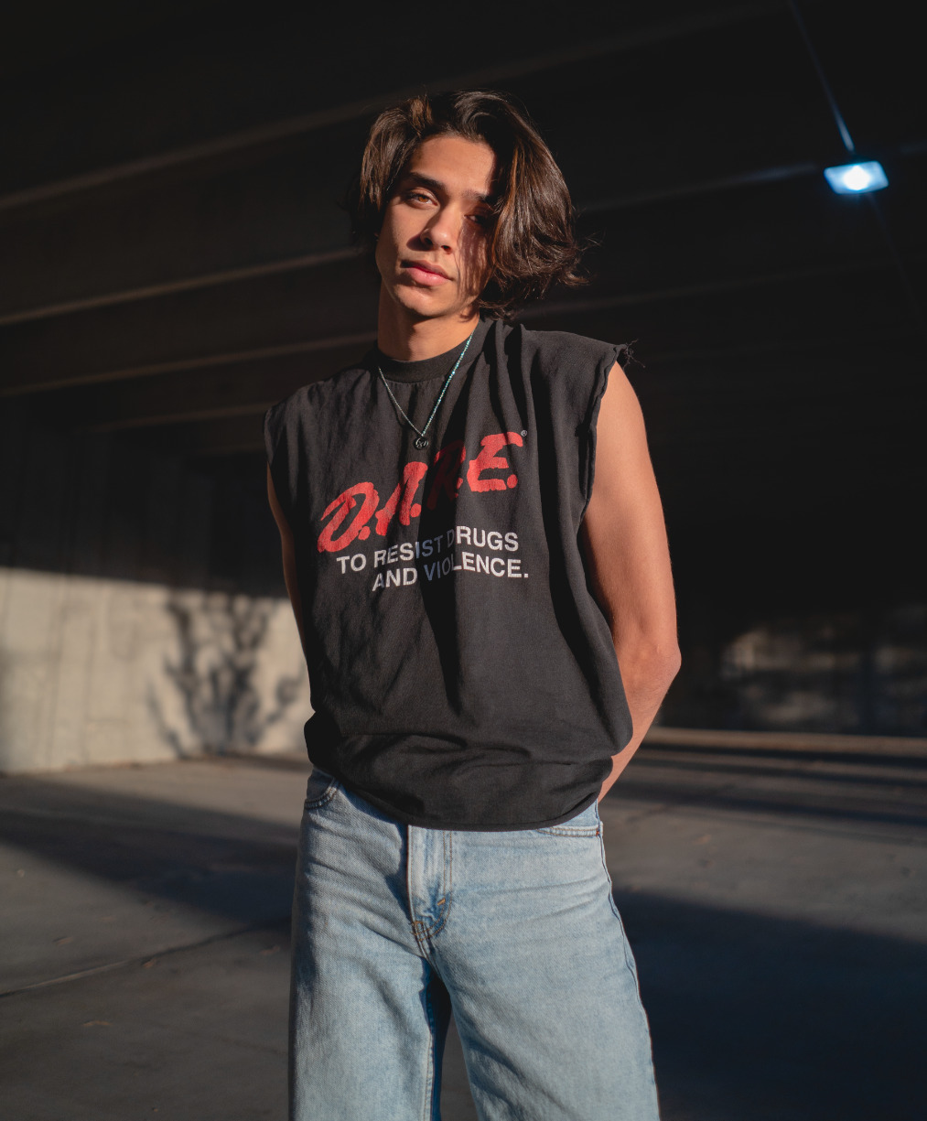
DOWNLOAD HIGH-RES IMAGE + ART (Credit: SAMPSON CLARK)

“Justice Carradine is a name that needs to be on your radar.”
– IDOLATOR

Chosen Music/Atlantic recording artist Justice Carradine has returned with the release of his irresistibly catchy new single, “Limbo,” available now via all DSPs and streaming services HERE. Shot in the beautiful outdoors of Utah while in quarantine, the song is joined by an official video streaming via YouTube HERE.

Co-written by Justice and produced by Luke Niccoli (Gryffin), “Limbo” pushes Carradine’s unique brand of high energy pop towards new heights, once again fusing alternative, R&B, rock, and more to create something moving, memorable and altogether his own.

“‘Limbo’ is about transitioning from one phase of life to another,” says Justice. “When I wrote it, I was coming to terms with turning 20. It sounds kind of dumb, but at the time my identity revolved around who I was as a teenager. Letting go of the way you identified for so long can be scary because it comes with uncertainty and anxiety. This song was my way of dealing with that.”

Today’s release follows the singer-songwriter and multi-instrumentalist’s latest single, “Necessary Evil,” which arrived earlier this year. Ones to Watch applauded “the dynamic track” as “a fusion of alternative elements and pop aesthetics that impeccably shows Carradine’s versatility,” calling Justice “a veritable pop tour-de-force.”

“Necessary Evil” arrived as the follow-up to Justice’s soulful debut single, “Dangerous Love” for which the official companion video, directed by acclaimed photography and film duo LOWFIELD (Pharrell Williams, Halsey), premiered via Billboard – watch HERE. “Dangerous Love” marked the first official single release from Carradine following a series of increasingly popular cover performances that earned him more than 5 million views on YouTube.

The Utah-born, Los Angeles-based artist grew up in a household surrounded by music, picking up ukulele, drums, piano, and guitar at just five years of age. His rich family heritage – Italian on his dad’s side and half-Samoan/half-Apache on his mom’s – proved hugely inspiring, with his Native American background especially influencing him on a profoundly personal level. At 13, Carradine began posting videos on Vine, fast developing a devout social media following whilst he was still in junior high. He transitioned to YouTube in 2015 and quickly racked up millions of views for tender and inventive covers of artists including The 1975, Post Malone, and Ed Sheeran. He soon began penning his own original material, unveiling his first independent single, “Okay,” in late 2018.

Hailed for his remarkable range and undeniable charisma, the gifted live performer earned acclaim on tour across North America supporting Spencer Sutherland and K-Pop star Amber Liu. Carradine’s distinctive presence and style has also landed him high profile campaigns for such diverse brands as Hollister, Puma, and M&Ms.

CONNECT WITH JUSTICE:
INSTAGRAM | FACEBOOK | YOUTUBE | TWITTER | PRESS ASSETS

PRESS CONTACT:
ANDREW.GEORGE@ATLANTICRECORDS.COM

# # #

