FOR IMMEDIATE RELEASE
MAY 26, 2021

JUSTICE CARRADINE WILL BE “OKAY”

SINGER-SONGWRITER AND MULTI-INSTRUMENTALIST
SHARES VULNERABLE NEW SONG AND COMPANION VISUAL

LISTEN HERE | WATCH HERE

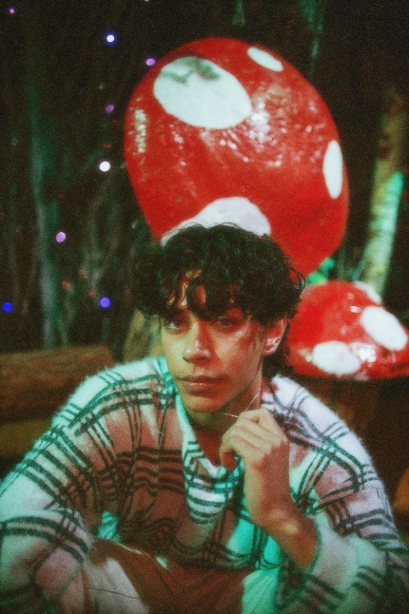
DOWNLOAD HIGH-RES ARTWORK

Chosen Music/Atlantic recording artist Justice Carradine has released his first new single of 2021. “Okay” is available now at all DSPs and streaming services. Written about mental health struggles endured in his teens, the emotionally raw and introspective song arrives alongside an official video directed by Eli Sokhn (Why Don’t We) and creative directed by Justice himself. Watch HERE.

“I was at a breaking point when I wrote this song,” says Justice. “At the time, my home life was rough and I was really struggling with my mental health. Being in that space while trying to understand life as a teenager, I kinda just wished someone cared enough to ask me if I was okay. This song was a way for me to do that for myself.”

“Okay” follows last year’s series of acclaimed single releases including “Can’t Feel A Thing” and “Limbo.” “It’s understandable to experience any type of derealization in this wildly disorienting year, and singer-songwriter Justice Carradine beautifully deploys his voice to capture that type of confusion on ‘Can’t Feel A Thing,’” wrote Billboard. Co-written by Justice and produced by Luke Niccoli (Gryffin), the irresistibly catchy “Limbo” was met by praise from Popdust, which raved, “‘Limbo’ is another unique offering of Carradine’s high energy pop music…combining alternative with R&B and funk.” Filmed in the singer-songwriter’s home state of Utah, the official video for “Limbo” is streaming now HERE.

Hailed by EUPHORIA as “an undeniable rising star,” Justice grew up surrounded by music, picking up ukulele, drums, piano, and guitar at just five years of age. His rich family heritage – Italian on his dad’s side and half-Samoan/half-Apache on his mom’s – proved tremendously inspiring, with his Native American background especially influencing him on a profoundly personal level. At 13, Carradine began posting videos on Vine, quickly developing a devout social media following. He transitioned to YouTube in 2015 where he racked up more than 5M views for tender and inventive covers of The 1975, Post Malone and more. Soon he began penning his own original songs fusing alternative, R&B, rock and more into his own unique brand of pop.

Towards the end of 2019, Justice made his major label debut with the soulful single, “Dangerous Love,” joined by an official music video directed by acclaimed photography and film duo LOWFIELD (Pharrell Williams, Halsey) and streaming now at YouTube HERE following its exclusive premiere via Billboard. Kicking off 2020 with his follow-up single, “Necessary Evil,” Ones To Watch instantly declared the rising star “a veritable pop tour-de-force.”

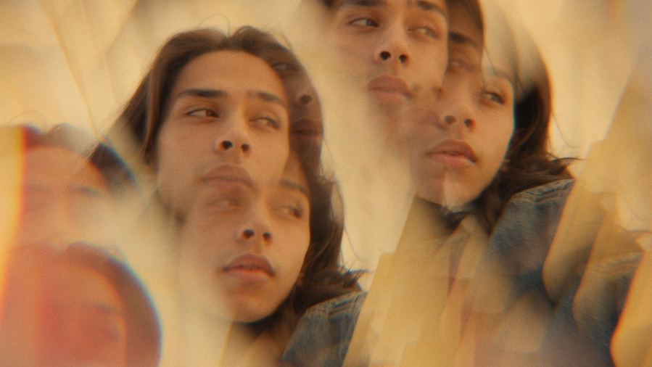

CONNECT WITH JUSTICE:
OFFICIAL | INSTAGRAM | FACEBOOK | YOUTUBE | TWITTER | PRESS ASSETS

PRESS CONTACT:
ANDREW.GEORGE@ATLANTICRECORDS.COM

