FOR IMMEDIATE RELEASE

JUNE 23, 2017

JAYMES YOUNG UNVEILS DEBUT ALBUM “FEEL SOMETHING”

SINGER-SONGWRITER-PRODUCER RELEASES EAGERLY AWAITED DEBUT PROJECT FEATURING
STREAMING SENSATIONS, “I’LL BE GOOD,” AND “WE WON’T” FT. PHOEBE RYAN

FIRST-EVER NATIONWIDE HEADLINE “FEEL SOMETHING” TOUR KICKS OFF JULY 10TH IN SANTA ANA
WITH MULTIPLE SOLD-OUT SHOWS, INCLUDING A STOP AT THE TROUBADOUR IN LA ON JULY 11TH,
AND A PERFORMANCE AT BOWERY BALLROOM IN NYC ON JULY 27TH

“FEEL SOMETHING” AVAILABLE EVERYWHERE TODAY

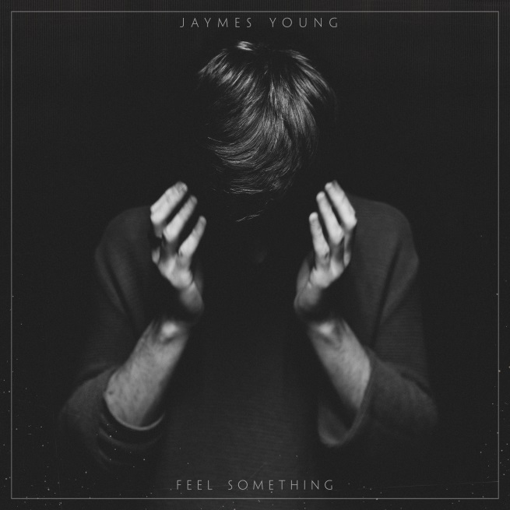
DOWNLOAD/STREAM “FEEL SOMETHING”

“Musically, it’s all lush arrangements, majestic synths, exotic rhythms and irresistible melodies – setting him exceedingly apart from his quotidian pop contemporaries.) – BLACKBOOK

“The release of Feel Something will no doubt solidify him as a major player in the pop market in years to come.” – EARMILK

"The album name and title track, Feel Something, fully encapsulates the core essence of his music–raw and honest interpretations of life and love bundled in a quality alt-pop sound." – ONES TO WATCH

Today, Please Rewind/Atlantic Records recording artist Jaymes Young officially releases his eagerly awaited debut album “FEEL SOMETHING” which is available now at all music retailers and streaming services. Download/Stream HERE.

“FEEL SOMETHING” features streaming hits “I’ll Be Good” and "We Won't" (feat. Phoebe Ryan)." Previously included on 2014's "HABITS OF MY HEART" EP, “I’ll Be Good” is Jaymes’ biggest single thus far with over 30 million streams and a companion video which is approaching nearly 20 million views. Stereogum has hailed the track and video as both a "gorgeous sadcore single" and "an equally heart-wrenching video...it's a scorching, introspective clip, with muted colors and surreal shots of fish swimming in IV bags." “We Won’t” reached #1 on Hype Machine, boasts over 30 million streams worldwide, and just last week received a compelling visual to accompany the track which premiered via Blackbook. Watch the video which stars both Jaymes Young and Phoebe Ryan themselves HERE. In the weeks leading up to the release of “FEEL SOMETHING,” Jaymes has received media attention for various exclusive track releases including praise from TIME, Billboard, VICE’s Noisey, NYLON, Idolator, Blackbook, Earmilk and more.

In conjunction with the album release, Jaymes’ first-ever 17-date headlining “Feel Something” tour will kick off in Santa Ana, CA at the Constellation Room, with multiple sold-out shows, including a stop at the famed Troubadour in Los Angeles on July 11th, and a performance at Bowery Ballroom in New York City on July 27th before wrapping up at the Exit/In in Nashville on August 2nd. Jaymes has traveled the road nearly non-stop in recent years, including headline shows and tours alongside London Grammar and F-Stop/Atlantic recording artist Vance Joy. For complete details and ticket information, please visit www.jaymesyng.com.

****

Jaymes Young will assure you that he’s a “songwriter before a singer and performer.” That wise and self-aware summation cuts to the core of who the Seattle-born and Los Angeles-based musician/poet really is. Spending countless hours holed up in his bedroom carefully piecing together compositions, penning lyrics, and exploring sounds, he creates music that’s steeped in pop palatability, dusky cinematic electronics, and stark, stirring instrumentation.

2013 saw Jaymes independently release the critically acclaimed “DARK STAR” mixtape, gaining praise from Nylon, Pigeons & Planes, VICE’s Noisey and more. Following his signing to Atlantic Records, his “HABITS OF MY HEART” EP spawned viral hits such as the title track and “I’ll Be Good,” which both surpassed 20 million Spotify streams. Supporting the EP, he hit the road with the likes of London Grammar and Vance Joy. And fueled by fan fervor, 2015’s “We Won’t” with Phoebe Ryan caught on like proverbial wildfire, amassing over 30 million Spotify streams and 4 million Soundcloud plays and receiving praise from Billboard, Earmilk, IndieShuffle and more. 2017 brings the arrival of his much-anticipated, full-length debut, “FEEL SOMETHING.”

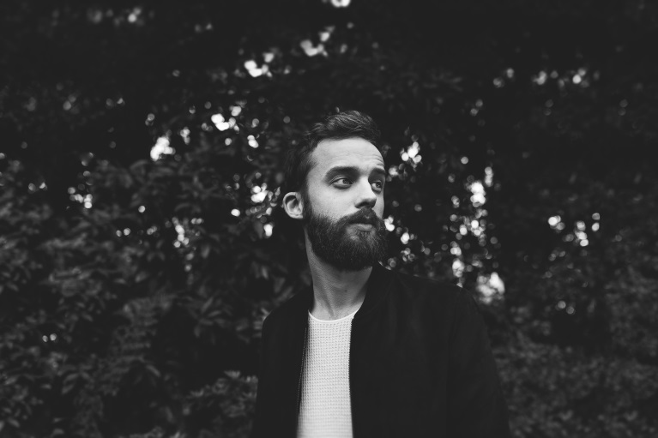
(photo credit: Lexus Gallegos / download high-res images)

JAYMES YOUNG SOCIALS:
Facebook / Twitter / Instagram / Soundcloud / Spotify / YouTube

“FEEL SOMETHING” LP TRACKLISTING:
1. Tied Down
2. Stoned On You
3. Don’t You Know
4. Stone
5. Sugar Burn
6. Feel Something
7. Black Magic
8. We Won’t
9 Naked
10. Two People
11. I’ll Be Good
12. Infinity

2017 NORTH AMERICAN SUMMER FEEL SOMETHING TOUR DATES:
7/10 – Constellation Room @ Santa Ana, CA
7/11 – Troubadour @ Los Angeles, CA
7/13 – Popscene @ Rickshaw Stop @ San Francisco, CA
7/14 – Hawthorne Theater @ Portland, OR
7/15 – The Biltmore Cabaret @ Vancouver, BC
7/16 – The Crocodile @ Seattle, WA
7/19 – Larimer Lounge @ Denver, CO
7/21 – recordBar @ Kansas City, MO
7/22 – Beat Kitchen @ Chicago, IL
7/23 – The Shelter @ Detroit, MI
7/25 – Velvet Underground @ Toronto, ON
7/27 – Bowery Ballroom @ New York, NY
7/28 – The Sinclair @ Boston, MA
7/29 – The Foundry v Philadelphia, PA
7/30 – Rock & Roll Hotel @ Washington, DC
8/1 – Vinyl @ Atlanta, GA
8/2 – Exit/In @ Nashville, TN​​​​​​​

CONTACTS:

Glenn Fukushima (National):
glenn.fukushima@atlanticrecords.com / 818-238-6833

Andrew George (Online/Tour):
andrew.george@atlanticrecords.com / 818-238-6850

