FOR IMMEDIATE RELEASE
FEBRUARY 18, 2022

OLIVER TREE UNVEILS NEW ALBUM COWBOY TEARS

NEW SINGLE & MUSIC VIDEO “SWING & A MISS” OUT TODAY

TO HOST EXCLUSIVE MEME MUSEUM POP-UP TODAY IN LA PRESENTED BY AMAZON MUSIC

COWBOY TEARS 2022 TOUR LAUNCHES TOMORROW AT A SOLD-OUT SHRINE EXPO HALL IN LOS ANGELES WITH A FULL NORTH AMERICAN RUN TO FOLLOW

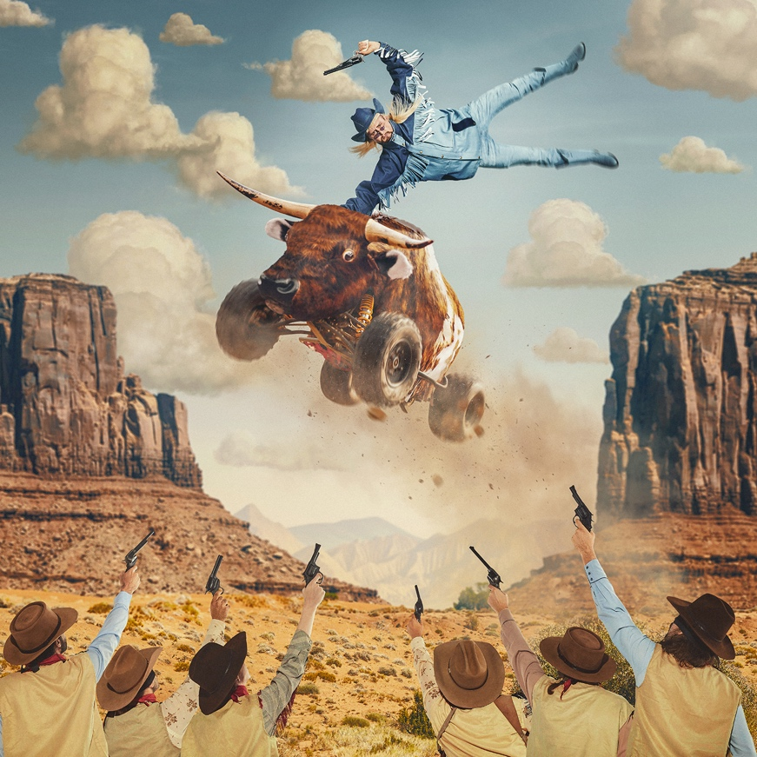
(Cowboy Tears album artwork)

(Los Angeles, CA: February 18, 2022) – Chart-topping, genre-bending artist Oliver Tree proudly presents his highly-anticipated new album, Cowboy Tears (Atlantic Records), today. It is available HERE.

It includes the breezy new single “Swing & A Miss,” which he shared a music video for. Watch it HERE. On the track, delicately plucked guitar brushes against his dynamic delivery before a glitchy beat ramps up. The momentum culminates on a hummable hook, “If this is it, it’s a swing and a miss.”

Earlier this month, he paved the way for the album with “Freaks & Geeks.” The track has already amassed over 5 million YouTube views in less than two weeks on the furry and fuzzy music video. In addition to plugs from DORK, Substream Magazine, and more, Vanyaland hailed it as “a new anthem for the outlaw misfit in all of us.”

From the pulpy pop of “Suitcase Full of Cash” to the epic finale on the title track “Cowboy Tears,” the album expands his fascinating and fiery world. Get ready to cry Cowboy Tears with Oliver Tree. See full tracklisting below.

Already, tracks from the record have cumulatively reeled in tens of millions of streams and views buoyed by the opener “Cowboys Don’t Cry.” He delivered the tune’s debut performance on Jimmy Kimmel LIVE! Watch it HERE. So far, the music video has racked up over 15 million YouTube views, while the song has garnered 15 million streams and counting. He also appeared on Apple Music 1’s ALT CTRL radio where he discussed the single and what’s in store for 2022.

Tonight, Oliver will host an exclusive Cowboy Tears Meme Museum Pop-up event where he and his special guests will celebrate the release of the new project with meet and greets, the world’s biggest scooter, merch giveaways and more. For additional details, visit www.olivertreemusic.com/RSVP

The Cowboy Tears tour kicks off tomorrow Saturday, February 19, 2022, at Los Angeles, CA’s legendary venue, The Shrine Expo Hall, and continues through late March in the US with support from RIAA certified singer/producer and viral phenomenon Sueco as well as 18-year-old Canadian DIY artist 347aidan. Oliver will also light up the stage at Ultra Music Festival, Hangout Fest, Boston Calling, and more in 2022. He’s recently announced headline dates in Mexico, South America, and Australia that’ll take him around the globe into late July. For all touring details, visit www.olivertreemusic.com.

(Oliver Tree Press Photo – credit: Jimmy Fontaine)

TRACKLISTING
- Cowboys Don’t Cry
- Swing & A Miss
- Freaks & Geeks
- Doormat
- Suitcase Full of Cash
- Cigarettes
- Balloon Boy
- Things We Used To Do
- California
- Get Well Soon
- Playing With Fire
- The Villain
- Cowboy Tears

ABOUT OLIVER TREE
An internet-based vocalist, producer, writer, director and performance artist, Oliver Tree explores the intersection where pop and alternative meet sonically and has arrived where art and entertainment collide visually. From comedy to action sports, mock reality TV drama to WWF wrestling in his live shows, the world of Oliver Tree is unlike any artist who has come before him.

A Santa Cruz, California native, Tree has emerged as a polymath from many different projects and iterations over the last 10 years. As unpredictable as one artist can be, no one can seem to put their finger on what Oliver Tree will do next. Unafraid to make you laugh, cry, think profoundly or feel completely uncomfortable for the length of a 4-minute music video, he is on the road to developing his own blueprint for packaging and marketing pop culture in the internet era. Versatile in every sense of the word, Tree not only explores every type of entertainment but also every type of genre in his music alike. The box he puts himself in is limitless. It has no boundaries. Oliver Tree has built a multimedia project designed to challenge people’s perspective of what art is, and he’s not the slightest bit concerned with what anyone has to say about it!

OLIVER TREE
COWBOY TEARS TOUR
Featuring special guests Sueco and 347aidan

FEBRUARY 2022
19 – Los Angeles, CA – Shrine Expo Hall *SOLD OUT*
22 – San Francisco, CA – The Warfield Theatre
25 – Seattle, WA – Showbox SoDo *SOLD OUT*
26 – Garden City, ID – Revolution Concert House & Event Center

MARCH 2022
1 – Salt Lake City, UT – The Complex *SOLD OUT*
2 – Denver, CO – The Mission Ballroom *SOLD OUT*
4 – Chicago, IL – Radius
5 – Detroit, MI – The Fillmore Detroit
6 – Cleveland, OH – Agora Theatre & Ballroom
9 – Columbus, OH – Kemba Live!
11 – Boston, MA – House of Blues *SOLD OUT*
12 – New York, NY – Hulu Theatre at Madison Square Garden
14 – Pittsburgh, PA – Stage AE
16 – Philadelphia, PA – The Fillmore Philadelphia
17 – Silver Spring, MD – The Fillmore Silver Spring
18 – Charlotte, NC – The Fillmore Charlotte *SOLD OUT*
19 – Atlanta, GA – The Tabernacle
22 – Nashville, TN – Marathon Music Works *SOLD OUT*
24 – Dallas, TX – The Factory
25 – Houston, TX – 713 Music Hall
25-27 – Miami, FL – Ultra Music Festival
26 – Austin, TX – Stubb's Waller Creek Amphitheater *SOLD OUT*

APRIL 2022
22 – Buenos Aires, AR – Teatro Vorterix
26 - Santiago, CL - Teatro Caupolicán
29 - Rio De Janeiro, BR - Sacadura 154
30 - São Paulo, BR - Audio

MAY 2022
3 - Lima, PE - Arena Peru (Hall)
7 - Bogotá, CO - Royal Center
9 - Guadalajara, MX - Teatro Diana
12 - Monterrey, MX - Auditorio Pabellón M
13, 14 - Mexico City, MX - Tecate Emblema Festival
20 – Gulf Shores, AL – Hangout Music Festival
27 – Boston, MA – Boston Calling Music Festival
29 – Louisville, KY – Forecastle Festival

JULY 2022
16 - Perth, AUS - Astor Theatre
19 - Sydney, AUS - Enmore Theatre
21 - Melbourne, AUS - Fourm
22 - Adelaide, AUS - Spinoff
23 - Yelgun, AUS - Splendour In The Grass

# # #

CONNECT WITH OLIVER TREE
WEBSITE | FACEBOOK | TWITTER | INSTAGRAM | YOUTUBE | SPOTIFY | TIK TOK

