FOR IMMEDIATE RELEASE
JANUARY 12, 2022

OLIVER TREE ANNOUNCES NEW ALBUM COWBOY TEARS – OUT FEBRUARY 18 ON ATLANTIC RECORDS
THE CHART-TOPPING VIRAL PHENOMENON SHARES NEW SINGLE & MUSIC VIDEO “COWBOYS DON’T CRY” STARRING BELLA THORNE – WATCH HERE
SET TO PERFORM ON JIMMY KIMMEL LIVE! TOMORROW JANUARY 13

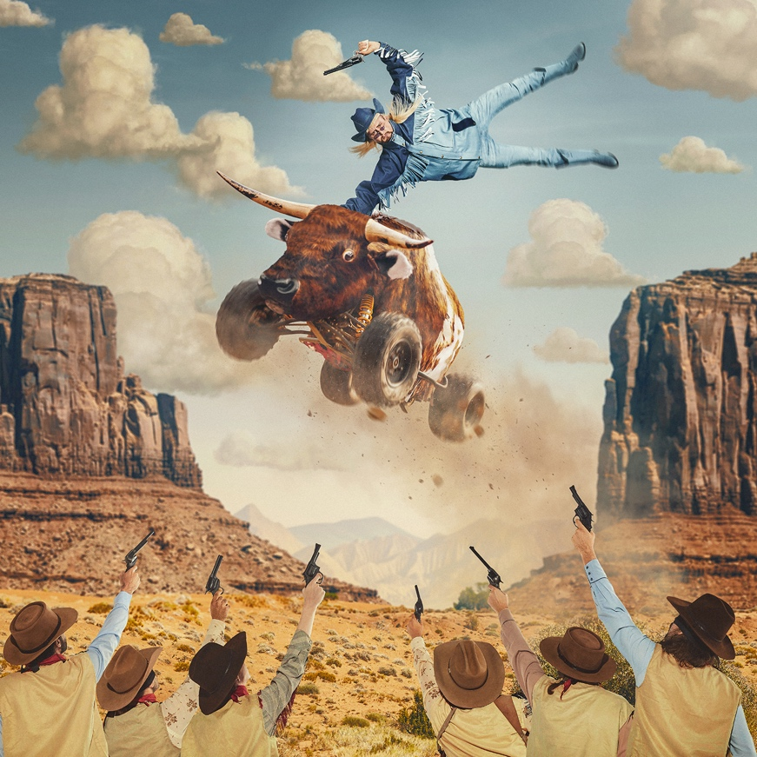
(Cowboy Tears album artwork)

Chart-topping, genre-bending artist Oliver Tree announces his eagerly awaited new album, Cowboy Tears (Atlantic Records). Embracing a new twangy, country sound, the upcoming project will be released on February 18th on Atlantic Records and is available for pre-order and pre-save HERE.

"Cowboys are the toughest guys. It's okay for us tough guys to cry, and the thing is, it's okay for everyone to cry," Tree explains. "There's a lot of anger that comes out of holding in your emotions, and that's really popular for guys. Cowboy Tears is teaching people how to let it out and be able to put it out in a way that isn't going to be violent or self-destructive."

He sets the stage for the record with a brand new single and music video entitled “Cowboys Don’t Cry.” Listen to “Cowboys Don’t Cry” HERE and watch the music video HERE.

Over sparse and breezy lo-fi production, Tree’s voice glides towards a catchy chorus, singing, “Riding around this carousel, if you catch my drift,” before lamenting, “Love is like a circle, there’s no easy way to end.”

In the accompanying visual, a scorned lover boots Oliver Tree out of the house as she tosses his clothes across the lawn. Joined by the incomparable Bella Thorne, Oliver gets into all kinds of cowboy antics. He cruises around town on a longhorn four-wheeler with two brides, hoists a boombox John Cusack-style, and gets pelted with tomatoes by an angry girl gang.

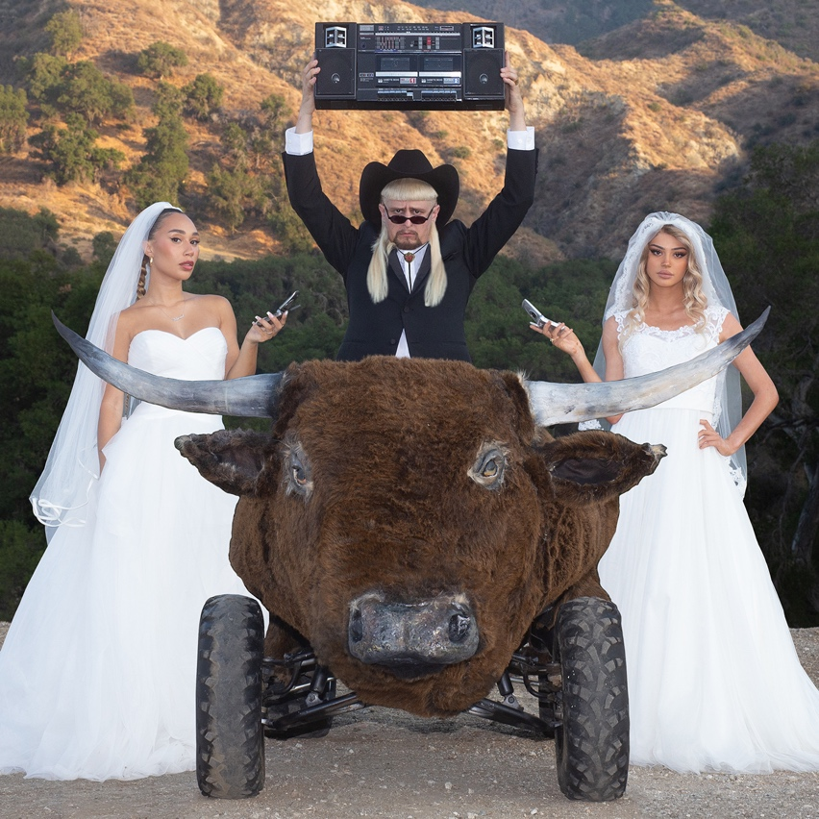
(“Cowboys Don’t Cry” single artwork)

Tree will cap this week off with an unforgettable performance on Jimmy Kimmel LIVE! Thursday, January 13. Tune in to witness the late-night television medley debut of new single “Cowboys Don’t Cry” and chart-topping hit “Life Goes On” —with a few surprises, of course.

Meanwhile, his buzzing smash single “Life Goes On” just cracked Top 25 at Pop Radio, marking his highest chart position yet. The song is cumulatively nearing half-a-billion total streams and counting.

Recently joined by remixes from RIAA-certified rappers Trippie Redd and Ski Mask The Slump God, GRAMMY award winning trio Clean Bandit, platinum selling global superstar Ty Dolla $ign and Brazilian superstar ALOK, the original track was featured on the deluxe edition of Tree’s acclaimed debut album Ugly is Beautiful: Shorter, Thicker & Uglier. The viral track is making waves across all platforms. Currently boasting over 600 million streams, 165 million video views, 3 million Instagram reels and 3.1 million Shazams. With over 25 million TikTok videos created with its sound, “Life Goes On” has amassed over 30 billion TikTok views across all videos, landing it at TikTok’s #6 global track of 2021 and Oliver as the #5 most viewed artist on the platform. He was also ranked the #6 artist with the most growth on the app in the U.S. in 2021.

(Oliver Tree Press Photo – credit: Jimmy Fontaine)

Oliver Tree will launch his largest North American headline tour to date and last tour ever. The Cowboy Tears tour kicks off February 19, 2022 at Los Angeles, CA’s legendary venue, The Shrine Expo Hall, and continues through late March with support from RIAA certified singer/producer and viral phenomenon Sueco as well as 18-year-old Canadian DIY artist 347aidan. The acclaimed live performer will also light up the stage at Ultra Music Festival in March 2022. For all touring details, please visit www.olivertreemusic.com.

With over 2.4 billion global streams to date, over 730 million video views on YouTube alone, and 12 million TikTok followers, Oliver Tree is undeniably among the most popular – and most provocative – artists of the Gen-Z era. Oliver kicked off 2021 by teaming up with rap superstar Lil Yachty for the acclaimed collaboration, “Asshole.” Most recently, Oliver teamed up with Russian viral hitmakers Little Big for the revolutionary joint EP, Welcome To The Internet. The project was first heralded by the lead single, “Turn It Up,” featuring Estonian rapper Tommy Cash. The project also included standout track “The Internet” which was accompanied by a meme-filled official video, streaming now HERE.

ABOUT OLIVER TREE
An internet-based vocalist, producer, writer, director and performance artist, Oliver Tree explores the intersection where pop and alternative meet sonically and has arrived where art and entertainment collide visually. From comedy to action sports, mock reality TV drama to WWF wrestling in his live shows, the world of Oliver Tree is unlike any artist who has come before him.

A Santa Cruz, California native, Tree has emerged as a polymath from many different projects and iterations over the last 10 years. As unpredictable as one artist can be, no one can seem to put their finger on what Oliver Tree will do next. Unafraid to make you laugh, cry, think profoundly or feel completely uncomfortable for the length of a 4 minute music video, he is on the road to developing his own blueprint for packaging and marketing pop culture in the internet era. Versatile in every sense of the word, Tree not only explores every type of entertainment but also every type of genre in his music alike. The box he puts himself in is limitless. It has no boundaries. Oliver Tree has built a multimedia project designed to challenge people’s perspective of what art is, and he’s not the slightest bit concerned with what anyone has to say about it!

OLIVER TREE
COWBOY TEARS TOUR
Featuring special guests Sueco and 347aidan

FEBRUARY 2022
19 – Los Angeles, CA – Shrine Expo Hall
22 – San Francisco, CA – The Warfield Theatre
25 – Seattle, WA – Showbox SoDo
26 – Vancouver, BC – PNE Forum

MARCH 2022
1 – Salt Lake City, UT – The Complex
2 – Denver, CO – The Mission Ballroom
4 – Chicago, IL – Radius
5 – Detroit, MI – The Fillmore Detroit
7 – Toronto, ON – History
9 – Montreal, QC – MTELUS
11 – Boston, MA – House of Blues
12 – New York, NY – Hulu Theatre at Madison Square Garden
14 – Pittsburgh, PA – Stage AE
16 – Philadelphia, PA – The Fillmore Philadelphia
17 – Silver Spring, MD – The Fillmore Silver Spring
18 – Charlotte, NC – The Fillmore Charlotte
19 – Atlanta, GA – The Tabernacle
22 – Nashville, TN – Marathon Music Works
24 – Dallas, TX – The Factory
25 – Houston, TX – 713 Music Hall
26 – Austin, TX – Stubb's Waller Creek Amphitheater

# # #

CONNECT WITH OLIVER TREE
WEBSITE | FACEBOOK | TWITTER | INSTAGRAM | YOUTUBE | SPOTIFY | TIK TOK

