FOR IMMEDIATE RELEASE

MARCH 3, 2017

ATLANTIC WELCOMES SONGBIRD RAVYN LENAE TO ITS HISTORIC ROSTER

18-YEAR-OLD CHICAGO-BASED SENSATION TO DEBUT
EAGERLY AWAITED NEW EP

ACCLAIMED SINGER-SONGWRITER TRAVELING NORTH AMERICA NOW
WITH NONAME’S “TELEFONE TOUR”

MIDNIGHT MOONLIGHT” AVAILABLE EVERYWHERE TODAY

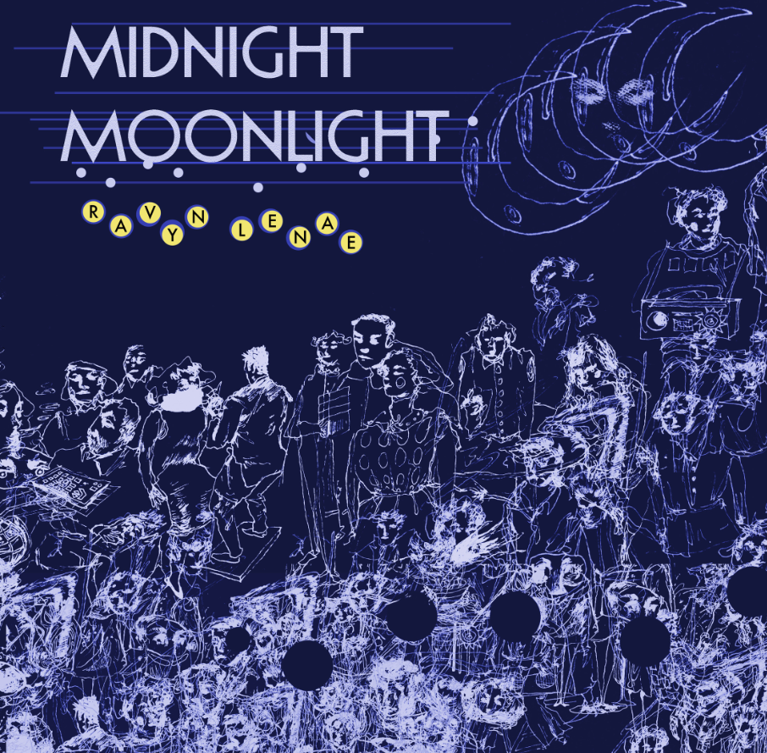
BUY | STREAM
“...one of the most compelling new voices in music.” – Pigeons & Planes
“…a jewel whose sensibility is so pristine one feels like they're trampling the grass just listening in on her…” – Complex
“Ravyn Lenae Doesn’t Want To Be A Star because she’s reaching for the moon.” – Nylon
Download Press Assets here

Three Twenty Three Music Group Inc /Atlantic Records has announced Ravyn Lenae as the newest member of its historic roster. The Chicago-based singer-songwriter will make her label debut with the new EP, “MIDNIGHT MOONLIGHT,” available everywhere today – https://atlanti.cr/midnightmoonlight for streaming and purchase at all U.S. digital retailers.

Named by NYLON as one of “21 Cool Artists 21 And Under,” Lenae is celebrating the announcement with the release of a new standalone video, “Alive.” The clip – which premiered on VIBE last week was directed by A Zae Production and is streaming now at the official Ravyn Lenae YouTube channel.

Already known as an energetic and exciting live presence, Lenae is currently wrapping up the “Telefone Tour” alongside fellow Chicagoan Noname, with dates set to continue through early March (see attached itinerary). To see a recap of the tour so far, check out https://youtu.be/z905M9TTdlQ. Additional live dates surrounding the release of “MIDNIGHT MOONLIGHT” will be announced soon – please see www.ravynlenae.com for updates and more.

At just 18 and still attending high school – Ravyn Lenae is a phenomenon, acclaimed for her natural talent, inimitable approach, and crafty songwriting. A member in good standing of Chicago’s influential Zero Fatigue collective, Lenae immediately made waves with 2015’s hit single, “Greetings,” followed shortly thereafter by her breakthrough debut EP, “MOON SHOES.” Hailed by Hypetrak as a “combination of entrancing vocals, control over creative cadences and superb writing,” the EP has earned close to 2.5 million individual plays while also reaching the top 25 on the iTunes Store’s “Top R&B/Soul Albums” chart.

Lenae has since earned applause from some of today’s biggest stars, including Nas, Erykah Badu, Martin Garrix, and fellow Atlantic recording artist Kehlani. She has also drawn ecstatic critical praise from a wide range of media outlets. Pigeons & Planes named Lenae to its “Best New Artists of 2016” ranking, declaring her “Chicago’s best-kept secret…Spinning words in novel ways while adhering to today’s high standards for unique delivery, Ravyn’s cathartic musings shine bright.” Pitchfork raved about Lenae’s “sun-dappled repertoire, offering impressionistic soul that glides like a feather floating down a lazy river… She roars. She soars. She has the right.”

For more information, please visit www.ravynlenae.com, twitter.com/ravynlenae, www.instagram.com/ravynlenae, facebook.com/ravynlenae, youtube.com/ravynlenae, www.atlanticrecords.com and https://www.323musicgroup.com/.

RAVYN LENAE
“MIDNIGHT MOONLIGHT” EP
(Atlantic Records)
Release Date: March 3, 2017
Tracklisting

1. Genesis (Produced by NversivE)
2. Unknown (Produced by Monte Booker)
3. Spice (Produced by Monte Booker)
4. Hiatus (Waiting) (Produced by Monte Booker)
5. Last Breath (Produced by J. Hill)
6. Thirst (Produced by Carter Lang)

* * * * *

RAVYN LENAE
TOUR 2017
Remaining Dates w/NONAME

MARCH
3 Boston, MA Middle East Upstairs
5 Toronto, ON Adelaide Hall
6 Detroit, MI El Club

# # #

For press inquiries, please contact:
Ariana White // 212.707.2236 // Ariana.White@atlanticrecords.com

