RAVYN LENAE SHARES NEW SINGLE "SKIN TIGHT" FEAT. STEVE LACY
AVAILABLE NOW VIA ATLANTIC RECORDS

LAUNCHES ALONGSIDE OFFICIAL ANIMATED MUSIC VIDEO

WATCH HERE | LISTEN HERE

"Skin Tight" single artwork

Chicago-born Ravyn Lenae returns with her new long-awaited single "Skin Tight" featuring Steve Lacy. The smooth and sultry R&B track arrives alongside an animated video directed by London-based visual artist Zongbo Jiang, recently featured by DAZED for his eclectic creations, portraying a surreal virtual world where digital versions of Ravyn relax in pink clouds and dance in the grass around a statue made of humanoids. Watch the "Skin Tight" video HERE and stream it HERE.

Recorded in Los Angeles with her longtime collaborator Steve Lacy (Kendrick Lamar, The Internet), “Skin Tight” heralds Lenae’s much anticipated new album, due later this year. With its fluttering harmonies, lush guitar, and mesmerizing beat, the towering new track takes inspiration from such R&B icons as Brandy while simultaneously leaning into a larger, distinctly original vision. Ravyn instantly enchants on “Skin Tight.” Her vocals floats along as she pleads, “Hold me while you can,” before Steve counters with an entrancing melody.

"Skin Tight" is the first offering from Ravyn since her 2020 collaboration "Today" with Luke Titus and her contribution to the Insecure: Music from The HBO Original Series Season 4 soundtrack with "Rewind”. The new track represents the first taste of much more to come from Ravyn this year. In 2018, she released her EP Crush, which features the Steve Lacy assisted songs "Computer Luv” and "4 Leaf Clover."

Speaking on the new song, she says "I wanted to snap people into my world through the sonics, so they can feel how I’ve felt over the past couple of years... It has those hypnotic elements, but it’s very simple, familiar, and fresh. Thematically, it’s about not being in a relationship with somebody, but still having those physical and mental ties. It speaks to sharing kinetic energy with another person, even if time has passed and you aren’t together anymore.”

Stay tuned for more from Ravyn Lenae coming soon.

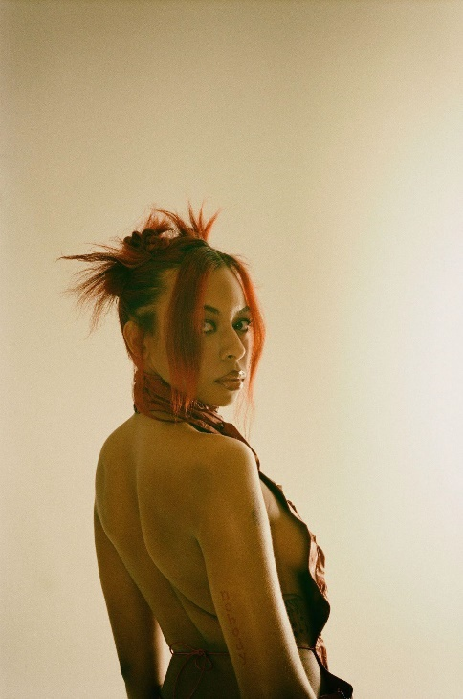

Download hi-res press photo(s), Credit: Jean Phillipe Joseph

About Ravyn Lenae:
Now boasting over 100M worldwide streams and counting, Ravyn Lenae honed her voice through intense classical training at Chicago’s High School For The Arts, inspired by a broad range of artists, from India.Arie and OutKast to Antonio Vivaldi and Reynaldo Hahn.

The young artist immediately made waves with her breakthrough debut EP, 2016’s Moon Shoes, earning over 12M individual plays while also reaching the top 25 on the iTunes Store’s “Top R&B/Soul Albums” chart.

Crush followed in 2018 and instantly established Lenae as a fan favorite and critical darling, with its sultry lead single, “Sticky,” amassing over 32M global streams while drawing praise from such national publications as Pitchfork, The FADER, and Billboard, which declared it to be “one of the most sumptuous, supple, meditative and detailed dispatches from a soulful young singer’s mind in recent memory.”

Widely praised as a sensational live performer – including headline shows and a blockbuster U.S. tour alongside fellow R&B sensation SZA – Lenae was among the top stars and rising artists featured on Raedio/Atlantic Record’s Insecure: Music From The HBO Original Series, with her “Rewind” prominently featured in one of Season 4’s key moments.

“When you listen to the music, I hope you have a better understanding of me and even catch a better understanding of yourself,” Lenae says. “As artists, we make music as a pathway to help other people understand certain aspects of their lives. I’ve gone through the tunnels and seen the light on the other side. I’m finding my way. I’m clearer on who I am and my power through music and lyricism. I’m pouring more into me, friendships, family, and music. Through all of that, I’m fulfilled.”

# # #

CONNECT WITH RAVYN LENAE
WEBSITE | TWITTER | INSTAGRAM | FACEBOOK | YOUTUBE

PRESS CONTACTS
Fairley McCaskill | Fairley.McCaskill@atlanticrecords.com
Nick Dierl |Nick@orienteer.us

