FOR IMMEDIATE RELEASE
AUGUST 5, 2019

ROB THOMAS SHARES “CAN’T HELP ME NOW” VIDEO

SECOND LEG OF NORTH AMERICAN CHIP TOOTH TOUR KICKS OFF AUG 16TH

SMASH SINGLE “ONE LESS DAY (DYING YOUNG)” HOLDS #1 SPOT
ON SIRUSXM FOR 7 CONSECUTIVE WEEKS

MULTI GRAMMY®-WINNING SUPERSTAR’S CRITICALLY ACCLAIMED
FOURTH SOLO ALBUM CHIP TOOTH SMILE AVAILABLE NOW

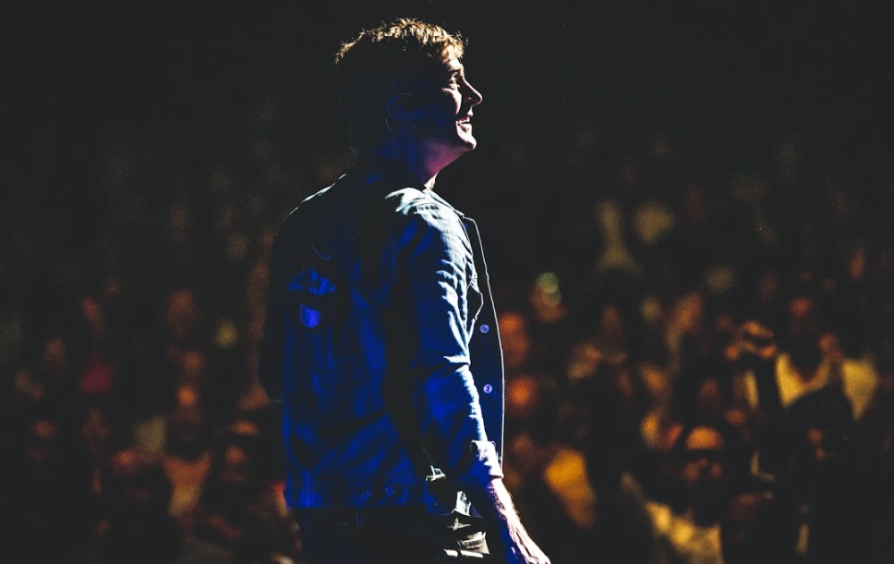

WATCH “CAN’T HELP ME NOW” VIDEO: LINK
BUY/STREAM Chip Tooth Smile: link

Multiple-GRAMMY® Award-winning singer/songwriter Rob Thomas has shared a dynamic new video for “Can’t Help Me Now,” off his critically acclaimed fourth solo album Chip Tooth Smile (available now via Emblem/Atlantic Records). The visual, shot along the just-wrapped first leg of Thomas’ North American Chip Tooth Tour, premiered this past weekend via Entertainment Tonight.

Thomas’ North American Chip Tooth Tour is set to resume next Friday, August 16th in Port Chester, NY and run through late September with special guest Max Frost (select dates only, full routing attached). Variety declared the live show to be “a fist-pumping celebration of life” following opening night in Red Bank, NJ, further praising Thomas as “a consummate performer” and noting “it’s impossible to keep your eyes off of him as he works every inch of the stage.”

Debuting at #3 on the Billboard Top Album Sales chart, Chip Tooth Smile has been met with an outpouring of critical acclaim since release last month. “Rob Thomas is an expert at his craft” raved Variety, while Forbes echoed “’Chip Tooth Smile’ is vintage Thomas – smart songwriting, excellent pop/rock craftsmanship, eclectic and at times moving, at times, fun, and always solid.” The 12-track collection features production from Butch Walker (Panic! At The Disco, P!nk) and Benny Blanco (Ed Sheeran), perfectly complimenting Thomas’ long-acclaimed songwriting talent.

Lead single “One Less Day (Dying Young)” has seen performances on ABC’s Good Morning America (WATCH), Jimmy Kimmel Live! (WATCH) and The Ellen DeGeneres Show (WATCH), in addition to holding the #1 spot on SirusXM’s The Pulse for 7 consecutive weeks & reaching #3 on Billboard’s Dance/Club Songs chart. Rolling Stone described the song as “thunderous, life-affirming” and “an impassioned vocal performance,” while Billboard declared it to be “one of the boldest singles released so far this year.” The album also includes standout tracks “Timeless,” inspired by classic songs of the 80s, and “I Love It,” which was featured nationwide for the 2019 NBA Playoffs (WATCH).

2019 also marks the 20th anniversary of Thomas’ explosive triple-platinum and triple-GRAMMY® Award winning collaboration with Santana, “Smooth” – which has received recent celebratory anniversary features and reignited viral acclaim via Rolling Stone, The FADER, Esquire the New York Post & more.

DOWNLOAD HIGH-RES PRESS IMAGE  (CREDIT: RANDALL SLAVIN) | DOWNLOAD HIGH-RES IMAGE  (CREDIT: ATLANTIC RECORDS)

***

ROB THOMAS
2019 NORTH AMERICAN CHIP TOOTH TOUR
LEG TWO – WITH SPECIAL GUEST MAX FROST

Fri Aug 16 | Port Chester, NY | Capitol Theatre
Sun Aug 18 | Burlington, VT | Flynn Center for the Performing Arts
Tues Aug 20 | Montreal, QC | MTELUS
Wed Aug 21 | Portland, ME | State Theatre
Fri Aug 23 | Ottawa, ON | Canadian Tire Centre
Sat Aug 24 | St Catharines, ON | Meridian Centre
Sun Aug 25 | London, ON | Budweiser Gardens
Tues Aug 27 | Pittsburgh, PA | Benedum Center for the Performing Arts
Wed Aug 28 | Rochester Hills, MI | Meadow Brook
Fri Aug 30 | Tulsa, OK | Brady Theater
Sat Aug 31 | Kansas City, MO | Uptown Theater
Sun Sept 1 | St Louis, MO | Stifel Theatre
Wed Sept 4 | Louisville, KY | Louisville Palace
Thurs Sept 5 | Youngstown, OH | Foundation Amphitheatre
Sun Sept 8 | Milwaukee, WI | Riverside Theatre
Fri Sept 13 | Albuquerque, NM | Route 66 Casino*
Fri Sept 20 | Riverside, CA | Fox Performing Arts Center*
Sat Sept 21 | Indio, CA | Fantasy Springs*
Tues Sept 24 | Tucson, AZ | Tucson Music Hall*
Fri Sept 27 | Reno, NV | Grand Sierra Casino*
Sat Sept 28 | Napa, CA | Silverado Resort and Spa*

*select dates without Max Frost

***

Rob Thomas is one of the most distinctive artists of this or any other era – a gifted vocalist, spellbinding performer, and acclaimed songwriter known worldwide as lead singer and primary composer with Matchbox Twenty as well as for his multi-platinum certified solo work and chart-topping collaborations with other artists. Among his countless hits are solo classics like “Lonely No More,” “This Is How A Heart Breaks,” and “Streetcorner Symphony,” Matchbox Twenty favorites including “Push,” “3AM,” “If You’re Gone,” and “Bent,” and of course “Smooth,” his 3x RIAA platinum certified worldwide hit collaboration with Santana which celebrates it’s 20th anniversary this year. Thomas earned three GRAMMY® Awards for his role as co-writer and vocalist on “Smooth,” which topped Billboard’s “Hot 100” for an astounding 12 consecutive weeks and spent 58 total weeks on the chart, the #1 song in Billboard’s “Top Hot 100 Rock Songs” chart history and #2 “Hot 100” song of all time. As if that weren’t enough, “Smooth” was declared the all-time #1 song on Billboard’s “Adult Pop Songs” radio airplay chart, the #1 song of the rock era based on chart performance on Billboard's Hot 100, and recently declared to still hold the spot as the second most successful song of all time by Billboard.

In 2004, Thomas was the first artist to be honored with the Songwriters Hall of Fame’s prestigious “Hal David Starlight Award,” created to recognize a composer in the early years of his or her career that has already made a lasting impact. He has won numerous BMI and ASCAP Awards, and twice earned the “Songwriter of the Year” crown from both Billboard and BMI. Overall, Thomas has contributed to sales of more than 80 million records.

Thomas made his solo debut with 2005’s platinum certified …Something To Be and immediately made history as the first album by a male artist from a rock or pop group to ever debut at # 1 on the Billboard 200. Thomas’ sophomore solo album, 2009’s Cradlesong, marked still another milestone, generating two #1 singles in “Her Diamonds” and “Someday.” Billboard chart history was made once again, with Thomas tying P!nk for the most #1 Adult Top 40 hits by a solo artist as well becoming the first male solo artist to score multiple chart-toppers at the format.

In 2012, Matchbox Twenty returned with their first all-new album in a decade, North. Fueled by the hit singles, “She’s So Mean,” “Overjoyed,” and “Our Song,” North proved a landmark for the band, their first ever #1 debut and Billboard 200 chart-topper. Thomas’ third solo album, 2015’s internationally acclaimed The Great Unknown, had a top 10 debut on the SoundScan/Billboard 200 upon its release and featured hit singles “Hold On Forever” and “Pieces.”

A charismatic, engaging, and indefatigable live performer, Thomas has spent much of the past two decades on the road, fronting massive world treks with Matchbox Twenty and on his own as well as a series of intimate acoustic tours. Thomas is also a dedicated philanthropist, establishing Sidewalk Angels Foundation with his wife Marisol Thomas in 2003. The organization is dedicated to providing critically needed funds and support to over 20 no-kill animal shelters and animal rescues, across the country, that help to fight for the rights and fair treatment of those with no voice. For additional information on Sidewalk Angels Foundation, please visit www.sidewalkangelsfoundation.org.

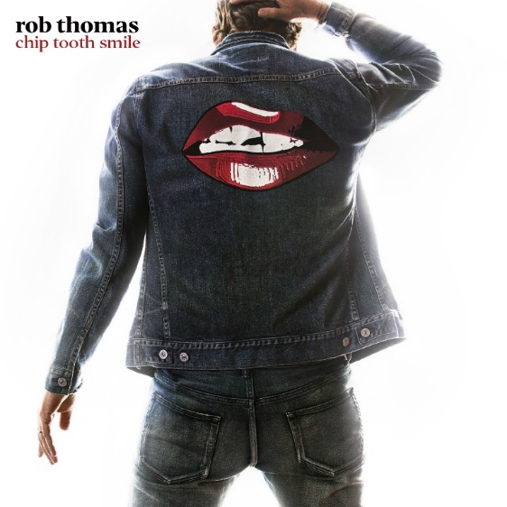

CONNECT:
RobThomasMusic.com | Twitter | Facebook | YouTube | Instagram | Press Assets
CONTACT:
Sheila Richman | sheila.richman@atlanticrecords.com
Ted Sullivan | ted.sullivan@atlanticrecords.com

