FOR IMMEDIATE RELEASE

SEPTEMBER 6, 2019

**ROB THOMAS SHARES “CAN’T HELP ME NOW (STRIPPED)”**

**MULTI GRAMMY®-WINNING SUPERSTAR’S CRITICALLY ACCLAIMED**

**FOURTH SOLO ALBUM *CHIP TOOTH SMILE* AVAILABLE NOW**

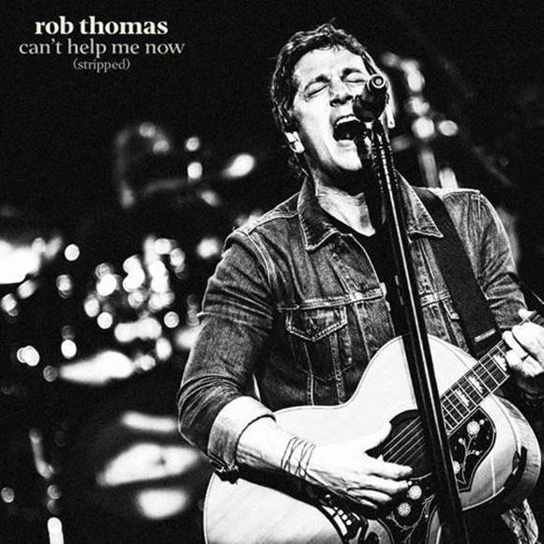

**WATCH “CAN’T HELP ME NOW (STRIPPED)”:** [LINK](https://nam04.safelinks.protection.outlook.com/?url=https%3A%2F%2Fwww.youtube.com%2Fwatch%3Fv%3DAjJVIziQMqg&data=02%7C01%7CBrian.Sommer%40atlanticrecords.com%7Cc66850176072416e63eb08d732d4bcf5%7C8367939002ec4ba1ad3d69da3fdd637e%7C0%7C0%7C637033761616232732&sdata=iwJb7OzhVknS5MgPEMTOTkHFoA8aTf0aZ5HOtl6hbA0%3D&reserved=0)

**BUY/STREAM *Chip Tooth Smile*:** [link](https://nam04.safelinks.protection.outlook.com/?url=https%3A%2F%2FAtlantic.lnk.to%2FChipToothSmilePR&data=02%7C01%7CBrian.Sommer%40atlanticrecords.com%7Cc66850176072416e63eb08d732d4bcf5%7C8367939002ec4ba1ad3d69da3fdd637e%7C0%7C0%7C637033761616242726&sdata=LfW2pVaFq0yRpOdY%2FP%2FsIqGEZ7S7RlCAx8XXQg%2BxmGw%3D&reserved=0)

Multiple-GRAMMY® Award-winning singer/songwriter **Rob Thomas** has shared a stripped back version of his latest single “**Can’t Help Me Now**,” off his critically acclaimed fourth solo album ***Chip Tooth Smile***(available now via **Emblem**/**Atlantic** **Records**). Thomas is currently on the road wrapping the second leg of his North American***Chip Tooth Tour***, which also served as the setting for the single’s [official music video](https://nam04.safelinks.protection.outlook.com/?url=https%3A%2F%2Fwww.youtube.com%2Fwatch%3Fv%3DXszjoovtcUU&data=02%7C01%7CBrian.Sommer%40atlanticrecords.com%7Cc66850176072416e63eb08d732d4bcf5%7C8367939002ec4ba1ad3d69da3fdd637e%7C0%7C0%7C637033761616252723&sdata=dVdI%2BDb%2BJgrnaMXfmU2vbqzoOogsz8JNgvLU6DT9It0%3D&reserved=0) that launched last month.

Debuting at #3 on the Billboard Top Album Sales chart, ***Chip Tooth Smile***has been met with an outpouring of critical acclaim. *“****Rob Thomas*** *is an expert at his craft”* raved **Variety**, while **Forbes** echoed “***’Chip Tooth Smile****’ is vintage Thomas – smart songwriting, excellent pop/rock craftsmanship, eclectic and at times moving, at times, fun, and always solid.”* The 12-track collection features production from **Butch Walker** (**Panic! At The Disco**, **P!nk**) and **Benny** **Blanco** (**Ed** **Sheeran**), perfectly complimenting Thomas’ long-acclaimed songwriting talent. **Rolling Stone** described lead single “[**One Less Day (Dying Young)**](https://nam04.safelinks.protection.outlook.com/?url=https%3A%2F%2Fyoutu.be%2FgaSoq9FELF8&data=02%7C01%7CBrian.Sommer%40atlanticrecords.com%7Cc66850176072416e63eb08d732d4bcf5%7C8367939002ec4ba1ad3d69da3fdd637e%7C0%7C0%7C637033761616262713&sdata=erS7qWBXyuW4LnSXX3ZN7qHeN8X85S9Ow8OaUlZ64J0%3D&reserved=0)” as “*thunderous, life-affirming”* and “*an impassioned vocal performance,”* while **Billboard** declared it to be “*one of the boldest singles released so far this year.”* The single also held the #1 spot on SirusXM’s *The Pulse* for 7 consecutive weeks.

**CONNECT:**

[RobThomasMusic.com](https://nam04.safelinks.protection.outlook.com/?url=https%3A%2F%2Fwww.robthomasmusic.com%2F&data=02%7C01%7CBrian.Sommer%40atlanticrecords.com%7Cc66850176072416e63eb08d732d4bcf5%7C8367939002ec4ba1ad3d69da3fdd637e%7C0%7C0%7C637033761616262713&sdata=SP6RhlQPWf3Y9pHBR5Bfmuo8jxhxEnTh7a0hYXnkfLs%3D&reserved=0) | [Twitter](https://nam04.safelinks.protection.outlook.com/?url=https%3A%2F%2Ftwitter.com%2FThisIsRobThomas&data=02%7C01%7CBrian.Sommer%40atlanticrecords.com%7Cc66850176072416e63eb08d732d4bcf5%7C8367939002ec4ba1ad3d69da3fdd637e%7C0%7C0%7C637033761616272711&sdata=6hkcIuouLltB1cEXiYXZhVZ3bgpiAeCASQkpkcTz%2B8c%3D&reserved=0) | [Facebook](https://nam04.safelinks.protection.outlook.com/?url=https%3A%2F%2Fwww.facebook.com%2Frobthomas&data=02%7C01%7CBrian.Sommer%40atlanticrecords.com%7Cc66850176072416e63eb08d732d4bcf5%7C8367939002ec4ba1ad3d69da3fdd637e%7C0%7C0%7C637033761616282706&sdata=eUMBFbYItVk%2BLKpIaDRaajWFnboi5LjDBSHMsEIzT0U%3D&reserved=0) | [YouTube](https://nam04.safelinks.protection.outlook.com/?url=https%3A%2F%2Fwww.youtube.com%2Fchannel%2FUCGisHCs_0OoG71Epo9ieSYA&data=02%7C01%7CBrian.Sommer%40atlanticrecords.com%7Cc66850176072416e63eb08d732d4bcf5%7C8367939002ec4ba1ad3d69da3fdd637e%7C0%7C0%7C637033761616292706&sdata=%2FCFMS36empxhy93lX8%2F7LO57eLCGnPU8%2BgEkI3Ssv80%3D&reserved=0) | [Instagram](https://nam04.safelinks.protection.outlook.com/?url=https%3A%2F%2Fwww.instagram.com%2Frobthomas%2F&data=02%7C01%7CBrian.Sommer%40atlanticrecords.com%7Cc66850176072416e63eb08d732d4bcf5%7C8367939002ec4ba1ad3d69da3fdd637e%7C0%7C0%7C637033761616292706&sdata=AxIufqDz5njXjBmmIYSUrSiDc6F3xeVmPByg%2BPwuymA%3D&reserved=0) | [Press Assets](https://nam04.safelinks.protection.outlook.com/?url=http%3A%2F%2Fpress.atlanticrecords.com%2Frob-thomas%2F&data=02%7C01%7CBrian.Sommer%40atlanticrecords.com%7Cc66850176072416e63eb08d732d4bcf5%7C8367939002ec4ba1ad3d69da3fdd637e%7C0%7C0%7C637033761616302699&sdata=DXodQveNIzHPxTJMqCimnfmdvjqwC4WNWnLMZDghy5M%3D&reserved=0)

**CONTACT**:

Sheila Richman | [sheila.richman@atlanticrecords.com](mailto:sheila.richman@atlanticrecords.com)

Ted Sullivan | [ted.sullivan@atlanticrecords.com](mailto:ted.sullivan@atlanticrecords.com)