FOR IMMEDIATE RELEASE

DECEMBER 8, 2017

RAVYN LENAE KICKS OFF 2018 WITH “CRUSH” EP

CHICAGO-BASED POP SENSATION UNVEILS EAGERLY AWAITED NEW EP

FIVE-TRACK COLLECTION EXECUTIVE PRODUCED BY STEVE LACY

FIRST SINGLE, “STICKY,” AVAILABLE NOW

“CRUSH” DROPS EVERYWHERE ON FRIDAY, JANUARY 26TH

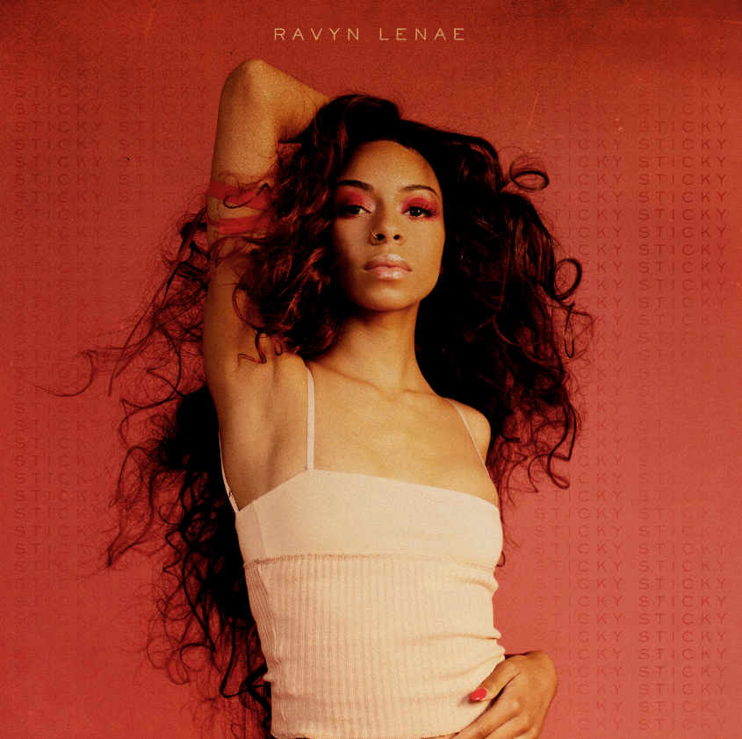

Acclaimed modern pop sensation Ravyn Lenae is set to unveil her much-anticipated new EP. “CRUSH” arrives at all digital music retailers and streaming services via 323 Music Group/ Atlantic Records on Friday, January 26th.

“CRUSH” is Executive Produced by Steve Lacy (The Internet, Kendrick Lamar), who also joins Lenae on two of its five tracks including the vocal call-and-response, “4 Leaf Clover” (track listing attached). The EP is highlighted by the sultry new single, “Sticky,” available now at all DSPs and streaming services https://Atlantic.lnk.to/Sticky.

“It’s about being stuck to someone and knowing you shouldn’t be,” says Lenae. “The person is not really nice to you; he’s actually a little mean. Even though you know that, you take him back all the time. He’s sticky.”

Acclaimed by Rolling Stone in its “10 New Artists You Need to Know: March 2017” for her “thoughtful and highly lyrical electronic soul,” Lenae made her label debut earlier this year with “MIDNIGHT MOONLIGHT.” The EP includes the single, “Unknown,” joined by a new companion visual directed by Weird Life Films (Joey Purp, Chance the Rapper) and streaming now at the official Rayvn Lenae YouTube channel.

“MIDNIGHT MOONLIGHT” instantly received a range of critical applause, with Pitchfork raving, “Chicago R&B singer Ravyn Lenae’s impressive new EP brims with quiet intensity, as her subtle falsetto glides over a blend of modern bounce, dream pop, and electro-soul…the vocalist captures a robust spectrum of black art while establishing her own aesthetic. Lenae doesn’t sing, per se; instead, her blend of atmospheric hums speaks directly to you, even as (producer Monte) Booker’s swirling beats threaten to take most of the attention. There’s a strong nostalgia to Lenae’s music that borrows from her late ’90s and early ’00s influences, but she doesn’t simply mimic them. Lenae’s art feels current.”

Named by NYLON as one of “21 Cool Artists 21 And Under,” Lenae is currently wrapping up “The CTRL Tour” alongside fellow R&B sensation SZA, with remaining dates set for Louisville, KY’s Mercury Ballroom (December 16th) and St. Louis, MO’s The Ready Room (December 17th). Additional live dates surrounding the release of “CRUSH” will be announced soon – please see www.ravynlenae.com for updates and more.

At just 18, Ravyn Lenae is a phenomenon, acclaimed for her natural talent, inimitable approach, and crafty songwriting. Lenae immediately made waves with 2015’s hit single, “Greetings,” followed shortly thereafter by her breakthrough debut EP, “MOON SHOES.” Hailed by Hypetrak as a “combination of entrancing vocals, control over creative cadences and superb writing,” the EP has earned over 12 million individual plays while also reaching the top 25 on the iTunes Store’s “Top R&B/Soul Albums” chart.

Lenae has since earned applause from some of today’s biggest stars, including SZA, Chloe Grace-Moretz and fellow Atlantic recording artist Kehlani. She has also drawn ecstatic critical praise from a wide range of media outlets. Pigeons & Planes named Lenae to its “Best New Artists of 2016” ranking, declaring her “Chicago’s best-kept secret…Spinning words in novel ways while adhering to today’s high standards for unique delivery, Ravyn’s cathartic musings shine bright.” Pitchfork raved about Lenae’s “sun-dappled repertoire, offering impressionistic soul that glides like a feather floating down a lazy river… She roars. She soars. She has the right.”

For more information, please visit www.ravynlenae.com, twitter.com/ravynlenae, www.instagram.com/ravynlenae, facebook.com/ravynlenae, youtube.com/ravynlenae, and www.atlanticrecords.com.

RAYVN LENAE
“CRUSH” EP
(323 Music Group/Atlantic Records)
Release Date: Friday, January 26th
Track listing

- Sticky
- Closer (ODE 2 U)
- Computer Luv feat. Steve Lacy
- The Night Song
- 4 Leaf Clover feat. Steve Lacy

* * * * *

For press inquiries, please contact:
Ariana White // 212.707.2236 // Ariana.White@atlanticrecords.com

