FOR IMMEDIATE RELEASE
FEBRUARY 14, 2022

HAPPY VALENTINE’S DAY FROM YOUR FAVORITE DUO! 🚂❤

SILK SONIC covers one of their favorite songs, “Love’s Train,”
by the band Con Funk Shun.

STREAM HERE

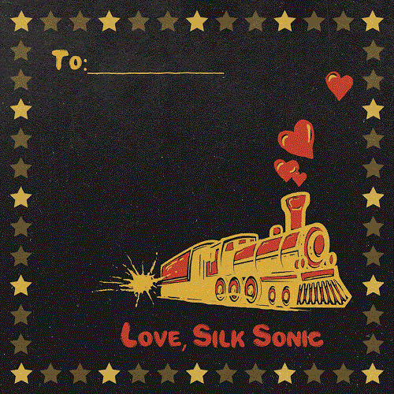

ABOUT SILK SONIC:
Silk Sonic introduced “Leave The Door Open” in March 2021 alongside an official music video directed by Mars and Florent Déchard, which won Best R&B Video and Best Editing at the 2021 MTV Music Video Awards. The track was followed by a hugely popular social media campaign, #LetSilkSonicThrive, which earned them a debut live performance at the GRAMMY® Awards (plus a powerful tribute to Little Richard) followed quickly by iconic live sets at the iHeartRadio Music Awards and the BET Awards. “Leave The Door Open” became Silk Sonic’s first #1 single on the Billboard Hot 100, spending two non-consecutive weeks at #1 and 18 consecutive weeks in the top 10. In the meantime, their infectious jingle co-written and performed for SelvaRey Rum amassed widescale praise over the summer. The duo then coasted into their sophomore release of “Skate,” which saw them glide into a second top 10 hit on Billboards Hot R&B/Hip-Hop Songs as it debuted at #4 and began as the genre’s best-selling song of the week. “Smokin Out The Window” arrived last week with Billboard noting how “Anderson .Paak and Bruno Mars take it all the way back to the 1970s Soul Train era in the retro video. [It]finds them going through their choreo on an old school TV set while rocking wide lapel tuxedo jackets.” An Evening With Silk Sonic is out now.

CONNECT WITH SILK SONIC
WEBSITE | FACEBOOK | TWITTER | INSTAGRAM | YOUTUBE | TIKTOK | SPOTIFY | APPLE MUSIC

CONNECT WITH BRUNO MARS
WEBSITE | FACEBOOK | TWITTER | INSTAGRAM | YOUTUBE

CONNECT WITH ANDERSON .PAAK
WEBSITE | FACEBOOK | TWITTER | INSTAGRAM | YOUTUBE

