SIA RELEASES NEW SINGLE “HEY BOY” FT. BURNA BOY

SHARES TRACKLIST FOR NEW ALBUM OUT 2/12
MUSIC - SONGS FROM AND INSPIRED BY THE MOTION PICTURE

DIRECTORIAL FEATURE FILM DEBUT MUSIC OUT FEBRUARY

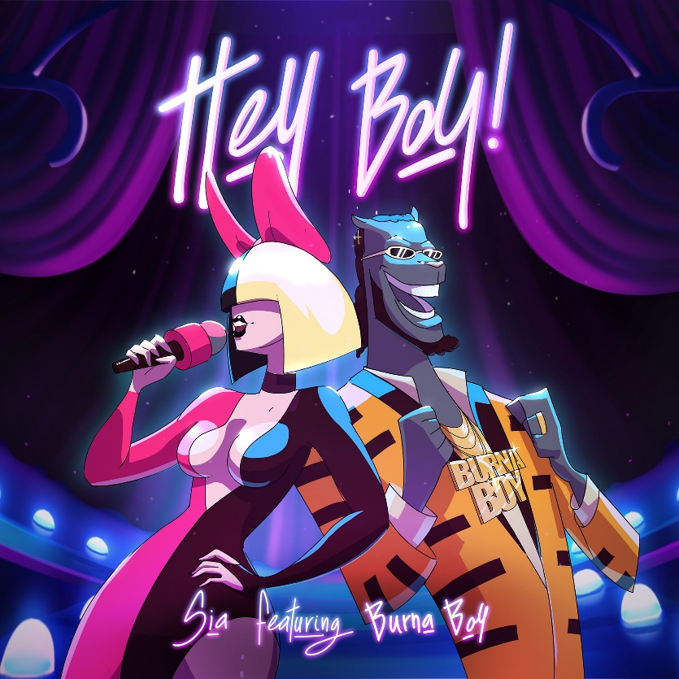

(New York, NY) January 14, 2021 - Today nine-time Grammy-nominated and multi-platinum artist Sia releases new single “Hey Boy” featuring Burna Boy off of her eighth studio album Music - Songs From And Inspired By The Motion Picture. The album is out February 12th via Monkey Puzzle/Atlantic.

Listen/share “Hey Boy” ft. Burna Boy here.

TRACKLIST FOR MUSIC - SONGS FROM AND INSPIRED BY THE MOTION PICTURE

- Together
- Hey Boy
- Saved My Life
- Floating Through Space
- Eye to Eye
- Music
- 1 + 1
- Courage to Change
- Play Dumb
- Beautiful Things Can Happen
- Lie to Me
- Oblivion
- Miracle
- Hey Boy ft Burna Boy

Sia’s upcoming feature film directorial debut Music will receive a special limited theatrical release by IMAX in February 2021. The film stars Academy Award® nominee and Golden Globe winner Kate Hudson (Almost Famous, Deepwater Horizon), Tony and Grammy Award winner and Emmy nominated Leslie Odom, Jr. (One Night in Miami..., Hamilton) together with breakout star Maddie Ziegler (upcoming West Side Story), and is a wholly original exploration of the healing power of love and the importance of community. Sia’s music is integral to the story of the film as the characters examine the fragile bonds that hold us together and, through fantastical musical sequences, imagine a world where those bonds can be strengthened in times of great challenge.

About Sia
Nine-time Grammy nominee Sia has cemented her role as one of today’s biggest stars, sought after songwriters, and captivating live performers. Sia's current single, "Courage To Change," is from her forthcoming album and motion picture Music due out February 2021. Last year she partnered with Diplo and Labrinth to form the group LSD. Their debut album, Labrinth, Sia & Diplo Present... LSD has 1 Billion + streams to date. She released the Grammy-nominated This Is Acting (Monkey Puzzle/RCA Records) in 2016 to much critical acclaim, followed by her sold-out Nostalgic For The Present World Tour. In 2017 she released the evergreen holiday collection Everyday Is Christmas. She has more videos in YouTube’s “Billion Views Club” than any other female on the planet. Along with her own successes, Sia has also written global smashes for today’s biggest acts including Beyonce, BTS, David Guetta, Kanye West, Rihanna, Britney Spears, Katy Perry, Ozuna, and many more.

Press Contacts:
Sia/Crush Music, Lauren Papapietro: LP@crushmusic.com
Atlantic Records, Sheila Richman: Sheila.Richman@atlanticrecords.com

