LISTEN TO SIA’S BALLAD “SNOWMAN”
FROM EVERYDAY IS CHRISTMAS OUT ON NOVEMBER 17
Original Holiday Album with 10 Brand New Songs Available for Pre-Order Now

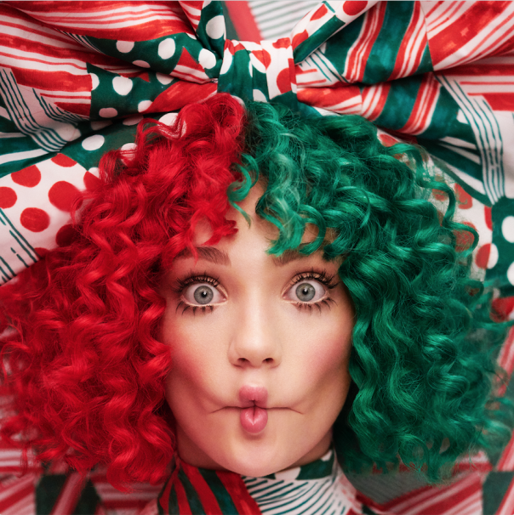
Photo Credit: RJ Shaughnessy
Hi-Res Cover Artwork: HERE

LISTEN TO “SNOWMAN” NOW: https://youtu.be/J_QGZspO4gg

(New York, NY) November 9, 2017: Today Sia has released “Snowman” - a ballad which is the second taste of music from her first-ever holiday album, Everyday is Christmas, to be released on November 17, 2017 via Monkey Puzzle/Atlantic Records. The collection of original holiday songs, written by Sia and Greg Kurstin, is available for pre-order now: https://sia.lnk.to/christmas

“Snowman” Available on all DSPs now: https://fanlink.to/snowman

Sia most recently wrapped up the North American leg of her headlining arena Nostalgic For The Present Tour which was proclaimed "creatively captivating” (Billboard), "magical performance art" (AXS), and "intensely personal.” The limited tour, Sia’s only live dates for 2017, will continue this winter in stadiums across Australia and New Zealand. For more information on her tour dates, visit siamusic.net/tour.

In addition to working on Everyday is Christmas, Sia is in the process of directing her first feature film, co-wrote and is featured on Zayn’s global Top 5 hit “Dusk Til Dawn,” and voices the character Songbird Serenade in My Little Pony: The Movie alongside actors Emily Blunt, Zoe Saldana, and Kristin Chenoweth.

Everyday is Christmas Tracklisting:
1. Santa's Coming For Us
2. Candy Cane Lane
3. Snowman
4. Snowflake
5. Ho Ho Ho
6. Puppies Are Forever
7. Sunshine
8. Underneath The Mistletoe
9. Everyday is Christmas
10. Underneath The Christmas Lights

About Sia:
EIght time Grammy Nominee, Sia, released the Grammy-nominated This Is Acting (Monkey Puzzle/RCA Records) in 2016 to much critical acclaim and has cemented her role as one of today’s biggest stars and sought after live performers. She is currently the 10th most globally streamed artist on Spotify and has amassed over 5.3 billion plays on her YouTube channel. Her massive single “Cheap Thrills” was a multi-format global radio hit and was one of the longest running singles at Top 40 of 2016. Along with her own successes, Sia has also written global smashes for today’s biggest acts including Beyonce, Kanye West, Rihanna, Britney Spears, Katy Perry, and many more.

Press Contacts:
Sia/Crush Music, Nadine Pena: Nadine@crushmusic.com
Atlantic Records, Sheila Richman: Sheila.Richman@atlanticrecords.com

