Skrillex just dropped his first official single since 2017

Listen to Skrillex, Boys Noize & Ty Dolla $ign - "Midnight Hour”: https://Skrillex.lnk.to/MHPR

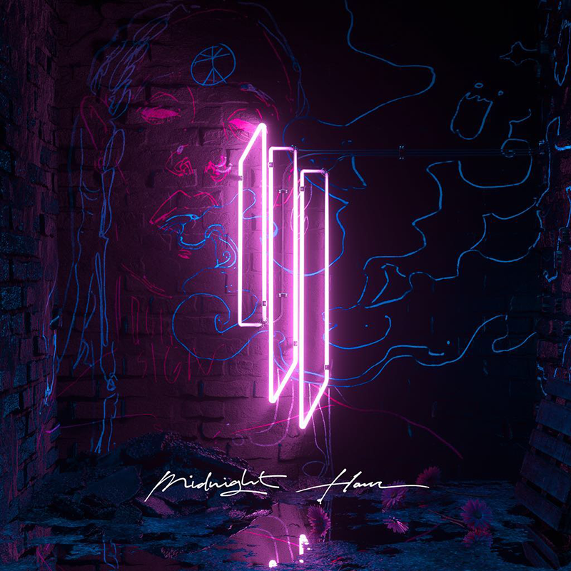
Photo credit: Coughs | DOWNLOAD PHOTO HERE

"Midnight Hour" with Ty Dolla $ign and Boys Noize dropped worldwide at midnight in all its undeniable R&B house glory that's a departure for all involved.

For the past few years, Skrillex has been on a creative sabbatical between LA and Tokyo and non-stop working with some of the biggest names in music including Ed Sheeran, FKA twigs, The Weeknd, Kelsey Lu, Camila Cabello, Incubus, Zac Brown Band and many more not announced.

CONNECT WITH SKRILLEX:
Facebook | Instagram | Twitter | YouTube | Spotify

SKRILLEX PRESS ASSETS: https://press.wearebigbeat.com/artists/skrillex/

FOR MORE INFORMATION:
Paige Rosoff – Big Beat Records
Paige.Rosoff@atlanticrecords.com

