June 1, 2017
For Immediate Release

THE WAR ON DRUGS ANNOUNCE NEW ALBUM, A DEEPER UNDERSTANDING,
OUT AUGUST 25TH ON ATLANTIC RECORDS, AND PRESENT LEAD SINGLE, “HOLDING ON”

LISTEN TO “HOLDING ON”
https://youtu.be/LBWiMAu3uII

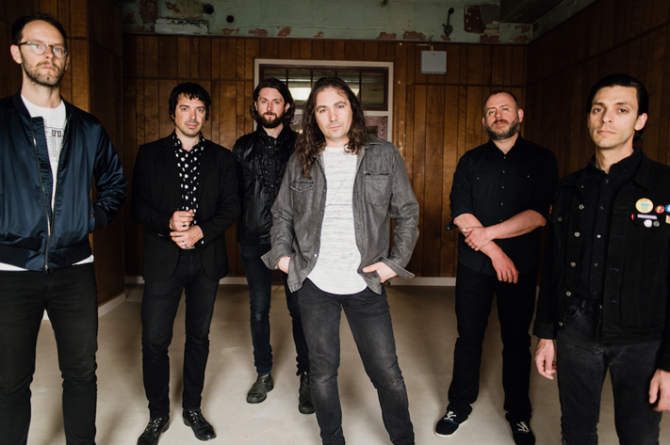

(photo credit – Shawn Brackbill)

The War On Drugs announce their fourth full-length album, A Deeper Understanding, out August 25th on Atlantic Records. A Deeper Understanding is the band’s first album since 2014’s universally acclaimed Lost In The Dream, and their debut album with Atlantic. Following the Record Store Day release of the 11-minute “Thinking of a Place,” The War On Drugs present the album’s lead single, “Holding On.”

For much of the three and a half year period since the release of Lost In The Dream, The War On Drugs’ frontman, Adam Granduciel, led the charge for his Philadelphia-based sextet as he holed up in studios in New York and Los Angeles to write, record, edit, and tinker—but, above all, to busy himself in work. Teaming up with engineer Shawn Everett (Alabama Shakes, Weezer), Granduciel challenged the notion of what it means to create a fully realized piece of music in today’s modern landscape. Calling on his bandmates – bassist Dave Hartley, keyboarding Robbie Bennett, drummer Charlie Hall and multi-instrumentalists Anthony LaMarca and Jon Natchez -- continuously throughout the process, the result is a “band record” in the noblest sense, featuring collaboration, coordination, and confidence at every turn. Through those years of relocation, the revisiting and reexamining of endless hours of recordings, unbridled exploration and exuberance, Granduciel’s gritty love of his craft succeeded in pushing the band to great heights.
The War On Drugs will hit the road for two-plus months beginning mid-September. Tickets are available for purchase at www.thewarondrugs.net. The band will perform on the Late Show with Stephen Colbert this coming Monday, June 5th.

Listen To The War On Drugs’ “Holding On” –
https://youtu.be/LBWiMAu3uII

Listen To The War On Drugs’ “Thinking of a Place” –
https://youtu.be/TeaDE1magRk

A Deeper Understanding Tracklisting:
1. Up All Night
2. Pain
3. Holding On
4. Strangest Thing
5. Knocked Down
6. Nothing To Find
7. Thinking of a Place
8. In Chains
9. Clean Living
10. You Don’t Have To Go

Pre-order A Deeper Understanding –
https://Atlantic.lnk.to/ADeeperUnderstanding

The War On Drugs’ Tour Dates:
Mon. Sep. 18 – Portland, ME @ State Theatre
Thu. Sep. 21 – Philadelphia, PA @ Dell Music Center
Fri. Sep. 22 – New York, NY @ SummerStage in Central Park
Sat. Sep. 23 – Boston, MA @ Blue Hills Bank Pavilion
Mon. Sep. 25 – Charlotte, NC @ The Fillmore Charlotte
Tue. Sep. 26 – Atlanta, GA @ The Tabernacle
Thu. Sep. 28 – Dallas, TX @ The Bomb Factory
Fri. Sep. 29 – Houston, TX @ White Oak Music Hall [Outside Lawn]
Sat. Sep. 30 – Austin, TX @ Stubb’s Waller Creek Amphitheater
Thu. Oct. 5 – Los Angeles, CA @ Greek Theatre
Fri. Oct. 6 – Berkeley, CA @ Greek Theatre
Mon. Oct. 9 – Seattle, WA @ Moore Theatre – SOLD OUT
Tue. Oct. 10 – Seattle, WA @ Moore Theatre
Wed. Oct. 11 – Portland, OR @ Arlene Schnitzer Concert Hall
Fri. Oct. 13 – Salt Lake City, UT @ The Complex
Sat. Oct. 14 – Denver, CO @ Ogden Theatre – SOLD OUT
Sun. Oct. 15 – Denver, CO @ Ogden Theatre
Wed. Oct. 18 – St. Paul, MN @ Palace Theatre
Thu. Oct. 19 – Chicago, IL @ Riviera Theatre
Fri. Oct. 20 – Columbus, OH @ Express Live!
Sat. Oct. 21 – Toronto, ON @ Massey Hall – SOLD OUT
Sun. Oct. 22 – Toronto, ON @ Massey Hall
Wed. Nov. 1 – Amsterdam, NL @ AFAS Live
Thu. Nov. 2 – Amsterdam, NL @ AFAS Live – SOLD OUT
Fri. Nov. 3 – Cologne, DE @ E-Werk
Sat. Nov. 4 – Brussels, BE @ Forest National – SOLD OUT
Mon. Nov. 6 – Paris, FR @ Bataclan
Thu. Nov. 9 – Glasgow, UK @ Barrowlands
Fri. Nov. 10 – Glasgow, UK @ Barrowlands – SOLD OUT
Sun. Nov. 12 – Manchester, UK @ O2 Apollo Manchester – SOLD OUT
Mon. Nov. 13 – Manchester, UK @ O2 Apollo Manchester
Tue. Nov. 14 – London, UK @ Alexandra Palace
Fri. Nov. 17 – Zurich, CH @ X-tra
Sat. Nov. 18 – Milan, IT @ Fabrique
Mon. Nov. 20 – München, DE @ Muffathalle
Tue. Nov. 21 – Hamburg, DE @ Große Freiheit 36
Wed. Nov. 22 – Berlin, DE @ Tempodrom
Fri. Nov. 24 – Oslo, NO @ Spektrum
Sat. Nov. 25 – Copenhagen, DK @ Tap 1
Mon. Nov. 27 – Stockholm, SE @ Annexet

Download hi-res cover art and press images –
www.pitchperfectpr.com/the-war-on-drugs/

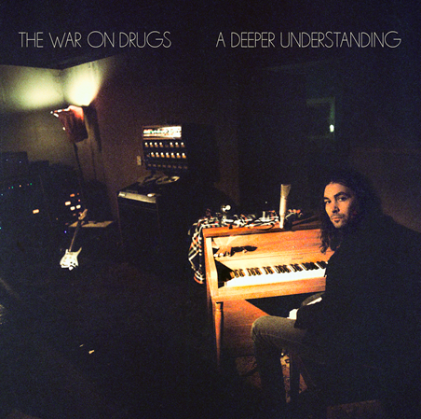
(A Deeper Understanding cover artwork)

Official Website | Instagram | Twitter | Facebook

For more information, contact:
Jessica Linker | Pitch Perfect PR – jessica@pitchperfectpr.com, 773-271-6844
Sheila Richman | Atlantic Records – sheila.richman@atlanticrecords.com, 212-707-3063

