June 13, 2017
For Immediate Release

WATCH THE WAR ON DRUGS’ “HOLDING ON” VIDEO –
https://youtu.be/6-oHBkikDBg

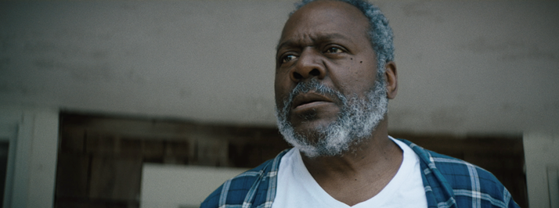

The War On Drugs are set to release their fourth full-length album, A Deeper Understanding, on August 25th via Atlantic Records. Following last week’s performance on the Late Show with Stephen Colbert, the band now presents the video for lead single, “Holding On.” The song, which debuted as the #1 most added at AAA radio last week, was named Best New Track by Pitchfork, who said “There’s a newfound sense of clarity here, from the magnificent production to the ornate instrumentation.”

The “Holding On” video stars Frankie Faison (of The Wire) and band leader Adam Granduciel and was directed by filmmaker Brett Haley with concept by Krysten Ritter. Haley is known for directing feature films I’ll See You In My Dreams and The Hero, in theaters now and starring Sam Elliott, Nick Offerman, Laura Prepon and Ritter.

A Deeper Understanding is The War On Drugs’ first album since 2014’s universally acclaimed Lost In The Dream, and their debut album with Atlantic. Produced by Granduciel and recorded in New York and Los Angeles with engineer Shawn Everett (Alabama Shakes, Weezer), A Deeper Understanding is a “band record” in the noblest sense featuring bassist Dave Hartley, keyboardist Robbie Bennett, drummer Charlie Hall and multi-instrumentalists Anthony LaMarca and Jon Natchez.

The War On Drugs will hit the road for two-plus months beginning mid-September. Tickets are available for purchase at www.thewarondrugs.net.

Watch The War On Drugs’ “Holding On” Video –
https://youtu.be/6-oHBkikDBg

Listen To The War On Drugs’ “Holding On” –
https://youtu.be/LBWiMAu3uII

Listen To The War On Drugs’ “Thinking of a Place” –
https://youtu.be/TeaDE1magRk

Pre-order A Deeper Understanding –
https://Atlantic.lnk.to/ADeeperUnderstanding

The War On Drugs’ Tour Dates:
Mon. Sep. 18 – Portland, ME @ State Theatre
Thu. Sep. 21 – Philadelphia, PA @ Dell Music Center
Fri. Sep. 22 – New York, NY @ SummerStage in Central Park
Sat. Sep. 23 – Boston, MA @ Blue Hills Bank Pavilion
Mon. Sep. 25 – Charlotte, NC @ The Fillmore Charlotte
Tue. Sep. 26 – Atlanta, GA @ The Tabernacle
Thu. Sep. 28 – Dallas, TX @ The Bomb Factory
Fri. Sep. 29 – Houston, TX @ White Oak Music Hall [Outside Lawn]
Sat. Sep. 30 – Austin, TX @ Stubb’s Waller Creek Amphitheater
Thu. Oct. 5 – Los Angeles, CA @ Greek Theatre
Fri. Oct. 6 – Berkeley, CA @ Greek Theatre
Mon. Oct. 9 – Seattle, WA @ Moore Theatre – SOLD OUT
Tue. Oct. 10 – Seattle, WA @ Moore Theatre
Wed. Oct. 11 – Portland, OR @ Arlene Schnitzer Concert Hall
Fri. Oct. 13 – Salt Lake City, UT @ The Complex
Sat. Oct. 14 – Denver, CO @ Ogden Theatre – SOLD OUT
Sun. Oct. 15 – Denver, CO @ Ogden Theatre
Wed. Oct. 18 – St. Paul, MN @ Palace Theatre
Thu. Oct. 19 – Chicago, IL @ Riviera Theatre
Fri. Oct. 20 – Columbus, OH @ Express Live!
Sat. Oct. 21 – Toronto, ON @ Massey Hall – SOLD OUT
Sun. Oct. 22 – Toronto, ON @ Massey Hall
Wed. Nov. 1 – Amsterdam, NL @ AFAS Live
Thu. Nov. 2 – Amsterdam, NL @ AFAS Live – SOLD OUT
Fri. Nov. 3 – Cologne, DE @ E-Werk
Sat. Nov. 4 – Brussels, BE @ Forest National – SOLD OUT
Mon. Nov. 6 – Paris, FR @ Bataclan
Thu. Nov. 9 – Glasgow, UK @ Barrowlands
Fri. Nov. 10 – Glasgow, UK @ Barrowlands – SOLD OUT
Sun. Nov. 12 – Manchester, UK @ O2 Apollo Manchester – SOLD OUT
Mon. Nov. 13 – Manchester, UK @ O2 Apollo Manchester
Tue. Nov. 14 – London, UK @ Alexandra Palace
Fri. Nov. 17 – Zurich, CH @ X-tra
Sat. Nov. 18 – Milan, IT @ Fabrique
Mon. Nov. 20 – München, DE @ Muffathalle
Tue. Nov. 21 – Hamburg, DE @ Große Freiheit 36
Wed. Nov. 22 – Berlin, DE @ Tempodrom
Fri. Nov. 24 – Oslo, NO @ Spektrum
Sat. Nov. 25 – Copenhagen, DK @ Tap 1
Mon. Nov. 27 – Stockholm, SE @ Annexet

Download hi-res cover art and press images –
www.pitchperfectpr.com/the-war-on-drugs/

Official Website | Instagram | Twitter | Facebook

For more information, contact:
Jessica Linker | Pitch Perfect PR – jessica@pitchperfectpr.com, 773-271-6844
Sheila Richman | Atlantic Records – sheila.richman@atlanticrecords.com, 212-707-3063

