News from SIMON & SCHUSTER

FOR IMMEDIATE RELEASE
Contacts: Elizabeth Gay, Simon & Schuster Publicity
212-698-7544, Elizabeth.Gay@simonandschuster.com
Ashley Kalmanowitz, Atlantic Records Publicity
212-707-2051, ashley.kalmanowitz@atlanticrecords.com

SIMON & SCHUSTER TO PUBLISH THE GUCCI MANE GUIDE TO GREATNESS ON OCTOBER 13, 2020

New York, NY, May 11, 2020—Simon & Schuster announced today that it will publish The Gucci Mane Guide to Greatness by platinum selling recording artist and New York Times bestselling author Gucci Mane on October 13, 2020.

In this inspiring follow up to his iconic 2017 memoir, The Autobiography of Gucci Mane, Gucci Mane gifts readers with his playbook for living your best life, offering an unprecedented look at his secrets to success, health, wealth, and self-improvement. Packed with stunning photographs, The Gucci Mane Guide to Greatness distills the legend’s timeless wisdom into a one-of-a-kind motivational guidebook. Gucci Mane emerged transformed after a turbulent life of violence, crime, and addiction to become a dazzling embodiment of the power of positivity, focus, and hard work. Using examples from his life of unparalleled success, Gucci Mane looks inward and upward to offer his blueprint for greatness. Simon & Schuster Senior Editor Stuart Roberts acquired world, audio and first serial rights from Robert Guinsler of Sterling Lord Literistic, Inc.

Gucci Mane writes, “I live by the principles in this book. I wanted to write this book to give you a tool set. This book should touch people who are going through something. It's not going to be easy. But study these words, and put them into action. I want this book to keep you motivated. I want you to keep coming back to it for guidance and inspiration. You can put it on your shelf and keep going to The Gucci Mane Guide to Greatness. This book is a challenge. Don't underestimate yourself. Don't think that what you’re saying is not important. Don’t think you can’t achieve the impossible. Everyone needs some game, so here it is. The Gucci Mane Guide to Greatness is for the world. Enjoy.”

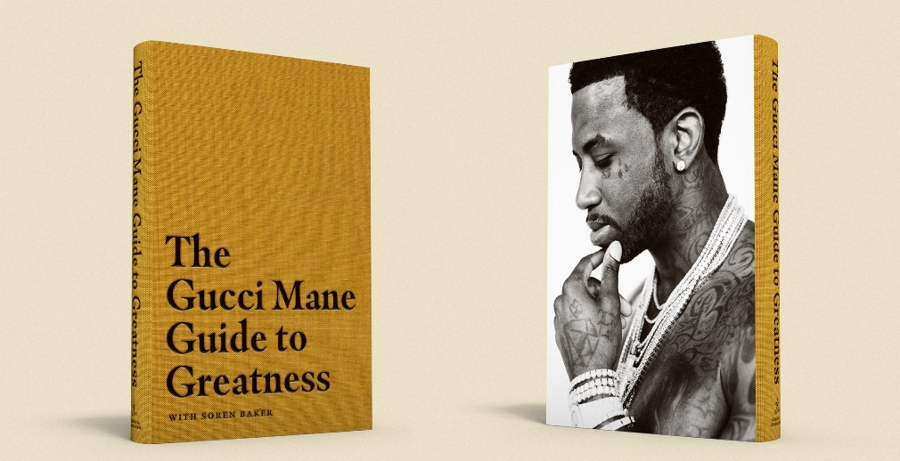
Download high-res jacket images

Gucci Mane is a critically acclaimed, platinum-selling recording artist and New York Times Bestselling author of The Autobiography of Gucci Mane. He has released fifteen studio albums and over a hundred overall projects. The Gucci Mane Guide to Greatness is his second book. Connect with Gucci Mane: OFFICIAL | INSTAGRAM | TWITTER | FACEBOOK | YOUTUBE

Simon & Schuster, a ViacomCBS Company, is a global leader in general interest publishing, dedicated to providing the best in fiction and nonfiction for readers of all ages, and in all printed, digital and audio formats. Its distinguished roster of authors includes many of the world’s most popular and widely recognized writers, and winners of the most prestigious literary honors and awards. It is home to numerous well-known imprints and divisions such as Simon & Schuster, Scribner, Atria Books, Gallery Books, Pocket Books, Adams Media, Simon & Schuster Children’s Publishing and Simon & Schuster Audio and international companies in Australia, Canada, India and the United Kingdom, and proudly brings the works of its authors to readers in more than 200 countries and territories. For more information visit our website at www.simonandschuster.com.

