**TY DOLLA $IGN UNVEILS VISUAL FOR “NOTHING LIKE YOUR EXES”**

**GRAMMY-NOMINATED HITMAKER’S CRITICALLY-ACCLAIMED NEW ALBUM**

***‘FEATURING TY DOLLA $IGN’*** **OUT NOW**

[**WATCH “NOTHING LIKE YOUR EXES” HERE**](https://nam04.safelinks.protection.outlook.com/?url=https%3A%2F%2Fwww.youtube.com%2Fwatch%3Fv%3DxdvnclDcn6A%26feature%3Dyoutu.be%26src%3DLinkfire%26lId%3D4200e5ea-0d60-47e2-a170-280a5040045d%26cId%3Dd3d58fd7-4c47-11e6-9fd0-066c3e7a8751&data=04%7C01%7CBrian.Sommer%40atlanticrecords.com%7Ce4913c1dc38d40a0666508d879eda888%7C8367939002ec4ba1ad3d69da3fdd637e%7C0%7C0%7C637393408937694967%7CUnknown%7CTWFpbGZsb3d8eyJWIjoiMC4wLjAwMDAiLCJQIjoiV2luMzIiLCJBTiI6Ik1haWwiLCJXVCI6Mn0%3D%7C1000&sdata=wuktsMNwM4qvbT5LAacOmh2Vt1%2FRyzuuJYk4l7TrqQk%3D&reserved=0)

[Directed by: Eif Rivera]

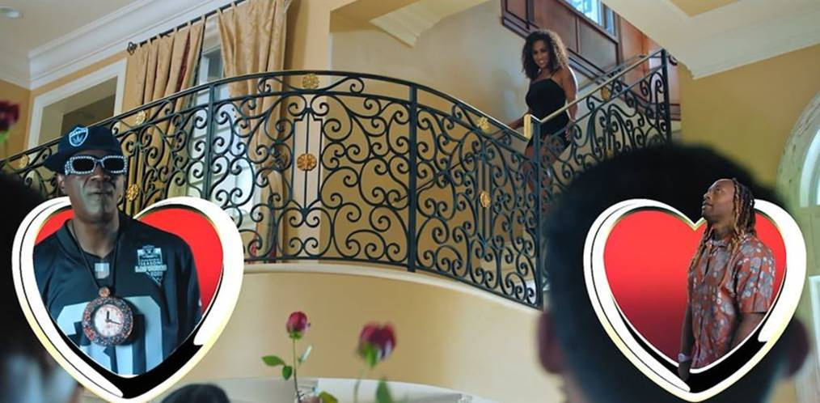

[**DOWNLOAD/STREAM ‘FEATURING TY DOLLA $IGN’ HERE**](https://nam04.safelinks.protection.outlook.com/?url=https%3A%2F%2Fdollasign.lnk.to%2FFeaturing&data=04%7C01%7CBrian.Sommer%40atlanticrecords.com%7Ce4913c1dc38d40a0666508d879eda888%7C8367939002ec4ba1ad3d69da3fdd637e%7C0%7C0%7C637393408937694967%7CUnknown%7CTWFpbGZsb3d8eyJWIjoiMC4wLjAwMDAiLCJQIjoiV2luMzIiLCJBTiI6Ik1haWwiLCJXVCI6Mn0%3D%7C1000&sdata=ZNt7IdTe8gBQTQ0wZkLAhRNVq2DtPXZf1mCpyYbXNzw%3D&reserved=0)

*“I’ve been blessed with the gift of collaborating. Not every artist can collaborate with another artist and have the final product be something incredible. Many people have said that when you see a song that says, “featuring Ty Dolla $ign,” you know it’s gonna be fire. As humbled as I am when I hear that, I can’t say I disagree.*

*My approach to music has always been about frequencies, emotions and energy. When I collaborate, whether it’s for my project or someone else’s, it’s always about marrying frequencies. When I create a project and have artists featured on my songs, I don’t pick who the hottest artist is or what’s going to get the most streams, I choose which artist’s frequency is going to work best on the song. I use featured artists with the same precision that I would use any instrument.*

*Everybody has their own side of ‘Ty Dolla $ign’ that they prefer: the go-to collaborator of all genres, the underrated king of R&B, the hitmaker of the often raunchy club banger, the multi-instrumentalist & producer. Sometimes, I even want to use my different frequencies on my own songs.*

*I decided to name my third studio album Featuring Ty Dolla $ign because there is truly something for everybody on this album. It features some of my most talented friends, on some of the best music I’ve made in my career.”*

[**DOWNLOAD APPROVED PRESS IMAGES**](https://warnermusicgroup.app.box.com/s/2nnn91vihrzgpwjs70jpssynll4ad5l6)

**TRACKLIST:**

1. Intro
2. Status
3. Temptations feat. Kid Cudi
4. serpentwithfeet Interlude
5. Spicy feat. Post Malone
6. Track 6 feat. Kanye West, Anderson .Paak & Thundercat
7. Freak feat. Quavo
8. Double R feat. Lil Durk
9. Expensive feat. Nicki Minaj
10. Burna Boy Interlude
11. Tyrone 2021 feat. Big Sean
12. It’s Still Free TC
13. Real Life feat. Roddy Ricch & Mustard
14. Nothing Like Your Exes
15. By Yourself feat. Jhené Aiko & Mustard
16. Universe feat. Kehlani
17. Lift Me Up feat. Future & Young Thug
18. Time Will Tell
19. Dr. Sebi
20. Powder Blue feat. Gunna
21. Everywhere
22. Slow It Down
23. Your Turn feat. Musiq Soulchild, Tish Hyman & 6lack
24. Return
25. Ego Death feat. Kanye West, FKA twigs & Skrillex [Bonus]

* * *

**ABOUT TY DOLLA $IGN:**

Hailed as “*one of the richest R&B talents of the last decade*” by The New York Times, Ty Dolla $ign is a multiple GRAMMY-nominated musical powerhouse who has single-handedly shaped the music industry with his undeniable classic songs (“Paranoid,” “Or Nah,” “Blasé”,) chart-topping collaborations (“Psycho” with Post Malone, “Work From Home” with Fifth Harmony) and genre-defying songwriting and production contributions (JAY-Z & Beyonce, Kanye West, Rihanna, Mariah Carey, Drake, Chris Brown, Christina Aguilera, Khalid, Wiz Khalifa and more.)

With over 5 billion streams, 10 million singles sold and a career-to-date total of nearly 50 RIAA platinum and gold certifications, the Los Angeles native’s solo discography features the critically acclaimed albums *Free TC* (2015) and *Beach House 3* (2017) and the timeless mixtapes *Beach House*, *Beach House 2*, *Sign Language*, *Airplane Mode* and *Campaign*.

Connect with Ty Dolla $ign: [Instagram](https://nam04.safelinks.protection.outlook.com/?url=http%3A%2F%2Fwww.instagram.com%2Ftydollasign&data=04%7C01%7CBrian.Sommer%40atlanticrecords.com%7Ce4913c1dc38d40a0666508d879eda888%7C8367939002ec4ba1ad3d69da3fdd637e%7C0%7C0%7C637393408937704960%7CUnknown%7CTWFpbGZsb3d8eyJWIjoiMC4wLjAwMDAiLCJQIjoiV2luMzIiLCJBTiI6Ik1haWwiLCJXVCI6Mn0%3D%7C1000&sdata=%2FEgic7%2FDgJBll1qEGr8nXg83lX6KDNGYOBTwSurrHeQ%3D&reserved=0) | [Twitter](https://nam04.safelinks.protection.outlook.com/?url=http%3A%2F%2Fwww.twitter.com%2Ftydollasign&data=04%7C01%7CBrian.Sommer%40atlanticrecords.com%7Ce4913c1dc38d40a0666508d879eda888%7C8367939002ec4ba1ad3d69da3fdd637e%7C0%7C0%7C637393408937704960%7CUnknown%7CTWFpbGZsb3d8eyJWIjoiMC4wLjAwMDAiLCJQIjoiV2luMzIiLCJBTiI6Ik1haWwiLCJXVCI6Mn0%3D%7C1000&sdata=YoOggiAROxCSjKfegiO2kMJBbz6AvWtKzo3ArL8vZQo%3D&reserved=0) | [Facebook](https://nam04.safelinks.protection.outlook.com/?url=http%3A%2F%2Fwww.facebook.com%2Ftydollasign&data=04%7C01%7CBrian.Sommer%40atlanticrecords.com%7Ce4913c1dc38d40a0666508d879eda888%7C8367939002ec4ba1ad3d69da3fdd637e%7C0%7C0%7C637393408937714959%7CUnknown%7CTWFpbGZsb3d8eyJWIjoiMC4wLjAwMDAiLCJQIjoiV2luMzIiLCJBTiI6Ik1haWwiLCJXVCI6Mn0%3D%7C1000&sdata=6F%2FgrHY7VHLBb0H7m68hHy4Tb%2BP0TCbXLmgYHtlaFg4%3D&reserved=0) | [YouTube](https://nam04.safelinks.protection.outlook.com/?url=https%3A%2F%2Fwww.youtube.com%2Fuser%2Ftydollasign&data=04%7C01%7CBrian.Sommer%40atlanticrecords.com%7Ce4913c1dc38d40a0666508d879eda888%7C8367939002ec4ba1ad3d69da3fdd637e%7C0%7C0%7C637393408937724951%7CUnknown%7CTWFpbGZsb3d8eyJWIjoiMC4wLjAwMDAiLCJQIjoiV2luMzIiLCJBTiI6Ik1haWwiLCJXVCI6Mn0%3D%7C1000&sdata=oRKrtXaGHkmvjGw4bHOBXJPcHjxUdpEVloSalFB%2BDYg%3D&reserved=0) | [Website](https://nam04.safelinks.protection.outlook.com/?url=http%3A%2F%2Fwww.dollasignworld.com%2F&data=04%7C01%7CBrian.Sommer%40atlanticrecords.com%7Ce4913c1dc38d40a0666508d879eda888%7C8367939002ec4ba1ad3d69da3fdd637e%7C0%7C0%7C637393408937724951%7CUnknown%7CTWFpbGZsb3d8eyJWIjoiMC4wLjAwMDAiLCJQIjoiV2luMzIiLCJBTiI6Ik1haWwiLCJXVCI6Mn0%3D%7C1000&sdata=6IYvl5NP1lPmwDCJ%2F6vrFJHEonQDPFTLicycTnO7RkQ%3D&reserved=0)

For all press inquiries, please contact: Jason Davis – [Jason.Davis@atlanticrecords.com](mailto:Jason.Davis@atlanticrecords.com)

# # #