FOR IMMEDIATE RELEASE

APRIL 19, 2019

**ATLANTIC RECORDS & STXFILMS UNLEASH “DON’T CHANGE” BY WHY DON’T WE**

**FROM EAGERLY AWAITED “UGLYDOLLS ORIGINAL MOTION PICTURE SOUNDTRACK”**

**LISTEN TO “DON’T CHANGE”** [**HERE**](https://wdw.lnk.to/DontChangePR)

**COMPANION MUSIC VIDEO SET TO LAUNCH** [**HERE**](https://wdw.lnk.to/DontChangePR/youtube) **TOMORROW AT 10AM PT/1PM ET**

**ON THE WHY DON’T WE OFFICIAL YOUTUBE CHANNEL**

**WATCH KELLY CLARKSON PERFORM THE SOUNDTRACK’S FIRST SINGLE “**[**BROKEN & BEAUTIFUL**](https://atlantic.lnk.to/BrokenAndBeautifulPR)**”**

**ON** [**THE *TONIGHT SHOW STARRING JIMMY FALLON***](https://www.youtube.com/watch?v=YK1NcsUZK7w) **AND** [***TODAY***](https://www.today.com/video/watch-kelly-clarkson-sing-broken-beautiful-live-on-today-1472096835555)

**ALL-STAR COMPANION TO ANIMATED MUSICAL FEATURES ORIGINAL SONGS FROM THE FILM’S STARS INCLUDING KELLY CLARKSON, JANELLE MONÁE, NICK JONAS, BLAKE SHELTON, BEBE REXHA,**

**CHARLI XCX, LIZZO, PITBULL, WANG LEEHOM & MORE**

**“UGLYDOLLS ORIGINAL MOTION PICTURE SOUNDTRACK” ARRIVES AT ALL DSPs ON APRIL 26TH**

**STXFILMS’ *UGLYDOLLS* OPENS IN THEATRES NATIONWIDE ON MAY 3RD**

**PRE-ORDERS AVAILABLE NOW** [**HERE**](https://Atlantic.lnk.to/UglyDollsPR)

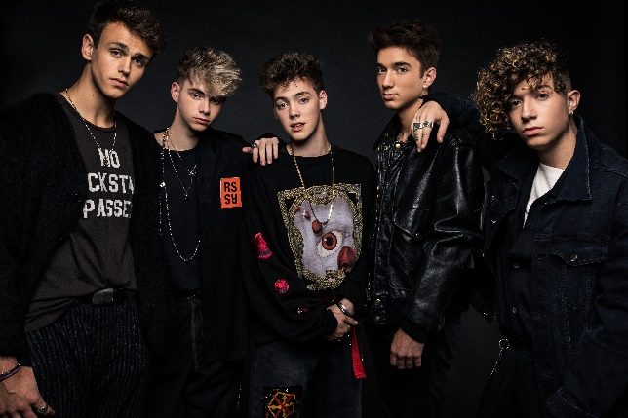

[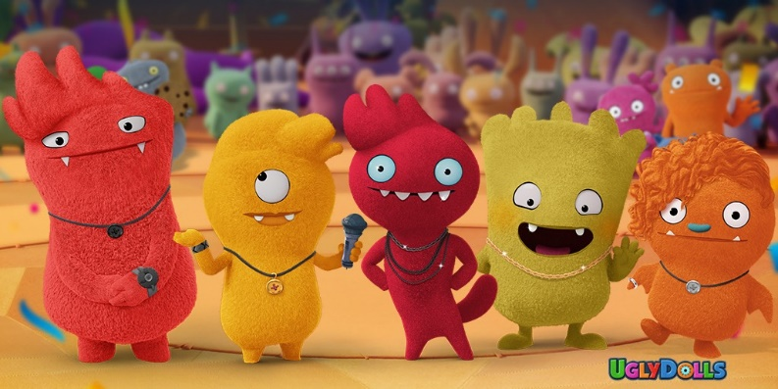](https://wdw.lnk.to/DontChangePR)

Atlantic Records in partnership with STXfilms have announced today’s premiere of the latest single and companion video from the eagerly awaited **“UGLYDOLLS ORIGINAL MOTION PICTURE SOUNDTRACK**.**”** “Don’t Change,” performed by rising pop stars **Why Don’t We**, is available at all DSPs [HERE](https://wdw.lnk.to/DontChangePR); the official video will premiere [HERE](https://wdw.lnk.to/DontChangePR/youtube) tomorrow morning at 10am PT/1pm ET on the group’s wildly popular YouTube channel. The all-star musical companion to the highly anticipated animated musical comedy arrives at all DSPs on April 26th; STXfilms’ ***UglyDolls*** arrives in theatres everywhere on May 3rd.

“Don’t Change” marks the fourth new song that Why Don’t We has unveiled in 2019, following last month’s release “[I Don’t Belong In This Club](https://wdw.lnk.to/IDBITCPR).” The track – a collaboration with GRAMMY winning, multiplatinum superstar Macklemore - has already logged over 20 million streams to date, with its [companion video](https://www.youtube.com/watch?v=75fEhQlc9h4), directed by Jason Koenig (Ed Sheeran, Macklemore), enjoying nearly 6 million views on YouTube. Why Don’t We just completed the first leg of their biggest headlining tour to date, the 8 Letters Tour, which was highlighted by sold out shows in Los Angeles, Boston, Chicago, and New York City, where their stop at the legendary Radio City Music Hall sold out in less than 2 hours. The summer leg of the tour launches in July. For tour dates, ticketing info, and more, please visit [www.whydontwemusic.com](http://www.whydontwemusic.com).

Approaching a BILLION global audio streams, 3.8 million Instagram followers, and total YouTube views exceeding 412 million with over 2.6 million subscribers, Why Don’t We has become one of pop music’s biggest breakout stories. Taking an innovative and unconventional approach towards releasing new music and actively engaging their rapidly growing fanbase, the prolific young group – the quintet ranges in age from 17-20 years old – put out four EPs in under 12 months. Their debut full length album, “8 LETTERS,” debuted in the top 10 on the *Billboard 200* at #9 and immediately shot to #1 on US iTunes’ “Overall Albums” chart (along with topping charts in over 20 more territories around the globe). The group recently performed “8 Letters,” “Big Plans,” and more on the outdoor stage at [Jimmy Kimmel Live!](https://www.youtube.com/watch?v=gNDfZQIt1sM) in front of one of the loudest audiences the show has seen.  Marking the event, *Rolling Stone* noted *“…the crowd’s screams and shrieks of glee nearly overpowered the musicians’ voices”* while *Billboard* simply described the performance as “*epic*.”  The pandemonium mirrored the band’s outdoor concert in Rockefeller Plaza as part of TODAY’s Citi Concert Series, where they garnered one of the largest crowds of the summer. Why Don’t We are: Daniel Seavey, Zach Herron, Corbyn Besson, Jonah Marais, and Jack Avery.

The brand-new album featuring original music by an incredible line-up of global superstars, **“UGLYDOLLS ORIGINAL MOTION PICTURE SOUNDTRACK”** is now available for pre-order at select DSPs [**HERE**](https://Atlantic.lnk.to/UglyDollsPR). The collection was first heralded with the release of the stunning first single, “[Broken & Beautiful](https://Atlantic.lnk.to/BrokenAndBeautifulPR),” performed by GRAMMY® Award-winning superstar Kelly Clarkson, who stars in *UglyDolls* as the film’s lead character, Moxy. Co-written by P!NK alongside Johnny McDaid, Steve Mac (Ed Sheeran’s “Shape Of You” and P!NK’s “What About Us”), and Marshmello and produced by Steve Mac & Marshmello, “Broken & Beautiful”is available now at all DSPs [**HERE**](https://Atlantic.lnk.to/BrokenAndBeautifulPR); the uplifting track is accompanied by a custom animated lyric video, streaming now via Kelly Clarkson’s official YouTube channel [**HERE**](https://Atlantic.lnk.to/BrokenAndBeautifulPR/youtube).

“[Broken & Beautiful](https://Atlantic.lnk.to/BrokenAndBeautifulPR)” – which was named Apple Music’s ‘Bop of the Week’ on Beats 1’s [A-List Pop Live](https://itunes.apple.com/us/curator/a-list-pop-live/1194191114) – earned immediate international applause upon its announcement, with [Rolling Stone](https://www.rollingstone.com/music/music-news/kelly-clarkson-new-song-broken-beautiful-813876/) praising it as a “sleek new electro-pop song… (‘Broken & Beautiful’) utilizes a quiet-loud dynamic, with Clarkson belting in a high register on the chorus.” [The New York Times](https://www.nytimes.com/2019/03/29/arts/music/playlist-sky-ferreira-lil-uzi-vert-rosalia-beck.html) declared “Broken & Beautiful” to be “a classic empowerment anthem…from the forthcoming animated movie *UglyDolls*, in which Clarkson plays a plush toy seeking self-acceptance,” while [GQ](https://www.gq.com/story/the-4-point-5-songs-you-need-to-hear-this-week-sky-ferreira-rosalia) named the single to its “The 4.5 Songs You Need to Hear This Week,” proclaiming simply, “Mark my words: Kelly Clarkson will EGOT.”

Clarkson celebrated the single’s immediate success with stunning live performances of “Broken & Beautiful” on NBC’s [*The Tonight Show Starring Jimmy Fallon*](https://www.youtube.com/watch?v=YK1NcsUZK7w) (streaming [HERE](https://www.youtube.com/watch?v=YK1NcsUZK7w)) and [*TODAY*](https://www.today.com/video/watch-kelly-clarkson-sing-broken-beautiful-live-on-today-1472096835555) (streaming [HERE](https://www.today.com/video/watch-kelly-clarkson-sing-broken-beautiful-live-on-today-1472096835555)). In addition, the multi-platinum singer-songwriter sat down for interviews on ABC’s *Live with Kelly & Ryan* and with Kathie Lee & Hoda on NBC’s *TODAY* (streaming [HERE](https://www.today.com/video/kelly-clarkson-tells-hoda-and-jenna-about-her-new-talk-show-1481270851784)). “Broken & Beautiful” was followed by the second single, “Ugly” (“Fea”) by Latin GRAMMY® Award-nominated Brazilian pop superstar **Anitta**, available now for streaming and download in three languages [HERE](https://Atlantic.lnk.to/UglyPR); companion visuals are available to view in [English](https://www.youtube.com/watch?v=5g-twWmpkUM), [Spanish](https://Atlantic.lnk.to/UglySpanishPR/youtube), and [Portuguese](https://atlantic.lnk.to/UglyPortuguesePR/youtube).

**“UGLYDOLLS ORIGINAL MOTION PICTURE SOUNDTRACK”** also includes brand new songs from the film by cast members Nick Jonas, Blake Shelton, Janelle Monáe, and Bebe Rexha, as well as songs inspired by the film from Pentatonix and others (see tracklisting below).

An STXfilms and Alibaba Pictures presentation, ***UglyDolls*** is directed by Kelly Asbury and will be released in theaters on May 3rd, 2019. Also starring in the film’s voice cast are Wanda Sykes, Gabriel Iglesias, Wang Leehom, Emma Roberts, Bebe Rexha, Charli XCX, and Lizzo. ***UglyDolls*** tells the tale of Moxy (Clarkson) and her gang of lovably imperfect characters will go on a hilarious journey through UglyVille, where they embrace what it means to be unique and discover that you don’t have to be perfect to be amazing!

**“UGLYDOLLS ORIGINAL MOTION PICTURE SOUNDTRACK”** is being overseen by GRAMMY® Award winning – and 5x nominee – Atlantic Records West Coast President **Kevin Weaver** (*The Greatest Showman*, *Furious 7*, *Suicide Squad*, *The Fault in Our Stars*, *The Fate of the Furious*) and President of Music for STXfilms and STXtelevision, Jason Markey. Acclaimed songwriters Christopher Lennertz and Glenn Slater worked in collaboration with a team of world-class producers on the record including, Philip Lawrence, Davy Nathan, Jesse Shatkin, Mayer Hawthorne, Stint, Jonas Jeberg, Jussifer, Scott Hendricks, The Monsters & Strangerz, MAG, and Louis Schoorl.

**PRESS CONTACT:**

Chelsey Northern / [chelsey.northern@atlanticrecords.com](mailto:chelsey.northern@atlanticrecords.com) / 818.238.6832

**FOR WHY DON’T WE:**

Glenn Fukushima / [glennfukushima@elektra.com](mailto:glennfukushima@elektra.com) / 818.238.6833

Ted Sullivan / [ted.sullivan@atlanticrecords.com](mailto:ted.sullivan@atlanticrecords.com) / 212.707.2045

[*http://press.atlanticrecords.com/why-dont-we/*](http://press.atlanticrecords.com/why-dont-we/)

**“UGLYDOLLS ORIGINAL MOTION PICTURE SOUNDTRACK”**

**(ATLANTIC RECORDS)**

**RELEASE DATE: FRIDAY, APRIL 26TH**

**PRE-ORDERS AVAILABLE NOW** [**HERE**](https://Atlantic.lnk.to/UglyDollsPR)

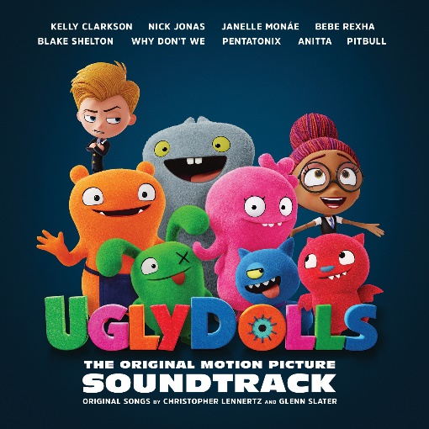

1. Kelly Clarkson - Broken & Beautiful (from the movie UGLYDOLLS)
2. Kelly Clarkson - Couldn’t Be Better (Pop Version)
3. Kelly Clarkson - Today’s the Day
4. Kelly Clarkson and the UglyDolls Cast - Couldn’t Be Better (Movie Version)
5. UglyDolls Cast - Today’s the (Perfect) Day
6. Nick Jonas - The Ugly Truth
7. Pentatonix - You Make My Dreams
8. Nick Jonas - The Uglier Truth
9. Janelle Monáe (Feat. Kelly Clarkson) - All Dolled Up
10. Janelle Monáe & Kelly Clarkson - Unbreakable
11. UglyDolls Cast - The Big Finale
12. Bebe Rexha - Girl in the Mirror
13. Anitta - Ugly
14. Why Don’t We - Don’t Change
15. Blake Shelton - Wallflowers & Weeds
16. Anitta - Ugly (“Fea”)

# # #