VANCE JOY
RELEASES NATION OF TWO

“This is (Vance Joy’s) time to really shine – and he seizes it.”
– Associated Press

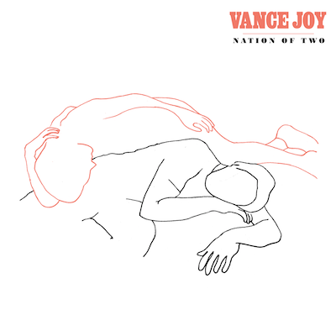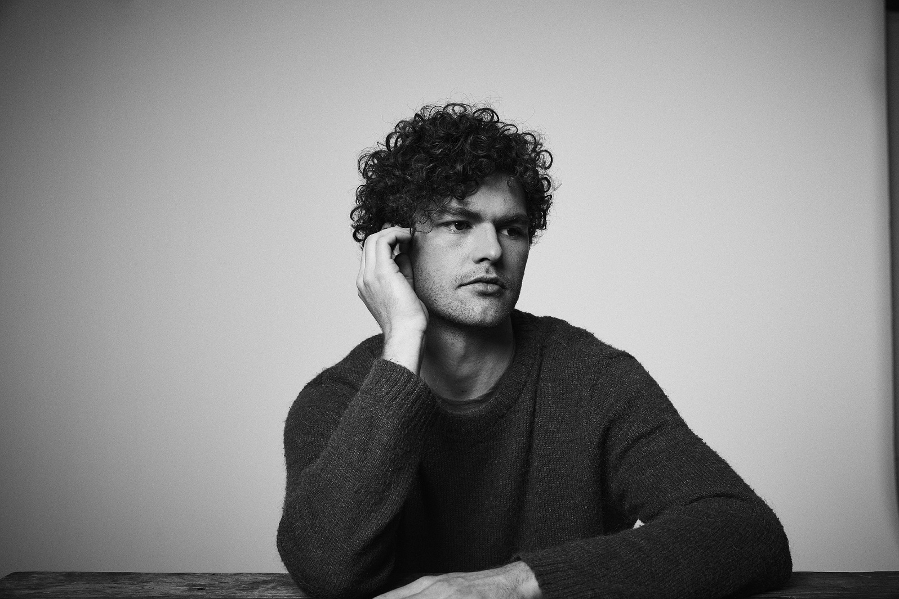

HIGHLY-ANTICIPATED SOPHOMORE ALBUM ALREADY A GLOBAL SENSATION
WITH OVER 60 MILLION STREAMS

NORTH AMERICAN DATES FOR THE NATION OF TWO WORLD TOUR
BEGIN APRIL 13TH AT BERKELEY, CA’S GREEK THEATRE

RANGE OF TOP FESTIVALS ALSO SLATED,
INCLUDING COACHELLA, SHAKY KNEES, FIREFLY, AND MORE

MULTI-PLATINUM SINGER/SONGWRITER TO CELEBRATE ALBUM RELEASE
WITH HIGH PROFILE TV PERFORMANCES INCLUDING
CBS’ THE LATE LATE SHOW WITH JAMES CORDEN, NBC’s TODAY,
AND NBC’s LAST CALL WITH CARSON DALY

NATION OF TWO AVAILABLE EVERYWHERE NOW

Today, Vance Joy releases his eagerly awaited sophomore album, Nation of Two. The already critically-acclaimed collection is available now at all music retailers and streaming services.

Nation of Two – which includes the hit singles, “Lay It On Me” and “Saturday Sun” – has quickly earned widespread critical applause around the world. “The Australian singer-songwriter has gone deeper and broader,” raved Newsday, “making singalongs that sound even bigger, ready for the stadiums he played as (Taylor) Swift’s opener.” Entertainment Weekly adds, “Joy focused on crafting piercing vignettes of young love and emotional restlessness --- and the results absolutely thrill.” “It all adds up to an appealing album from an artist with a promising future,” wrote Associated Press. “This is (Vance Joy’s) time to really shine – and he seizes it.”

Nation of Two has already amassed over 60 million worldwide streams, thanks to a series of five distinctive tracks unveiled in the months leading up to the album’s official release. In addition to aforementioned “Lay It On Me” and “Saturday Sun,” the album was further heralded by beautifully written gems from the 13-track collection, “Like Gold,” “We’re Going Home,” and “Call If You Need Me,” the latter joined by an emotional companion visual, filmed by frequent Vance Joy collaborator Mimi Cave, who also directed the videos for “Lay It On Me” and “We’re Going Home.”

“Saturday Sun,” the album’s second official U.S. single, is impacting now at Alternative radio outlets nationwide. The bright and uplifting track is quickly proving a worldwide fan favorite, with over one million global streams in its first five days of release. An official companion visual will make its debut in the coming weeks.

Vance Joy will mark the arrival of Nation of Two with his biggest worldwide headline tour thus far, announced earlier this month during an intimate Facebook Live event in Venice, CA. The first North American leg of the Nation of Two World Tour will get underway April 13th at Berkeley, CA’s world-renowned Greek Theatre and then continues into the summer (tour itinerary attached). Tickets for all headline dates are available beginning today at 10am (local); for more information and ticket details, please visit http://www.vancejoy.com/tour. Every online ticket purchased for the 2018 Vance Joy tour includes a standard digital copy of the new album, Nation of Two. Instructions on how to redeem your copy will be sent via email on release day, February 23rd, 2018. As if that weren’t enough, Vance Joy will also perform at multiple high-profile festivals throughout 2018, including Coachella, Shaky Knees, Firefly and more.

Vance Joy – who is currently featured on the cover of Rolling Stone Australia – will celebrate the release of Nation of Two with a run of high-profile national TV performances, beginning with CBS’ The Late Late Show with James Corden on Tuesday, February 27th followed by NBC’s Today on Friday, March 8th. What’s more, Wednesday, March 6th will see NBC’s Last Call with Carson Daly presenting two performances by Vance Joy, filmed live from Los Angeles’ Fonda Theatre (check local listings).

Nation of Two is the follow up to Vance Joy’s critically acclaimed breakthrough debut album dream your life away, which recently surpassed one million in consumption in the U.S. alone. The album spawned the 4x Platinum blockbuster hit, “Riptide” and RIAA Platinum certified “Mess Is Mine.” dream your life away also featured “fire and the flood” and “Georgia,” which are both now certified Gold. Based on the success of these songs, Vance Joy was the #1 Most Played artist at Alternative radio in 2015.

CONNECT WITH VANCE JOY:
WEBSITE | FACEBOOK | TWITTER | INSTAGRAM | YOUTUBE | ASSETS

PRESS CONTACT:
Chelsey Northern | chelsey.northern@atlanticrecords.com (NATIONAL)
Elizabeth Kober | elizabethkober@atlanticrecords.com (TOUR/ONLINE)

(TOUR ITINERARY ATTACHED)
VANCE JOY
“NATION OF TWO WORLD TOUR”
2018 NORTH AMERICAN DATES
*festival date
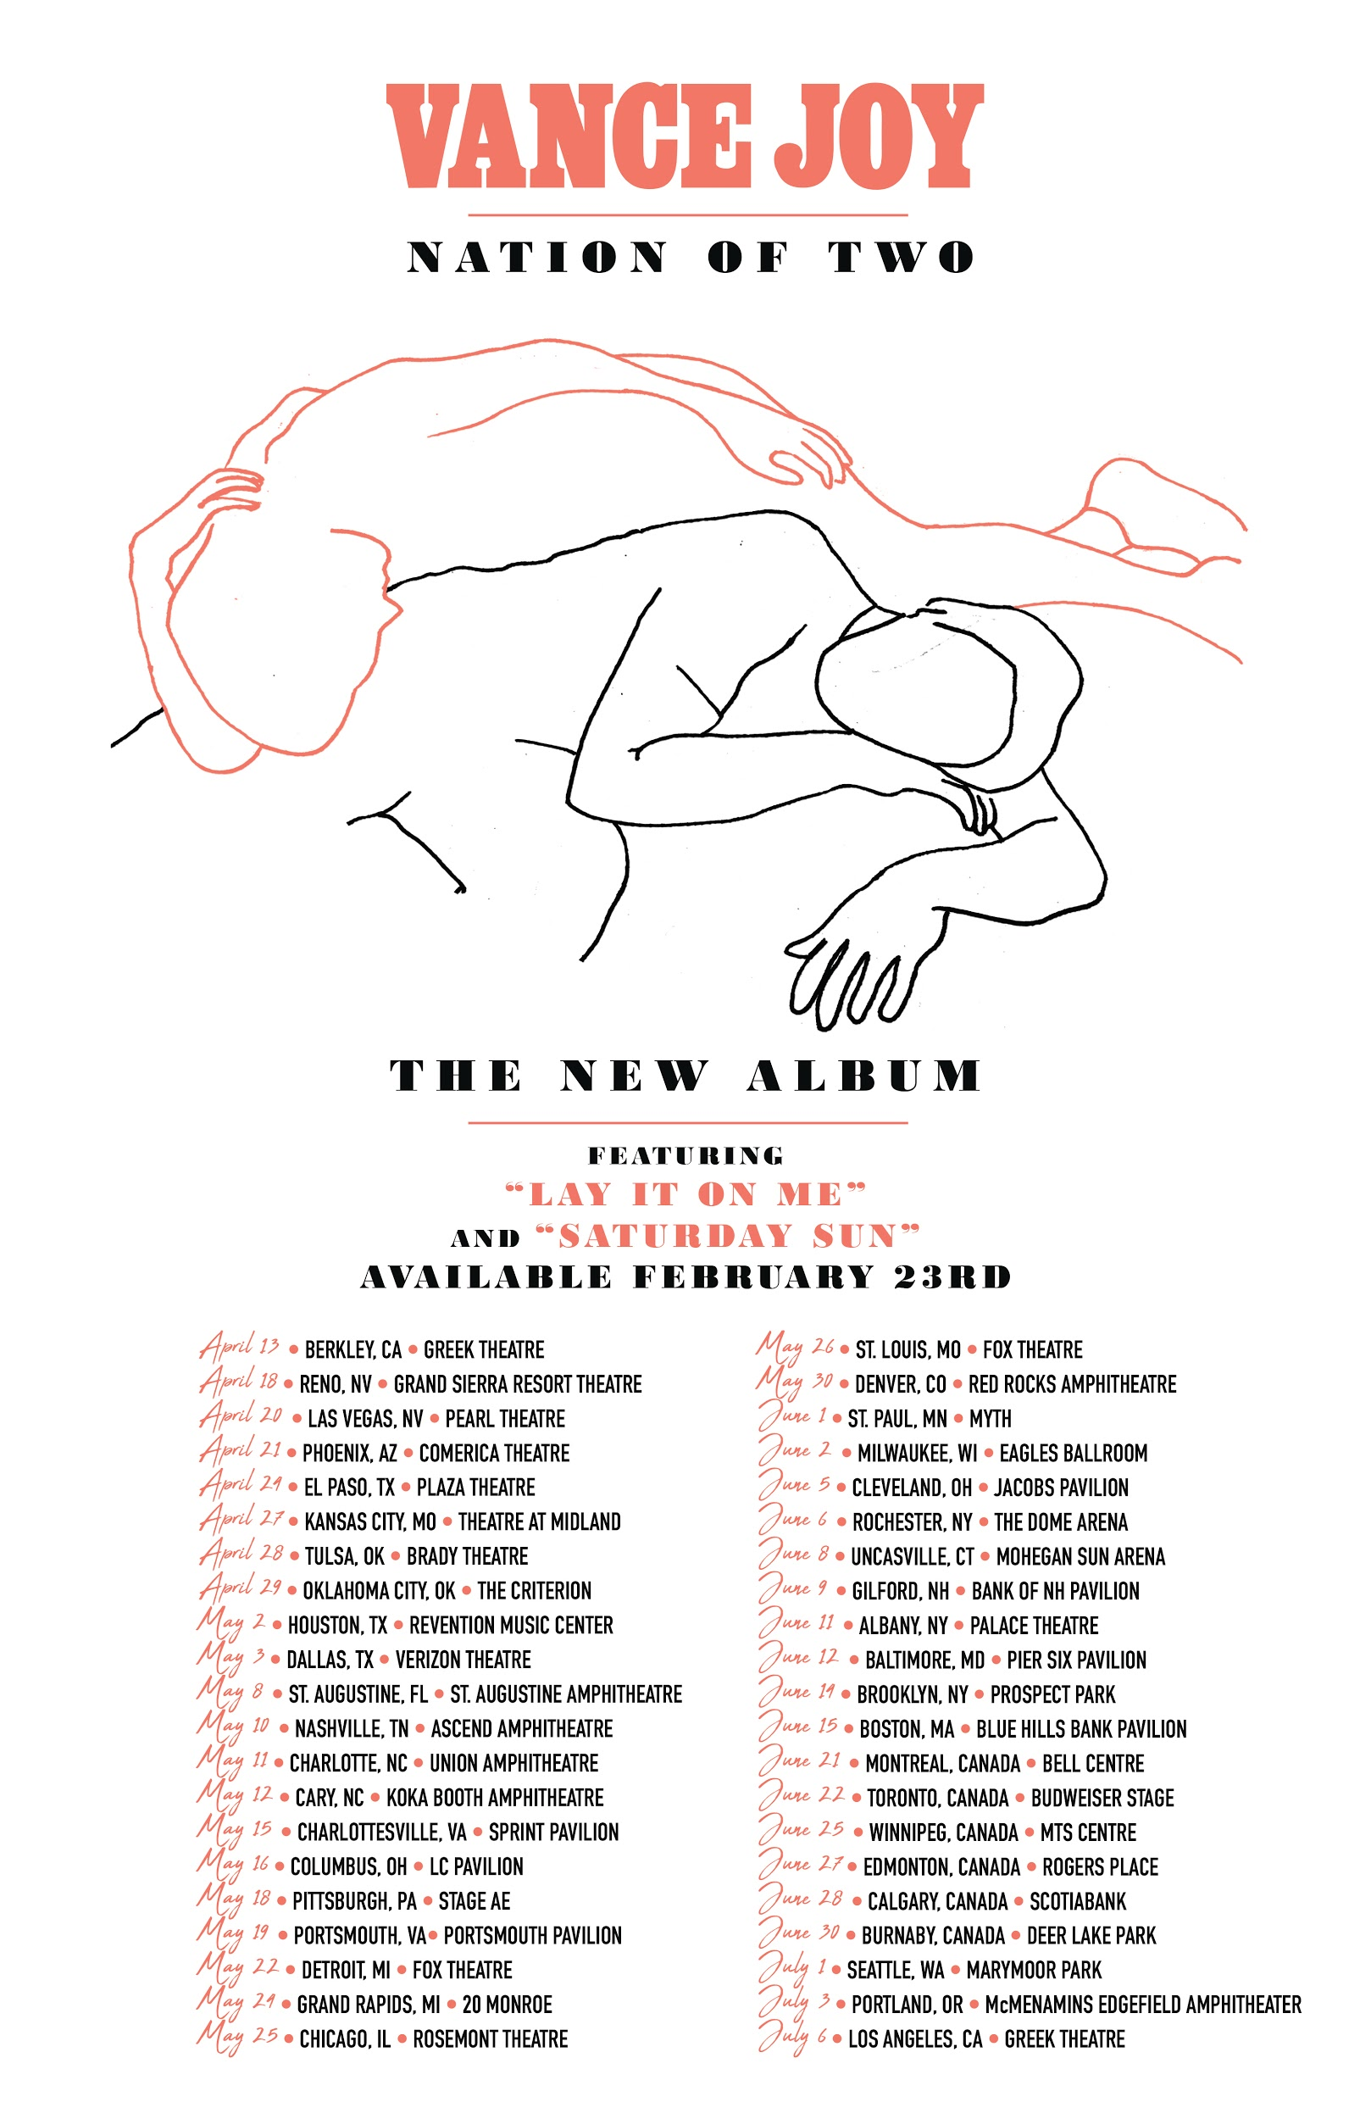

APRIL
13 – Berkeley, CA – Greek Theatre
15 – Indio, CA – Coachella*
18 – Reno, NV – Grand Sierra Resort Theatre
20 – Las Vegas, NV – Pearl Theatre
21 – Phoenix, AZ – Comerica Theatre
22 – Indio, CA – Coachella*
24 – El Paso, TX – Plaza Theatre
27 – Kansas City, MO – Arvest Bank Theatre at The Midland
28 – Tulsa, OK – Brady Theatre
29 – Oklahoma City, OK – The Criterion

MAY
2 – Houston, TX – Revention Music Center
3 – Dallas, TX – Verizon Theatre
5 – Memphis, TN – Beale Street*
6 – Atlanta, GA – Shaky Knees*
8 – St. Augustine, FL – St. Augustine Amphitheatre
10 – Nashville, TN – Ascend Amphitheatre
11 – Charlotte, NC – Charlotte Metro Credit Union Amphitheatre
12 – Cary, NC – Koka Booth Amphitheatre
15 – Charlottesville, VA – Sprint Pavilion
16 – Columbus, OH – Express Live!
18 – Pittsburgh, PA – Stage AE
19 – Portsmouth, VA – Union Bank & Trust Pavilion
22 – Detroit, MI – Fox Theatre
24 – Grand Rapids, MI – 20 Monroe
25 – Chicago, IL – Rosement Theatre
26 – St. Louis, MO – Fox Theatre
30 – Denver, CO – Red Rocks Amphitheatre

JUNE
1 – St. Paul, MN – Myth Live
2 – Milwaukee, WI – Eagles Ballroom
5 – Cleveland, OH – Jacobs Pavilion
6 – Rochester, NY – The Dome Arena
8 – Uncasville, CT – Mohegan Sun Arena
9 – Gilford, NH – Bank of NH Pavilion
11 – Albany, NY – Palace Theatre
12 – Washington, DC – The Anthem
14 – Brooklyn, NY – Celebrate Brooklyn! Festival at the Prospect Park Bandshell
15 – Boston, MA – Blue Hills Bank Pavilion
16 – Dover, DE – Firefly*
21 – Montreal, Canada – Bell Centre
22 – Toronto, Canada – Budweiser Stage
25 – Winnipeg, Canada – MTS Centre
27 – Edmonton, Canada – Rogers Place
28 – Calgary, Canada – Scotiabank
30 – Burnbaby, Canada – Deer Lake Park

JULY
1 – Seattle, WA – Marymoor Park
3 – Portland, OR – McMenamins Edgefield Amphitheater
13 – Louisville, KY – Forecastle*
14 – Birmingham, AL – Sloss*

###

