VANCE JOY
ANNOUNCES MASSIVE WORLD TOUR
+ REVEALS INTIMATE NEW SONG AND VISUAL
“CALL IF YOU NEED ME” FROM FORTHCOMING ALBUM NATION OF TWO
WATCH/LISTEN HERE: https://youtu.be/dQjTQFRZsD4
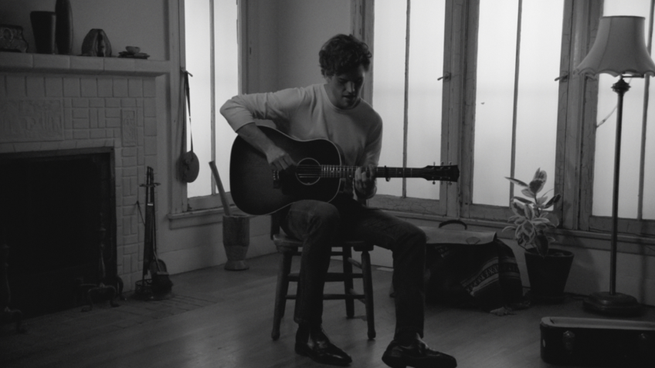
*Download Hi-Res Image HERE*

SONGS UNVEILED FROM NATION OF TWO COLLECTIVELY GAIN
OVER 60 MILLION GLOBAL STREAMS AHEAD OF ALBUM RELEASE

NORTH AMERICAN DATES FOR THE NATION OF TWO WORLD TOUR KICK OFF
APRIL 13TH AT BERKELEY, CA’S GREEK THEATRE

MULTI-PLATINUM SINGER/SONGWRITER SLATED TO CELEBRATE ALBUM RELEASE WEEK WITH PERFORMANCES ON THE LATE LATE SHOW WITH JAMES CORDEN, THE TODAY SHOW & LAST CALL WITH CARSON DALY

HIGHLY-ANTICIPATED SOPHOMORE ALBUM NATION OF TWO
ARRIVES EVERYWHERE FEBRUARY 23RD

From an intimate event last night in Venice, CA, Vance Joy announced to his fans via a global Facebook Live stream, his biggest headline tour to date, the Nation of Two World Tour. Alongside the massive world tour announce, the multi-platinum artist surprised fans with another new song and visual, “Call If You Need Me,” from his eagerly-awaited sophomore album Nation Of Two, due February 23rd.

Watch/listen to “Call If You Need Me” HERE.
Stream/pre-order Nation of Two HERE.

Vance Joy’s Nation Of Two World Tour will see the acclaimed Australian singer/songwriter take on some of his biggest stages yet. The North American leg of the tour will get underway April 13th in Berkeley, CA at the world-renowned Greek Theatre (full tour itinerary attached). Ticket presales for the Nation Of Two World Tour begin February 19th (see details for Verified Fan presale below), and general on-sale begins February 23rd at 10am local time. Every online ticket purchased for the 2018 Vance Joy tour includes a standard digital copy of the new album, ‘Nation of Two.’ Instructions on how to redeem your copy will be sent via email on release day, February 23rd, 2018. For more information and ticket details, please visit http://www.vancejoy.com/tour. Vance Joy will also perform at multiple high-profile festivals throughout 2018 including Coachella, Firefly and Shaky Knees.

“Call If You Need Me,” the fifth and final track unveiled before the Nation Of Two album release (Feb 23), is the hauntingly beautiful album opener featuring Vance Joy’s trademark visual lyrics, painting pictures of fluorescent lights and conversations through foggy shower glass. The accompanying visual, which features Vance Joy delivering an emotional performance in a beautiful, stripped-back setting, was filmed by frequent collaborator Mimi Cave, who also directed videos for the album’s first single “Lay It On Me” and the recently released “We’re Going Home.”

With still two weeks until the release of Nation of Two, the album has already amassed over 60 million global streams, accounted for by the four tracks Vance Joy has unveiled throughout the past few months. The Nation Of Two campaign launched with massive alternative hit single, “Lay It On Me,” and was followed by releases of “Like Gold,” “We’re Going Home,” and “Saturday Sun,” the latter of which will mark the album’s second U.S. single. A promising fan-favorite, the bright and uplifting “Saturday Sun” was streamed over one million times in its first five days of release, and is currently impacting alternative radio stations nationwide.

Vance Joy – who is currently featured on the cover of Rolling Stone Australia – will celebrate his Nation Of Two album release week with a run of high-profile national TV performances, beginning with CBS’ The Late Late Show with James Corden on Tuesday, February 27th followed by NBC’s Today on Friday, March 2nd. The March 6th episode of NBC’s Last Call with Carson Daly will feature two previously filmed live performances by Vance Joy from Los Angeles’ Fonda Theatre.

Nation of Two is the follow up to Vance Joy’s critically-acclaimed breakthrough debut album dream your life away, which recently surpassed one million in consumption in the U.S. alone. The album spawned the 4x Platinum blockbuster hit, “Riptide” and RIAA Platinum certified “Mess Is Mine.” dream your life away also featured “fire and the flood” and “Georgia,” which are both now certified Gold. Based on the success of these songs, Vance Joy was the #1 Most Played artist at Alternative radio in 2015.

VERIFIED FAN PRE-SALE REGISTRATION
via http://vancejoy.tmverifiedfan.com
Begins: Sunday 11 February (5pm ET)
Ends: Wednesday 14 February (10pm ET)

VERIFIED FAN PRE-SALE
Beings: Monday 19 February (10am local)
(or until allocation exhausted)

CONNECT WITH VANCE JOY:
WEBSITE | FACEBOOK | TWITTER | INSTAGRAM | YOUTUBE | ASSETS

PRESS CONTACT:
Chelsey Northern | chelsey.northern@atlanticrecords.com (NATIONAL)
Elizabeth Kober | elizabethkober@atlanticrecords.com (TOUR/ONLINE)

(TOUR ITINERARY ATTACHED)
VANCE JOY
“NATION OF TWO WORLD TOUR”
2018 NORTH AMERICAN DATES
*festival date
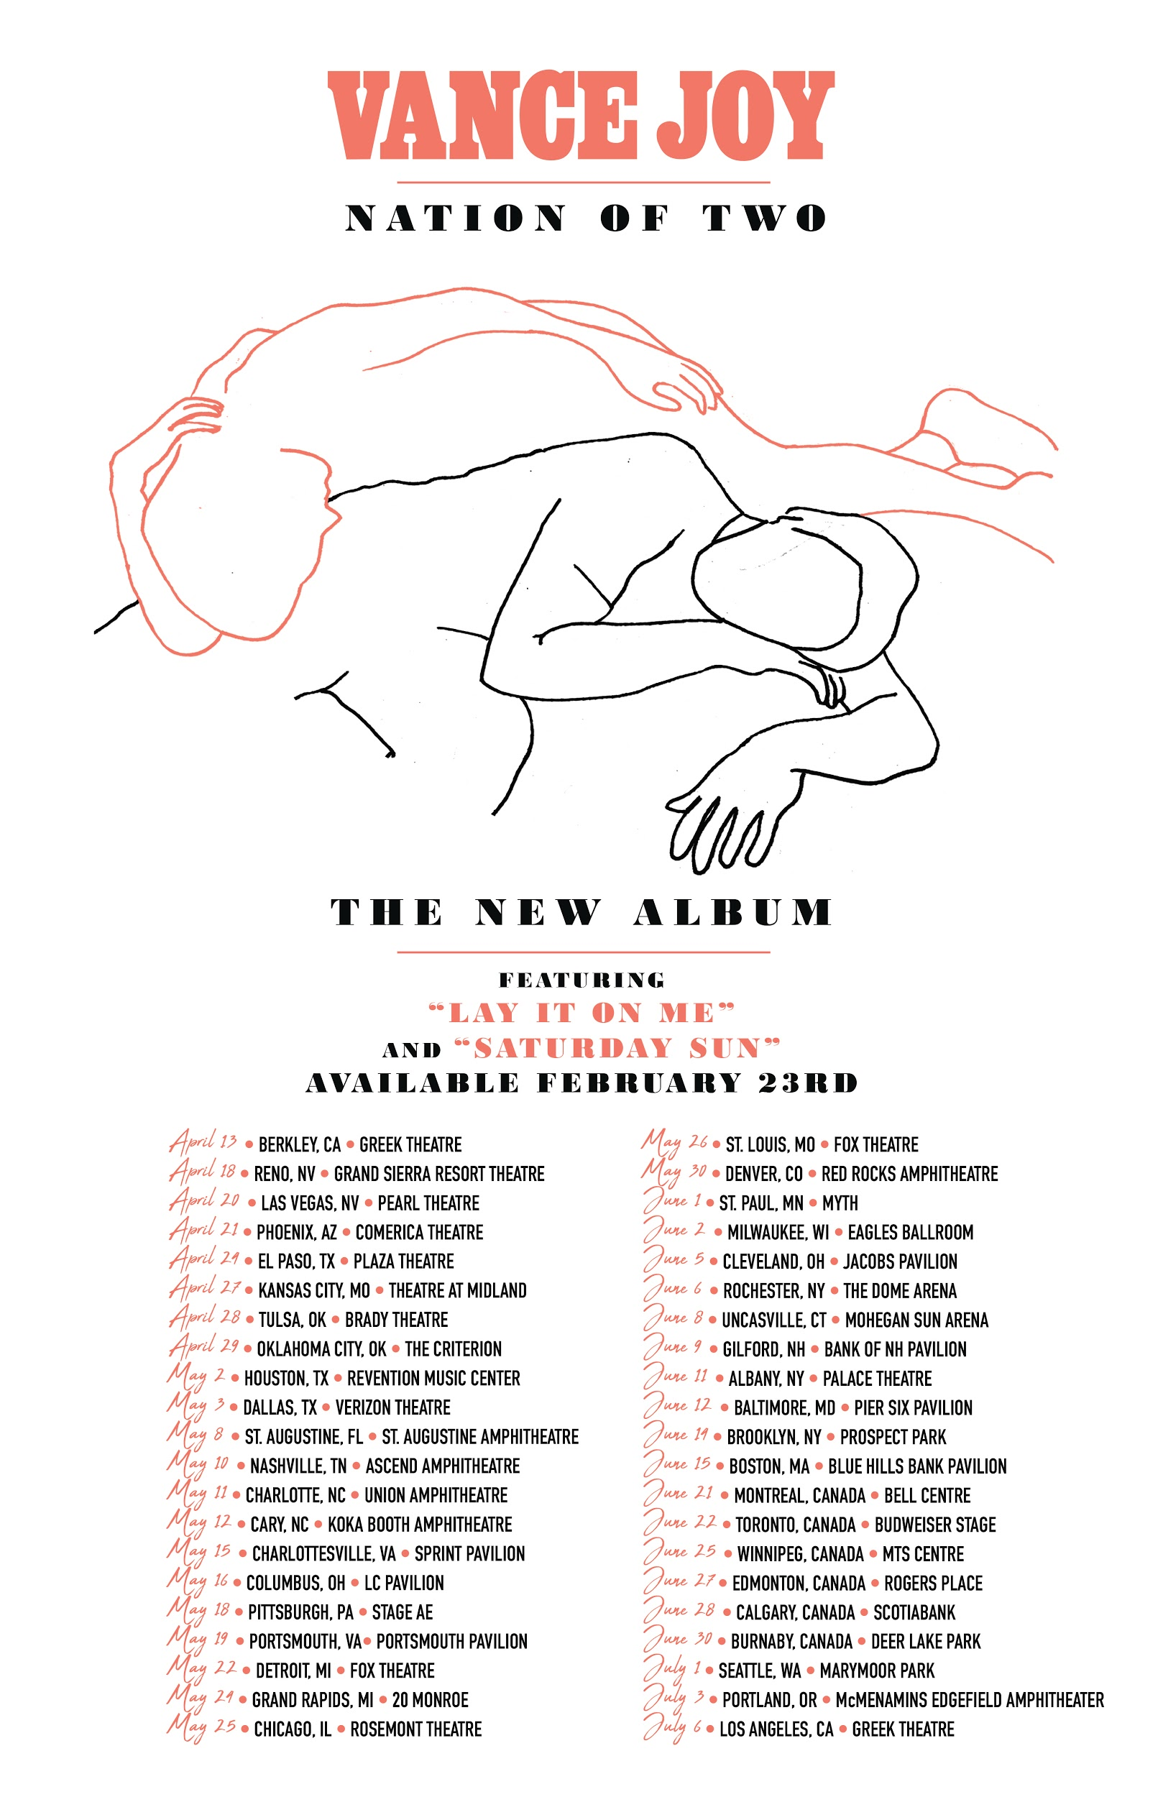

APRIL
13 – Berkeley, CA – Greek Theatre
15 – Indio, CA – Coachella*
18 – Reno, NV – Grand Sierra Resort Theatre
20 – Las Vegas, NV – Pearl Theatre
21 – Phoenix, AZ – Comerica Theatre
22 – Indio, CA – Coachella*
24 – El Paso, TX – Plaza Theatre
27 – Kansas City, MO – Arvest Bank Theatre at The Midland
28 – Tulsa, OK – Brady Theatre
29 – Oklahoma City, OK – The Criterion

MAY
2 – Houston, TX – Revention Music Center
3 – Dallas, TX – Verizon Theatre
5 – Memphis, TN – Beale Street*
6 – Atlanta, GA – Shaky Knees*
8 – St. Augustine, FL – St. Augustine Amphitheatre
10 – Nashville, TN – Ascend Amphitheatre
11 – Charlotte, NC – Charlotte Metro Credit Union Amphitheatre
12 – Cary, NC – Koka Booth Amphitheatre
15 – Charlottesville, VA – Sprint Pavilion
16 – Columbus, OH – Express Live!
18 – Pittsburgh, PA – Stage AE
19 – Portsmouth, VA – Union Bank & Trust Pavilion
22 – Detroit, MI – Fox Theatre
24 – Grand Rapids, MI – 20 Monroe
25 – Chicago, IL – Rosement Theatre
26 – St. Louis, MO – Fox Theatre
30 – Denver, CO – Red Rocks Amphitheatre

JUNE
1 – St. Paul, MN – Myth Live
2 – Milwaukee, WI – Eagles Ballroom
5 – Cleveland, OH – Jacobs Pavilion
6 – Rochester, NY – The Dome Arena
8 – Uncasville, CT – Mohegan Sun Arena
9 – Gilford, NH – Bank of NH Pavilion
11 – Albany, NY – Palace Theatre
12 – Baltimore, MD – Pier Six Pavilion
14 – Brooklyn, NY – Celebrate Brooklyn! Festival at the Prospect Park Bandshell
15 – Boston, MA – Blue Hills Bank Pavilion
16 – Dover, DE – Firefly*
21 – Montreal, Canada – Bell Centre
22 – Toronto, Canada – Budweiser Stage
25 – Winnipeg, Canada – MTS Centre
27 – Edmonton, Canada – Rogers Place
28 – Calgary, Canada – Scotiabank
30 – Burnbaby, Canada – Deer Lake Park

JULY
1 – Seattle, WA – Marymoor Park
3 – Portland, OR – McMenamins Edgefield Amphitheater
13 – Louisville, KY – Forecastle*
14 – Birmingham, AL – Sloss*

###

