VANCE JOY
RELEASES ACOUSTIC VERSION OF SMASH SINGLE
“SATURDAY SUN” FROM NATION OF TWO

+ HIGHLY-ANTICIPATED SHOW AT LOS ANGELES’ GREEK THEATRE ADDED TO MASSIVE HEADLINE NATION OF TWO TOUR; ON SALE TODAY

LISTEN TO “SATURDAY SUN” (ACOUSTIC) HERE: https://lnk.to/SaturdaySunAcoustic
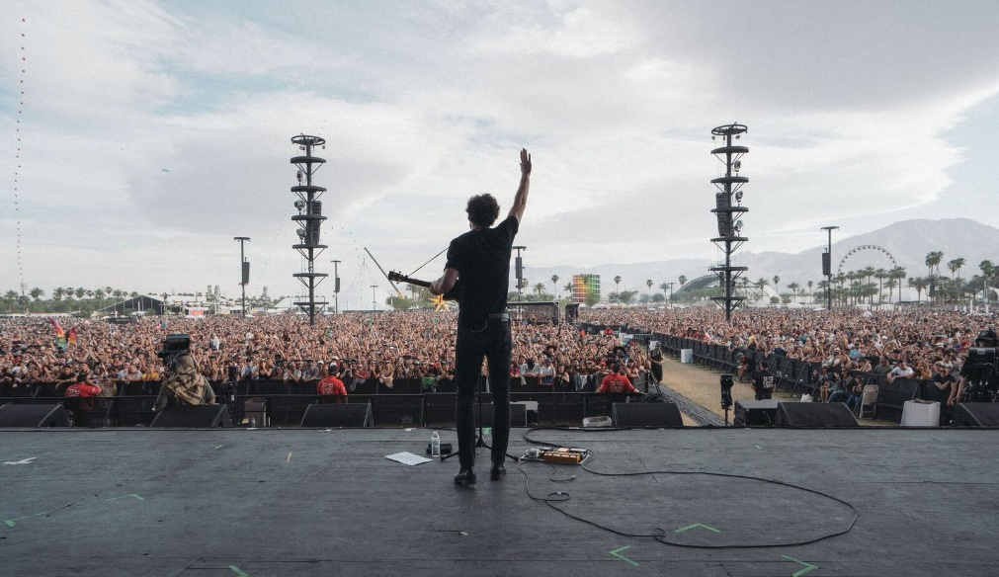

NEWEST SINGLE FROM CRITICALLY-ACCLAIMED SOPHOMORE ALBUM GETS MADE OVER WITH SPECIAL ACOUSTIC RENDITION

MULTI-PLATINUM SINGER/SONGWRITER HIGHLIGHTS NORTH AMERICAN TREK WITH BACK-TO-BACK MAINSTAGE PERFORMANCES AT COACHELLA

After wrapping up a pair of Coachella performances, Vance Joy is back out on the North American leg of his biggest headline world tour thus far, celebrating the release of his new sophomore album Nation of Two (Atlantic Records). Today, he releases a brand new acoustic version of his smash single “Saturday Sun,” which is currently climbing multiple radio, sales and streaming charts nationwide. “Saturday Sun” (Acoustic) is now available at all DSPs. Earlier this week, Joy added to his tour agenda a highly-anticipated July 6th date at Los Angeles’ Greek Theatre, which is on sale today at www.vancejoy.com. See all dates below.

Tonight at 9:00pm ET/PT, the broadcast premiere of Vance Joy’s concert special on AT&T* AUDIENCE Network will air via DIRECTV Ch 239, AT&T U-verse Ch 1114 and streaming on-demand through DIRECTV NOW. The concert special highlights Vance Joy’s poetic pop melodies and beloved, sing-along anthems, and includes an in-depth interview with Ted Stryker. Watch a preview of the show HERE; and watch a sneak peek of Vance Joy’s performance of “Saturday Sun” HERE.
Nation of Two - which includes previous hit single “Lay It On Me” in addition to “Saturday Sun” - has been streamed over 150 million times globally since its February 23rd release. The 13-track collection debuted at No. 10 on the Billboard 200 and at No. 5 on the Current Album Sales chart. Nation of Two will receive a vinyl release on May 25th, pre-order HERE.

Nation of Two has not only proven a sales and streaming success, but Joy’s sophomore album has earned widespread critical applause around the world. “Keogh has crafted a confident follow-up in Nation of Two that signals a promising career ahead,” raved USA Today. “It all adds up to an appealing album from an artist with a promising future,” wrote Associated Press. “This is (Vance Joy’s) time to really shine – and he seizes it.”

Only a few weeks ago, Joy released a romantic and dreamy visual companion for “Saturday Sun,” watch here: https://youtu.be/uKqMNQkjHmI.The eye-catching video was directed by The Young Astronauts and stars a suited-up, corporate version of Vance Joy, who finds himself daydreaming on the job. His weekend memories of finding new love collide with his boring daily work routine, blending his colorful imagination into reality.

CONNECT WITH VANCE JOY:
WEBSITE | FACEBOOK | TWITTER | INSTAGRAM | YOUTUBE | ASSETS

PRESS CONTACT:
Chelsey Northern | chelsey.northern@atlanticrecords.com (NATIONAL)
Elizabeth Kober | elizabethkober@atlanticrecords.com (TOUR/ONLINE)
VANCE JOY
“NATION OF TWO WORLD TOUR”
2018 NORTH AMERICAN DATES
*festival date
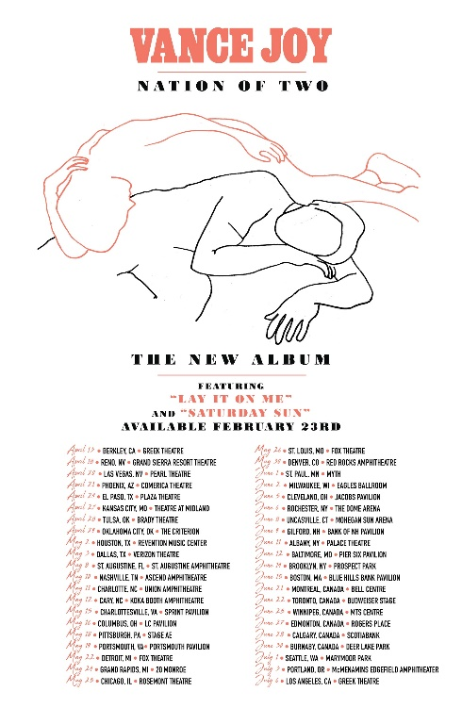

MAY
5 – Memphis, TN – Beale Street*
6 – Atlanta, GA – Shaky Knees*
8 – St. Augustine, FL – St. Augustine Amphitheatre
10 – Nashville, TN – Ascend Amphitheatre
11 – Charlotte, NC – Charlotte Metro Credit Union Amphitheatre
12 – Cary, NC – Koka Booth Amphitheatre
15 – Charlottesville, VA – Sprint Pavilion
16 – Columbus, OH – Express Live!
18 – Pittsburgh, PA – Stage AE
19 – Portsmouth, VA – Union Bank & Trust Pavilion
22 – Detroit, MI – Fox Theatre
24 – Grand Rapids, MI – 20 Monroe – SOLD OUT
25 – Chicago, IL – Rosement Theatre
26 – St. Louis, MO – Fox Theatre
30 – Denver, CO – Red Rocks Amphitheatre

JUNE
1 – St. Paul, MN – Myth Live
2 – Milwaukee, WI – Eagles Ballroom
5 – Cleveland, OH – Jacobs Pavilion
6 – Rochester, NY – The Dome Arena
8 – Uncasville, CT – Mohegan Sun Arena
9 – Gilford, NH – Bank of NH Pavilion
11 – Albany, NY – Palace Theatre
12 – Washington, DC – The Anthem
14 – Brooklyn, NY – Celebrate Brooklyn! Festival at the Prospect Park Bandshell
15 – Boston, MA – Blue Hills Bank Pavilion
16 – Dover, DE – Firefly*
21 – Montreal, Canada – Bell Centre
22 – Toronto, Canada – Budweiser Stage
25 – Winnipeg, Canada – MTS Centre
27 – Edmonton, Canada – Rogers Place
28 – Calgary, Canada – Scotiabank
30 – Burnbaby, Canada – Deer Lake Park

JULY
1 – Seattle, WA – Marymoor Park
3 – Portland, OR – McMenamins Edgefield Amphitheater
6 – Los Angeles – Greek Theatre
13 – Louisville, KY – Forecastle*
14 – Birmingham, AL – Sloss*

###

