VANCE JOY
UNVEILS NEW MUSIC VIDEO FOR SINGLE
“SATURDAY SUN” FROM NATION OF TWO

WATCH HERE:
https://youtu.be/uKqMNQkjHmI
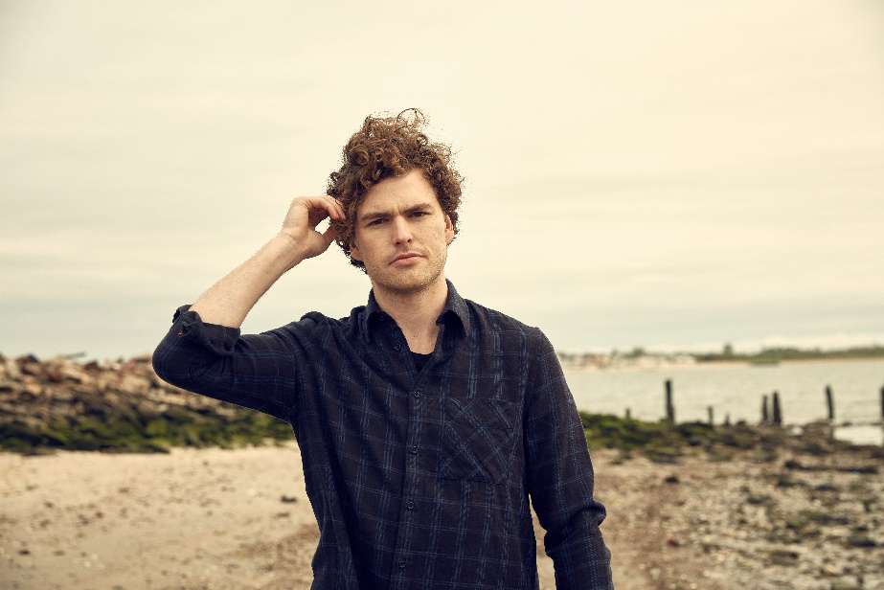

NEWEST SINGLE FROM CRITICALLY-ACCLAIMED SOPHOMORE ALBUM GETS ROMANTIC DAYDREAM VISUAL

MULTI-PLATINUM SINGER/SONGWRITER KICKS OFF NORTH AMERICAN HEADLINE TREK THIS WEEK, AND RETURNS TO COACHELLA

VINYL EDITION OF NATION OF TWO SET TO ARRIVE MAY 25TH,
AVAILABLE FOR PRE-ORDER TODAY

On the heels of the North American leg of his Nation Of Two World Tour and a highly-anticipated return to Coachella, Vance Joy released today a stunning music video for the latest single “Saturday Sun” from his sophomore album Nation of Two. Watch here: <https://youtu.be/uKqMNQkjHmI>.

The eye-catching visual for “Saturday Sun” was directed by The Young Astronauts and stars a suited-up, corporate version of Vance Joy, who finds himself daydreaming on the job. His weekend memories of finding new love collide with his boring daily work routine, blending his colorful imagination into reality.

The new clip comes on the heels of the eagerly-awaited launch of the North American leg of Vance Joy’s biggest worldwide headline tour thus far. The stateside dates of the Nation of Two World Tour will get underway April 13th at Berkeley, CA’s world-renowned Greek Theatre and continue into the summer (tour itinerary attached).

This Sunday, April 15th, Vance Joy will return to Coachella for a second time to perform at 4:45pm on the Coachella stage. This year’s performance will follow his momentous 2015 Coachella debut where the “Mojave tent was overflowing” and he “wowed the crowd.” The multi-Platinum singer-songwriter will continue to perform at several high-profile festivals throughout 2018, including Shaky Knees, Firefly and more.

Nation of Two – which includes previous hit single “Lay It On Me” in addition to “Saturday Sun” – has been streamed over 150 million times globally since its February 23rd release. The 13-track collection debuted at No. 10 on the Billboard 200 and at No. 5 on the Current Album Sales chart with over 27,000 sales equivalents first week. Nation of Two is being further celebrated with a vinyl edition that will arrive May 25th and is available for pre-order today at www.vancejoy.com/store.

Nation of Two has not only proven a sales and streaming success, but the sophomore album has earned widespread critical applause around the world. “Keogh has crafted a confident follow-up in Nation of Two that signals a promising career ahead,” raved USA Today. “The Australian singer-songwriter has gone deeper and broader,” added Newsday, “making singalongs that sound even bigger, ready for the stadiums he played as (Taylor) Swift’s opener.” Entertainment Weekly continues, “Joy focused on crafting piercing vignettes of young love and emotional restlessness --- and the results absolutely thrill.” “It all adds up to an appealing album from an artist with a promising future,” wrote Associated Press. “This is (Vance Joy’s) time to really shine – and he seizes it.”

Vance Joy – who was recently featured on the cover of Rolling Stone Australia – celebrated the release of Nation of Two with a run of high-profile national TV performances of “Saturday Sun,” including CBS’ The Late Late Show with James Corden and NBC’s Today.

Nation of Two is the follow up to Vance Joy’s critically acclaimed breakthrough debut album dream your life away, which recently surpassed one million in consumption in the U.S. alone. The album spawned the 4x Platinum blockbuster hit, “Riptide” and RIAA Platinum certified “Mess Is Mine.” dream your life away also featured “fire and the flood” and “Georgia,” which are both now certified Gold. Based on the success of these songs, Vance Joy was the #1 Most Played artist at Alternative radio in 2015.

CONNECT WITH VANCE JOY:
WEBSITE | FACEBOOK | TWITTER | INSTAGRAM | YOUTUBE | ASSETS

PRESS CONTACT:
Chelsey Northern | chelsey.northern@atlanticrecords.com (NATIONAL)
Elizabeth Kober | elizabethkober@atlanticrecords.com (TOUR/ONLINE)

(TOUR ITINERARY ATTACHED)
VANCE JOY
“NATION OF TWO WORLD TOUR”
2018 NORTH AMERICAN DATES
*festival date
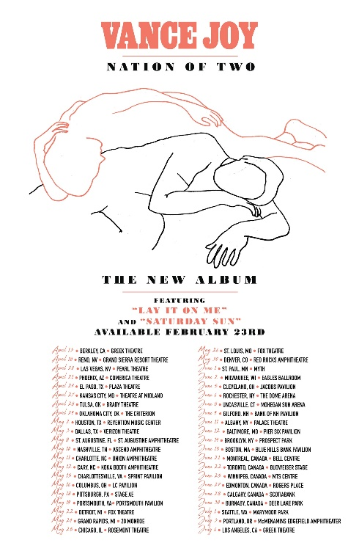

APRIL
13 – Berkeley, CA – Greek Theatre
15 – Indio, CA – Coachella*
18 – Reno, NV – Grand Sierra Resort Theatre
20 – Las Vegas, NV – Pearl Theatre
21 – Phoenix, AZ – Comerica Theatre
22 – Indio, CA – Coachella*
24 – El Paso, TX – Plaza Theatre
27 – Kansas City, MO – Arvest Bank Theatre at The Midland
28 – Tulsa, OK – Brady Theatre
29 – Oklahoma City, OK – The Criterion

MAY
2 – Houston, TX – Revention Music Center
3 – Dallas, TX – Verizon Theatre
5 – Memphis, TN – Beale Street*
6 – Atlanta, GA – Shaky Knees*
8 – St. Augustine, FL – St. Augustine Amphitheatre
10 – Nashville, TN – Ascend Amphitheatre
11 – Charlotte, NC – Charlotte Metro Credit Union Amphitheatre
12 – Cary, NC – Koka Booth Amphitheatre
15 – Charlottesville, VA – Sprint Pavilion
16 – Columbus, OH – Express Live!
18 – Pittsburgh, PA – Stage AE
19 – Portsmouth, VA – Union Bank & Trust Pavilion
22 – Detroit, MI – Fox Theatre
24 – Grand Rapids, MI – 20 Monroe
25 – Chicago, IL – Rosement Theatre
26 – St. Louis, MO – Fox Theatre
30 – Denver, CO – Red Rocks Amphitheatre

JUNE
1 – St. Paul, MN – Myth Live
2 – Milwaukee, WI – Eagles Ballroom
5 – Cleveland, OH – Jacobs Pavilion
6 – Rochester, NY – The Dome Arena
8 – Uncasville, CT – Mohegan Sun Arena
9 – Gilford, NH – Bank of NH Pavilion
11 – Albany, NY – Palace Theatre
12 – Washington, DC – The Anthem
14 – Brooklyn, NY – Celebrate Brooklyn! Festival at the Prospect Park Bandshell
15 – Boston, MA – Blue Hills Bank Pavilion
16 – Dover, DE – Firefly*
21 – Montreal, Canada – Bell Centre
22 – Toronto, Canada – Budweiser Stage
25 – Winnipeg, Canada – MTS Centre
27 – Edmonton, Canada – Rogers Place
28 – Calgary, Canada – Scotiabank
30 – Burnbaby, Canada – Deer Lake Park

JULY
1 – Seattle, WA – Marymoor Park
3 – Portland, OR – McMenamins Edgefield Amphitheater
13 – Louisville, KY – Forecastle*
14 – Birmingham, AL – Sloss*

###

