FOR IMMEDIATE RELEASE
FEBRUARY 10, 2022

MULTI-PLATINUM SINGER-SONGWRITER VANCE JOY UNVEILS “DON’T FADE” – PREVIEWING FRESH NEW SOUND OF FORTHCOMING ALBUM

AFTER DOMINATING ALTERNATIVE RADIO WITH 2021 SMASH “MISSING PIECE,” JOY RETURNS WITH NEW SINGLE PRODUCED BY HITMAKERS TAKE A DAY TRIP, ALTERNATIVE INNOVATOR DAVE LONGSTRETH + LONG COLLABORATORS DAVE BASSETT & EDWIN WHITE

SELECT NORTH AMERICAN LIVE DATES KICK OFF MAY 14 IN REDONDO BEACH, CA

LISTEN TO “DON’T FADE” HERE
WATCH OFFICIAL VIDEO HERE
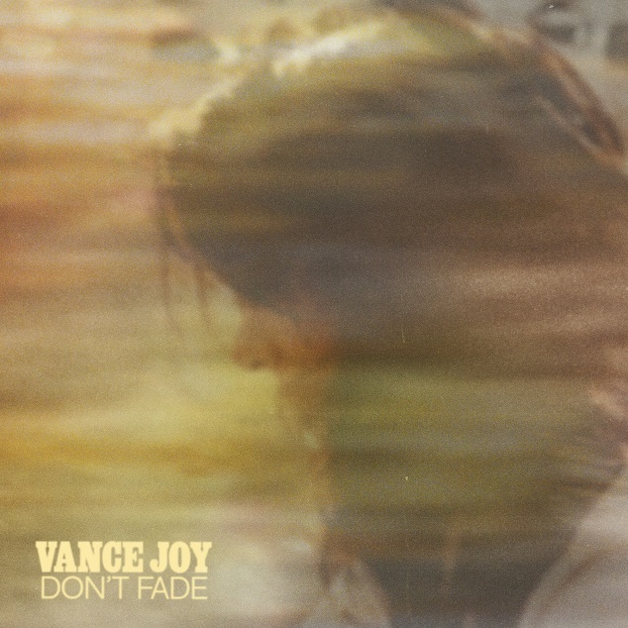
DOWNLOAD ARTWORK HERE

Multi-platinum singer-songwriter Vance Joy has today unveiled his latest single “Don’t Fade” – showcasing a fresh and propulsive sound and providing fans with a preview of his forthcoming third studio album. Listen to “Don’t Fade” HERE.

Produced by hitmaking duo Take a Day Trip (Lil Nas X, Kid Cudi, Juice Wrld, James Blake), Dirty Projectors’ Dave Longstreth (Solange), and long time collaborators Dave Bassett & Edwin White (Lay It On Me, Saturday Sun) the track marks a foray into new sonic territory for the Australian artist. It arrives with an official video streaming now HERE.

“I wrote ‘Don’t Fade’ with my friend and frequent songwriting partner Dave Bassett toward the end of 2019,” Vance Joy shared. “It came as a surprise and felt like a special discovery. I like writing about that feeling of timelessness you get when you’re with someone you love. When we came to produce the song, I had the great fortune to work with Take a Daytrip, Edwin White and David Longstreth (of Dirty Projectors). Writing this song was the starting point for my new album. I knew I was on a path somewhere once this song came along.”

“Don’t Fade” follows the worldwide success of last year’s “Missing Piece.” Co-written with GRAMMY® Award-winning songwriter Joel Little (Taylor Swift, Khalid, Lorde), the irresistibly infectious track proved a sensation following its world premiere on ABC’s Grey’s Anatomy.

The track ascended to #2 at Alternative Radio, earning more than 130 million global streams and bringing Joy’s catalogue up over 5 billion streams worldwide, as well as a massive 3 billion TikTok views (with 2.6 million user-created videos). Hailed by American Songwriter as “a heartfelt indie-folk anthem,” “Missing Piece” was joined by inventive remixes from GRAMMY Award-nominated artists Sofi Tukker (Lady Gaga, Billie Eilish) and RAC (Lana Del Rey, Odesza).

Last year also saw Vance Joy team up with superstar producers Benny Blanco and Marshmello for the hit single, “You.” The song proved an immediate hit upon arrival, cracking the Top 20 on both Billboard’s “Alternative Airplay” and “Rock Airplay” charts, while earning critical acclaim from publications such as Rolling Stone, which declared it to be “a sweet and uplifting bit of pop-rock that finds Joy crooning over Blanco and Marshmello’s horn-inflected production.”

Having previously lit up stages around the world with a string of sold-out headline tours, special guest slots on stadium runs with Taylor Swift and P!nk, and marquee festival appearances at Coachella, Firefly and Austin City Limits, Joy recently announced a highly-anticipated return to North America set for Spring 2022.

The run of select live dates kicks off May 14 at Beachlife Festival in Redondo Beach and will include sold-out headline performances at Nashville’s historic Ryman Auditorium (June 2) and New York’s Pier 17 (June 4). For updates and ticket information, please visit: https://www.vancejoy.com/tour.

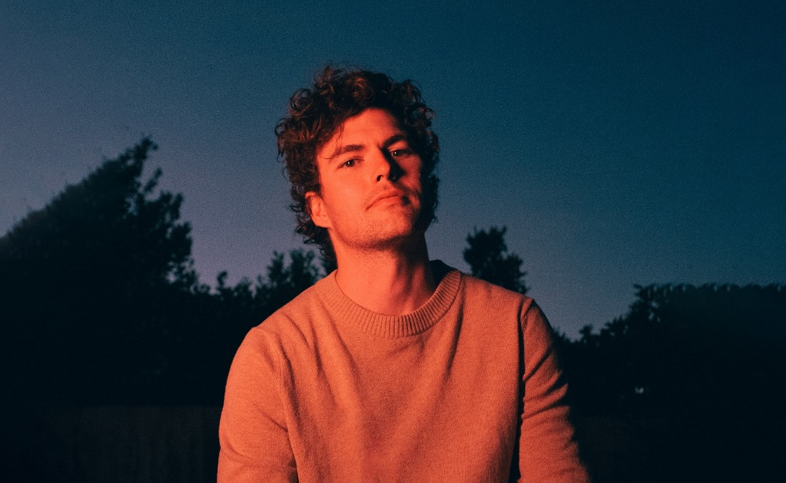
DOWNLOAD PRESS PHOTOS HERE

VANCE JOY
NORTH AMERICAN 2022 LIVE SHOWS

MAY
14 – Redondo Beach, CA – Beachlife Festival
27 – Vancouver, BC – Rogers Arena
29 – Napa, CA – Bottlerock Festival

JUNE
2 – Nashville, TN – Ryman Auditorium (SOLD OUT)
4 – New York, NY – The Rooftop At Pier 17 (SOLD OUT)
9 – Toronto, ON – Budweiser Stage

# # #

CONNECT WITH VANCE JOY:
WEBSITE | FACEBOOK | TWITTER | INSTAGRAM | YOUTUBE

For press inquiries, please contact:
Kelly McWilliam // Kelly.McWilliam@atlanticrecords.com
Libby Kober // Libby.Kober@atlanticrecords.com

