MULTI-PLATINUM SINGER/SONGWRITER VANCE JOY RELEASES “MISSING PIECE” ACOUSTIC

STRIPPED-BACK VERSION OF RISING SINGLE FEATURING
VANCE JOY PLAYING HIS ICONIC UKELELE

ORIGINAL TRACK CURRENTLY TOP 20 AT ALTERNATIVE RADIO
+ CONTINUES TO STREAM OVER 1 MILLION TIMES A WEEK IN THE US

LISTEN TO “MISSING PIECE (ACOUSTIC)” HERE
CHECK OUT THE PERFORMANCE VIDEO HERE
DOWNLOAD ARTWORK HERE

Multi-platinum singer/songwriter Vance Joy has released the beautiful, stripped back version of his recent single “Missing Piece,” along with an acoustic performance video.

The original track dropped in late May and has already cracked the top 20 at alternative radio (currently #19), racked up over 15 million worldwide streams, and continues to stream over a million times a week in the US alone.

“Missing Piece” marked the first taste of new music from Vance Joy in three years, and followed on from his recent collaboration with fellow superstars Benny Blanco and Marshmello on “You.” Written virtually during a COVID lockdown with Joel Little (Taylor Swift, Khalid, Lorde), “Missing Piece” saw an impressive debut on ABC’s Grey’s Anatomy as well as widespread critical acclaim from Variety, American Songwriter, and more.

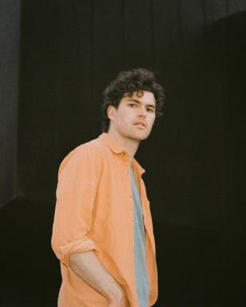
DOWNLOAD PRESS PHOTOS HERE

ABOUT VANCE JOY
You don't sell over two million copies of your debut album without some serious hard work, and Australian singer/songwriter Vance Joy has never been shy of major elbow grease. After performing at open mic nights in Melbourne, Joy introduced the world to his ukulele-led charm ‘Riptide’, which became an instant global classic.

Vance Joy (born James Keogh) consolidated on that first impression with further anthems ‘Mess is Mine’, ‘Georgia’ and ‘Fire and the Flood’ off his 2014's debut ’dream your life away’. Vance Joy then toured the globe on Taylor Swift’s 1989 World Tour, and played world famous festivals such as Lollapalooza, Coachella, and more. After his successful Sold Out 2016 ‘Fire and The Flood’ North American theatre run, and Australian performances at the Sydney Opera House, Vance Joy kicked off the campaign for his Sophomore album ‘Nation of Two’ with the lead single ‘Lay It On Me’ showing it was destined to be another successful album. The success of ‘Nation of Two’ saw Vance Joy tour the world throughout 2018 headlining legendary venues such as Red Rocks Amphitheatre, and theatres acorss Latin American, Europe and Australia including two sold-out hometown shows at Melbourne’s Rod Laver Arena.

It’s no surprise that listeners all over the world connect to Vance Joys intimate yet anthemic songwriting. His lyrics take you on a journey that will reach out and hold you for a delicate moment. Bringing together a unique, charming mix of folk music with pop influences, these songs capture the familiar pulse of everyday experiences in a unique and celebratory manner.

CONNECT WITH VANCE JOY:
WEBSITE | FACEBOOK | TWITTER | INSTAGRAM | YOUTUBE

For press inquiries, please contact:
Kelly McWilliam // Kelly.McWilliam@atlanticrecords.com
Libby Kober // Libby.Kober@atlanticrecords.com

