FOR IMMEDIATE RELEASE
NOVEMBER 16, 2021

VANCE JOY ANNOUNCES PAIR OF US HEADLINING SHOWS

MULTI-PLATINUM SINGER-SONGWRITER TO PLAY
NASHVILLE’S ICONIC RYMAN AUDITORIUM AND NEW YORK’S PIER 17

CURRENT SINGLE “MISSING PIECE” NOW #2 AT ALTERNATIVE RADIO
JOY’S CATALOGUE BOASTS OVER 5 BILLION STREAMS

TICKETS ON SALE THIS FRIDAY, NOVEMEBER 19 AT 10AM LOCAL TIME HERE
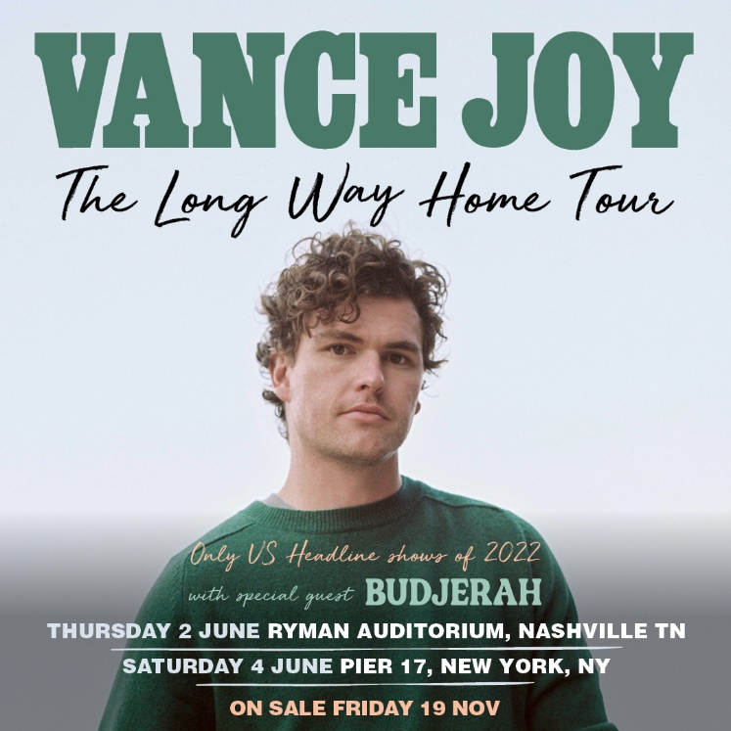
DOWNLOAD ADMAT HERE

Multi-platinum singer/songwriter Vance Joy has announced a pair of US headlining shows for June 2022. The acclaimed artist will play Nashville, TN’s famed Ryman Auditorium on June 2, 2022 and New York’s Pier 17 on June 4, 2022. The shows will go on sale this Friday, November 19 at 10AM local time. For tickets and details please visit: https://www.vancejoy.com/tour.

An acclaimed live performer, Joy has lit up stages around the world on a string of sold out headline tours and festivals, playing iconic stages such as Red Rocks Amphitheatre, Coachella, Firefly, Austin City Limits and more, as well as special guest turns on stadium runs by Taylor Swift and P!nk.

Joy recently kicked off the holiday season with the release of a beautiful cover of The Pogues’ “Fairytale of New York.” Part of Atlantic Records’ annual holiday compilation, the rendition of the English punk band’s 1987 Christmas classic was originally released to his YouTube channel last year, instantly becoming a fan favorite (watch here).

Joy’s catalogue boasts over 5 billion streams, as well as over 3 billion views on TikTok (with 2.6 million user-created videos). His current single, “Missing Piece” was written with Joel Little (Taylor Swift, Khalid, Lorde) and released in May of this year. It has gone on to amass over 75 million global streams, while currently streaming over 2 million times a week in the US alone.

The single currently sits at #2 at Alternative Radio, making it Joy’s highest charting single since his smash hit “Riptide.” “Missing Piece” was also featured on ABC’s Grey’s Anatomy and performed by Joy on The Late Late Show with James Corden. Most recently, the track saw an impressive rework from GRAMMY-nominated duo Sofi Tukker (Lady Gaga, Billie Eilish).

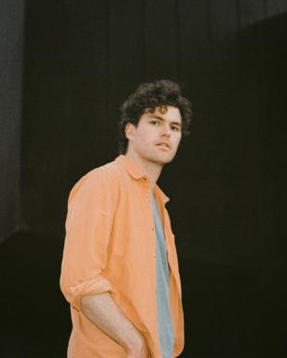
DOWNLOAD PRESS PHOTOS HERE

ABOUT VANCE JOY
You don't sell over two million copies of your debut album without some serious hard work, and Australian singer/songwriter Vance Joy has never been shy of major elbow grease. After performing at open mic nights in Melbourne, Joy introduced the world to his ukulele-led charm ‘Riptide’, which became an instant global classic.

Vance Joy (born James Keogh) consolidated on that first impression with further anthems ‘Mess is Mine’, ‘Georgia’ and ‘Fire and the Flood’ off his 2014's debut ’dream your life away’. Vance Joy then toured the globe on Taylor Swift’s 1989 World Tour, and played world famous festivals such as Lollapalooza, Coachella, and more. After his successful Sold Out 2016 ‘Fire and The Flood’ North American theatre run, and Australian performances at the Sydney Opera House, Vance Joy kicked off the campaign for his Sophomore album ‘Nation of Two’ with the lead single ‘Lay It On Me’ showing it was destined to be another successful album. The success of ‘Nation of Two’ saw Vance Joy tour the world throughout 2018 headlining legendary venues such as Red Rocks Amphitheatre, and theatres across Latin American, Europe and Australia including two sold-out hometown shows at Melbourne’s Rod Laver Arena.

It’s no surprise that listeners all over the world connect to Vance Joys intimate yet anthemic songwriting. His lyrics take you on a journey that will reach out and hold you for a delicate moment. Bringing together a unique, charming mix of folk music with pop influences, these songs capture the familiar pulse of everyday experiences in a unique and celebratory manner.

CONNECT WITH VANCE JOY:
WEBSITE | FACEBOOK | TWITTER | INSTAGRAM | YOUTUBE

For press inquiries, please contact:
Kelly McWilliam // Kelly.McWilliam@atlanticrecords.com
Libby Kober // Libby.Kober@atlanticrecords.com

